|  |  |
| --- | --- |
|  |  |
| A |  |
| 'Ik | w&<7< u  «EsLS-sl |

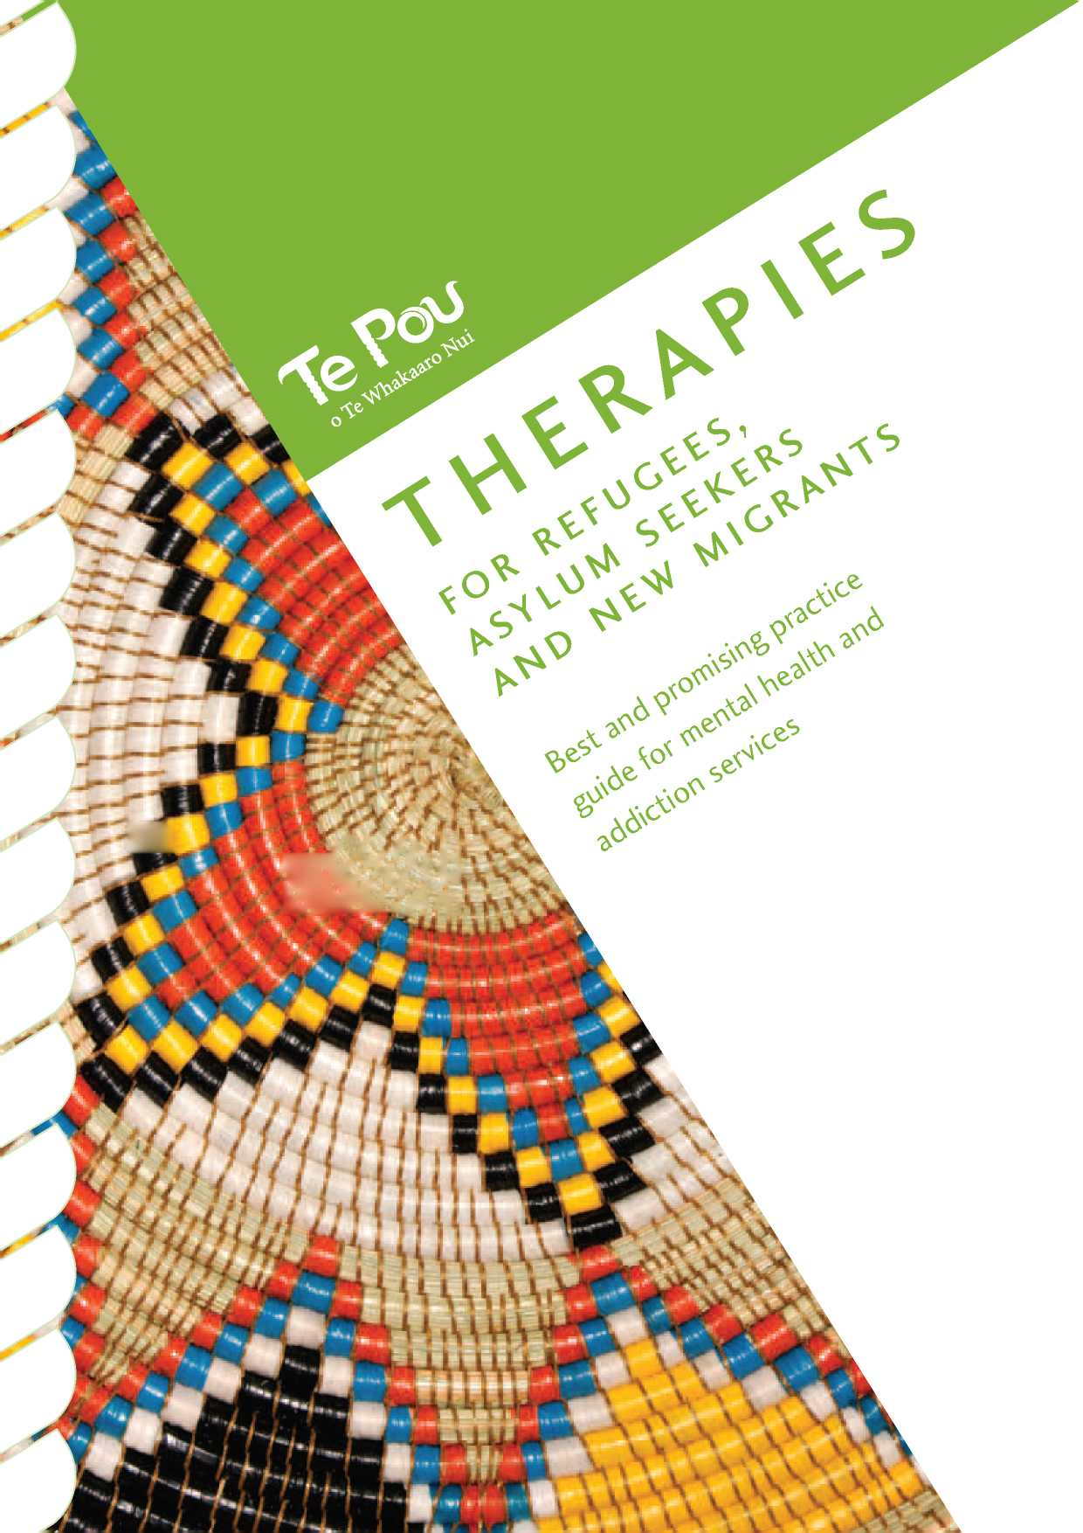

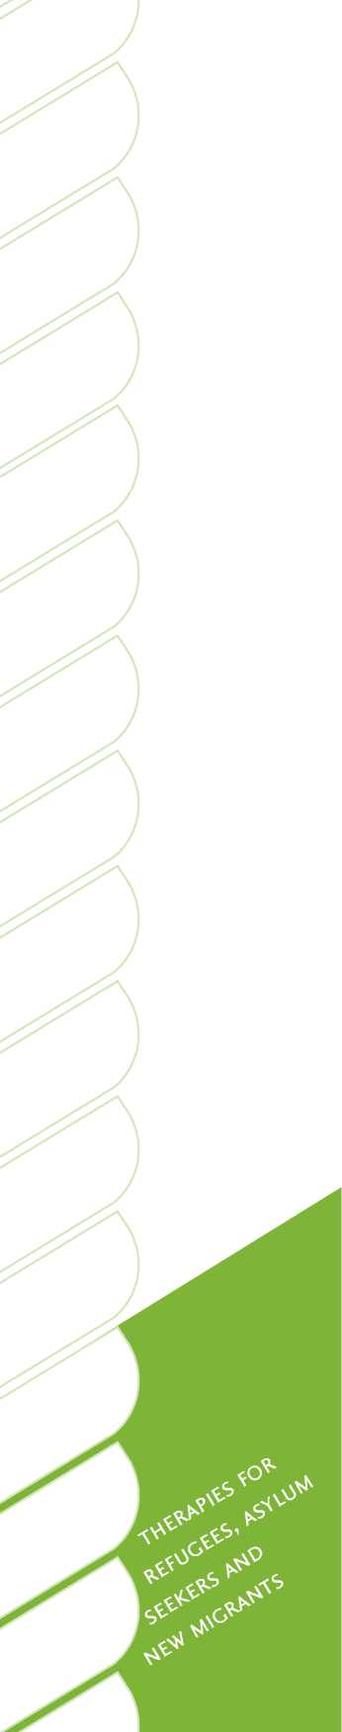*Therapies for refugees, asylum seekers and new migrants: Best and promising practice guide for mental health and addiction services.* Auckland: Te Pou o te Whakaaro Nui.

Published in August 2010 by Te Pou o Te Whakaaro Nui

The National Centre of Mental Health Research, Information and Workforce Development

PO Box 108-244, Symonds Street, Auckland, New Zealand

Web [www.tepou.co.nz](http://www.tepou.co.nz) and [www.leva.co.nz](http://www.leva.co.nz)

Email [info@tepou.co.nz](mailto:info@tepou.co.nz)

ISBN 978-1-877537-61-5

Disclaimer

This guide has been prepared by Refugees as Survivors New Zealand (RASNZ) and Mental Health Programmes Ltd (Te Pou) as a general guide and is based on current medical knowledge and practice at the time of preparation. It is not intended to be a comprehensive training manual or a systematic review of talking therapies in Aotearoa/New Zealand. RASNZ and Te Pou will not be liable for any consequences resulting from reliance on statements made in this guide. You should seek specific specialist advice or training before taking (or failing to take) any action in relation to the matters covered in the guide.

Foreword

It is a pleasure to write this foreword for the new Te Pou guide on working with refugees, asylum seekers and new migrants. This work emerges from a wider call from service users, families and clinicians for greater access to evidence-based therapies across the mental health and addiction sector.

The aim of Te Pou's work in this area is to explore which therapies are currently used, and what might enhance the basic quality, sustainability and spread of therapies across Aotearoa/New Zealand. In 2009, Te Pou published *[A guide to talking therapies](http://www.tepou.co.nz/page/760-talking-therapies+a-guide-to-talking-therapies-in-new-zealand) [in New Zealand](http://www.tepou.co.nz/page/760-talking-therapies+a-guide-to-talking-therapies-in-new-zealand)*, a user-friendly guide to talking therapies. In 2010, Te Pou is producing a series of guides intended to better inform staff working therapeutically with specific population groups about the processes of engagement and therapies that are particularly appropriate to those groups.

Working effectively with new migrants from culturally and linguistically diverse backgrounds requires sensitivity, openness to learning, and a commitment to practising cross-culturally responsive skills and competencies. It is easy to assume that all refugees will have mental health problems or that such problems will become apparent immediately on arrival in Aotearoa/New Zealand. Neither of these assumptions is true, but refugees and some new migrant groups are at higher risk of presenting with mental health problems at some time after settlement. Some of these problems are triggered by the resettlement experience itself, while others reflect past trauma. It is vital that practitioners recognise this and can work sensitively with people from resettled refugee and migrant populations in a health-promoting way.

Services provided to new settlers who have refugee or related forced-migration backgrounds have developed over time. However, many mainstream mental health and addiction practitioners may never have met such a person, nor had the opportunity to explore the unique issues that relate specifically to this group of people. While the mental health needs of resettled refugees and new migrants are similar in some ways to those of any other person using services, key differences exist in understandings, in experiences of health systems, education, family and community, and in other social and personal areas. This means that mental health professionals may need to apply special attention and new skills if they are to help this group of people achieve a sense of well-being in a country and society where many cultural values and practices are new to them.

This resource has been developed by a multi-disciplinary team of experienced senior practitioners from Refugees as Survivors New Zealand (RASNZ), Aotearoa/ New Zealand's specialist refugee health agency. It provides important information about the kinds of issues that may arise when health professionals are engaging with resettled new migrants and refugees. For the new practitioner or the experienced clinician meeting service users from such backgrounds for the first time, this will prove a highly valuable guide and essential resource.

Dr Kathleen Jackson

Cross-cultural psychologist, lecturer and researcher

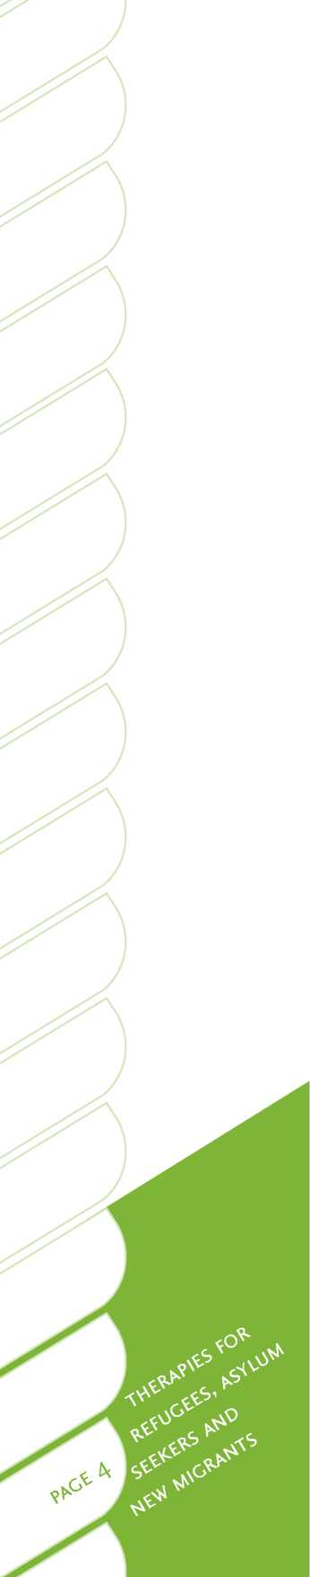I have great pleasure in writing this foreword for the new Te Pou guide and in recommending it to all those who work with individuals and communities from refugee and migrant backgrounds.

One of the most rewarding, exciting and complex challenges for mental health and addiction practitioners is providing quality and competent care to service users, families and communities in a cross-cultural context. In addressing the challenges and problems faced by refugees, asylum seekers and new migrants, health care providers are required to adopt a culturally-appropriate or culturally-sensitive approach to assessment, diagnosis and treatment. Yet because it is impossible for practitioners to have comprehensive knowledge of all the cultural groups they must work with, there is a need for a model or framework to guide their practice. One such framework is this guide. The guide's strength lies in its diversity of contributors who draw not only from a range of cultural backgrounds, but also from a variety of professional backgrounds. Together they bring a diverse range of perspectives and approaches to contemporary issues in cross-cultural mental health and addiction.

This guide will equip health professionals with the theoretical knowledge and practical strategies required to provide culturally competent care in an increasingly complex area of practice. As such, I have no doubt it will become a standard reference for practitioners across a diverse range of disciplines, not only in Aotearoa/New Zealand but in other resettlement countries as well.

Dr Tahereh Ziaian

Transcultural community health psychologist, senior lecturer and researcher

Division of Health Sciences

University of South Australia

Migration, in its various forms, is occurring on an historically unprecedented scale. It has been argued that we are entering a new era - the age of migration - where migration is increasingly “the visible face of social change”. Relative to most countries, Aotearoa/New Zealand has a high proportion of overseas-born citizens and residents. It also has large numbers of sojourners; international students, visitors and tourists, who stay for varying periods of time. New Zealanders, both new and long-settled, are also highly mobile, with many visiting or residing in other countries.

Without a significant inflow of new settlers, Aotearoa/New Zealand's total population would contract and age more rapidly than it is at present, and there would be workforce shortages in key areas. Migration, tourism and export education are major economic drivers, both directly and by building relationships to foster further business, academic, community and other development. They also benefit and enrich society in numerous other ways.

In recent decades the ethnic mix of new settlers has increased markedly. Reasons for coming, both push and pull factors, vary. Irrespective of the reasons for migrating, adjusting to life in a new society and culture inevitably presents a raft of challenges and opportunities. Challenges can be substantial, even for the most robust individual with a supportive family and social networks. They are typically greater when cultural differences are significant, supports are thin or lacking, and when multiple trauma, privation and losses precede arrival. This is typically the situation for asylum seekers and refugees. While the country takes only a relatively small number of people of refugee origin, it makes an important humanitarian contribution that does not go unnoticed in intergovernmental forums.

Recent migrants, overall, are usually in good health relative to those in the wider population they become part of. This is mainly due to various selective factors on the part of both the migrant and host country. Even, indeed particularly, those who have survived extreme and prolonged trauma are, by definition, survivors. Others have fallen along the way. Over time there is a tendency for migrants and subsequent generations to resemble the health status of wider society, and sometimes to be over-represented on morbidity indicators.

Against the foregoing broad health backdrop there are various adjustment challenges, acute and longer term, associated with relocation and acculturative stress. Periods of unemployment and under-employment are not uncommon and can contribute to psychological distress and mental health disorder, particularly during early years of resettlement.

The present Te Pou publication provides an excellent overview and resource to assist practitioners who work with refugees and migrants. I believe it also has wider relevance to others in various capacities who seek to understand and enhance the resettlement and well-being of this significant and important sector of Aotearoa/ New Zealand society. I commend the authors and Te Pou on bringing it to fruition, and for their sustained dedication to this challenging and important work.

Professor Max Abbott

Pro vice-chancellor and dean, Faculty of Health and Environmental Sciences, AUT Director, Asian and Migrant Health Research Centre, AUT

Past-president, World Federation for Mental Health

Acknowledgements

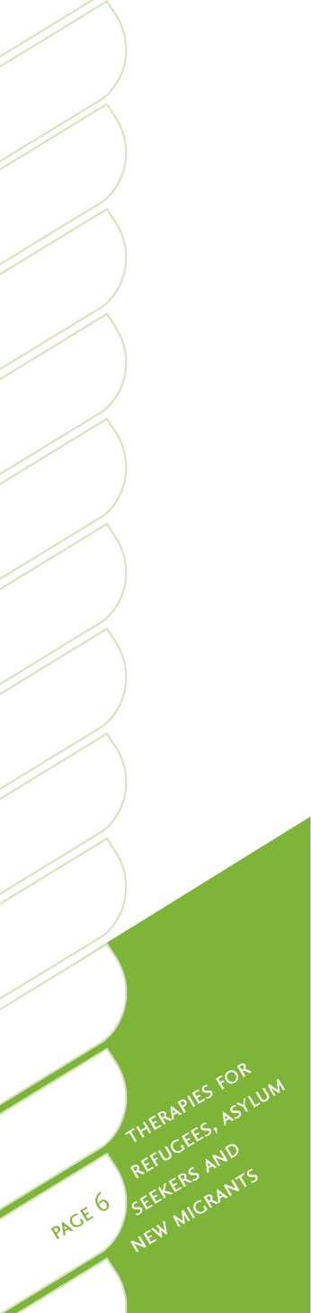Principal authors and editors

G. E. Poole, CEO, RASNZ

Eileen Swan, clinical manager, National Refugee Centre, RASNZ

Contributing writers

Dr Grant Galpin, consultant psychiatrist

Chaykham Choummanivong, clinical psychologist

Andrew Duirs, community psychologist

Sangita Wadnerkar, registered psychologist

David Lyon, registered psychologist

Dr Jo Schmidt, University of Auckland

Steven Gin, body therapist

Claire Duggan, body therapist

Surpreet Cheema, clinical team manager

Pratima Devi Prasad, clinical nurse specialist

Zoreh Karimi, interpreter coordinator

With sincere thanks to

Dr Nooria Meharaby, STARTTS Centre, Sydney, Australia (peer reviewer)

Professor Max Abbott, AUT (peer reviewer)

Santino Deng, refugee and migrant advocate, NZ Health and Disability Commissioner (peer reviewer)

Ranka Margetic-Sosa, clinical manager, Wellington Refugees as Survivors Trust

Dr Fahima Saeid, counsellor, advocate and community link worker, RASNZ

Kailesh Thana, secretary, Refugee Council of New Zealand (peer reviewer)

Executive summary

This guide is intended to provide a concise overview of recent patterns of immigration to this country, and to cover some of the challenges and issues that may affect refugees, asylum seekers and new migrants. New migrants comprise a large and extremely diverse group of people who resettle in Aotearoa/New Zealand each year from many different countries and cultures. The principal focus for this guide is therapies relevant for three subgroups of migrants: those from culturally and linguistically diverse backgrounds, refugees and asylum seekers. The latter two subgroups often have special and unique requirements.

The guide summarises some of the knowledge and skills that health practitioners require if they are to work in more culturally responsive ways to better meet the needs of these service user groups. It reviews the domestic and international literature about current best and promising practices, and provides some practical guidelines on working with and through interpreters. It also provides detailed information to assist those working in the challenging and rewarding field of cross-cultural practice. Although this guide is produced as part of Te Pou's series of guides on talking therapies, specialists in the field recognise that a range of other treatments and modalities can be of considerable value when working with refugees, asylum seekers and new migrants. Therefore, while talking therapies are discussed, the potential value of kinaesthetic, narrative, traditional, collective, and other therapeutic approaches are also included.

The guide addresses some of the important principles for engagement, and includes some practical tips and helpful links to further resources. It also provides an overview of the main therapies and approaches that are currently considered effective and more culturally responsive. Specific issues around medications and care management are also covered, as they relate to the special characteristics and needs of these particular groups of service users.

Working in the area of cross-cultural international health can be highly rewarding and challenging. The aim is to assist migrants and refugees to overcome obstacles and enhance their resettlement success. In working with new migrants, there are constant opportunities to learn about new cultures and concepts of mental health, and different customs and ways of life. With an attitude of sincerity, openness, flexibility and a willingness to learn, a practitioner may gain experience and develop confidence in providing help for people from a wide variety of countries, cultures, backgrounds and needs.

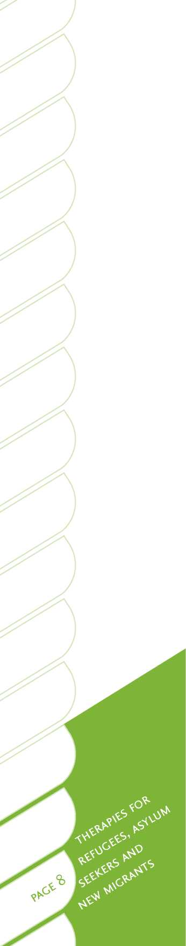Contents

Foreword

Acknowledgements

Executive summary

Contents

1. - Introduction

Purpose and target audience Development of this guide Refugees and migrants in Aotearoa/New Zealand The Aotearoa/New Zealand immigration process Common health issues for refugees and migrants Mental health issues for refugees and migrants Addiction issues for refugees and migrants Stigma about mental illness in refugees and migrants Cultural world views of refugees and migrants Access to mental health services

National evidence and knowledge gaps International evidence

1. - Principles of engagement

*Let's get real*

Human rights and respect

Cultural differences

Brief guidelines for working with and through interpreters Engagement during assessment

Engagement during therapy for refugees and migrants Working with asylum seekers

Family reunification

Community support

1. - The therapies

Key issues in treatment Overview of therapies Cognitive behaviour therapy Counselling Family therapy Problem-solving therapy Psychotherapy with children Other useful therapies Narrative therapy and collaborative narrative practice Narrative exposure therapy and testimonial psychotherapy A community psychology approach

Body therapies

Eye movement desensitisation and reprocessing

6

7

8

11

11

12

13

17

18

19

23

25

25

26

27

27

29

29

30

31

32

33

33

38

39

40

43

43

45

48

50

51

51

52

55

55

57

58

60

62



| Promising new approaches | 65 |
| --- | --- |
| Neurofeedback | 65 |
| Less widely used therapies | 67 |
| Acceptance and commitment therapy | 67 |
| Bibliotherapy | 68 |
| Computerised cognitive behaviour therapy | 69 |
| Dialectic behaviour therapy | 69 |
| Interpersonal psychotherapy | 70 |
| Motivational interviewing | 70 |
| Multisystemic therapy | 71 |
| Psychotherapy | 71 |
| Summary | 73 |
| 4 - Resources and links | 75 |
| Appendix A: Medication | 77 |
| Appendix B: Aotearoa/New Zealand  Refugee Quota 2006-2009 | 80 |
| References | 83 |

**List of tables**

Table 1. Differences between refugees and migrants 14

Table 2. International and domestic law relating to refugees 15

Table 3. Legal refugee categories in Aotearoa/New Zealand 15

Table 4. Aotearoa/New Zealand refugee claims 16

Table 5. Prevalence of PTSD and depression among refugees 21

Table 6. Fundamental values underpinning *Let's get real* for mental health and addiction services 29

Table 7. Overview of evidence for use of different

therapies with Refugee, Asylum Seekers and New Migrants 45



1. Introduction

Purpose and target audience

Purpose

This guide aims to provide mental health and addiction practitioners with an overview of key issues and considerations when working with refugees, asylum seekers and new migrants in Aotearoa/New Zealand. Specialists in the field recognise that effective treatment for this group moves beyond talking therapies and psychotropic medication, to include other valuable therapeutic modalities that are also addressed by this guide. The special characteristics and needs of refugees, asylum seekers and migrants are examined, and an overview of practical skills is provided.

A guide has specifically been developed for refugees and migrants because:

• migrants constitute a large and growing proportion of the national population

• migrants come from culturally and linguistically diverse backgrounds and have needs that may well not be adequately met by existing health or human services

• migrants are likely to include subgroups that are at high risk of mental illness or dysfunction due to pre and post-migration stresses and challenges. 3

Although a number of migrants to Aotearoa/New Zealand are of English-speaking or culturally similar origins[1], the focus of this guide is on refugee, asylum seekers and migrants from culturally and linguistically diverse backgrounds, as these people have special and unique requirements. It is well beyond the scope of this guide to address the unique cultural aspects and mental health profiles of the highly diverse former refugee, new migrant, and ethnic minority communities. Instead, the purpose of this resource is to provide an overview of key issues and considerations, and to put forward some practice guidelines and protocols that may assist practitioners to understand and work more effectively with service users from a refugee, asylum or migrant background.

Target audience

This guide is intended for mental health and addiction practitioners who work therapeutically with refugees, asylum seekers and migrants. Practitioners may include psychologists, nurses, social workers, medical doctors, community workers, psychiatrists, physiotherapists, occupational therapists and others.

Assessment and treatment are key roles for practitioners working with refugees and migrants. Practitioners may also be required to produce assessment reports to inform asylum claims to the Immigration and Protection Tribunal, or to advocate for service users in cases managed by Immigration New Zealand or other government departments.

Additional resources

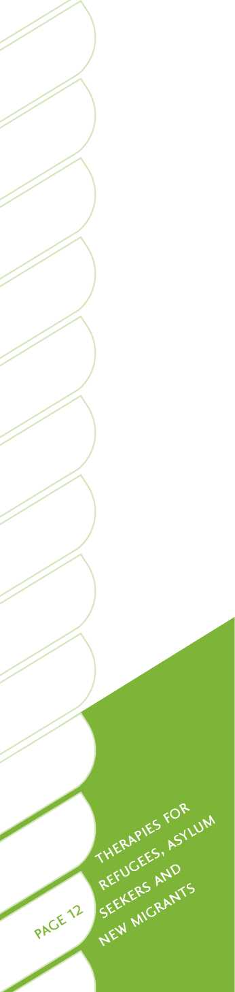This guide is not a substitute for specialist training, experience or supervised practice. Some further training and information resources are included in Section Four of this guide.

This guide assumes readers are familiar with the essential knowledge, skills and attitudes required to deliver effective mental health and addiction services, as described in the Ministry of Health's *Let's get real* framework. The *Let's get real* framework is explicit in stating the expectations for people who work in mental health and addiction services irrespective of their role, discipline or position in an organisation. *Let's get real* is discussed further in Section Two of this guide.

Development of this guide

This guide has been developed through a process that has included an international literature review, expert opinion and consultation. The principal authors, G. E. Poole and Eileen Swan, wrote most of the material, and compiled and edited the submissions from a multi-disciplinary team that included clinical, community and educational psychologists, a consultant psychiatrist, a clinical nurse, refugee community health workers, an interpreter coordinator, and body therapists.

As there was no prior practice guide such as this in Aotearoa/New Zealand, United Nations High Commissioner for Refugees, Canadian and Australian (in particular) documents were referenced. Key Aotearoa/New Zealand and Australian specialists in the field were consulted at several stages in the guide's preparation.

The document underwent extensive peer review, including input from the STARTTS Centre (a leading trauma and torture treatment centre in NSW), the Refugee and Migrant Advocate, Health and Disability Commissioner, and the Refugee Council of New Zealand. Comment was also invited from Auckland University of Technology, Christchurch Resettlement Services, Wellington Refugees as Survivors Trust, Changemakers Refugee Forum, and the Refugee Coalition.

Individual contributing writers and peer reviewers are named in the acknowledgements section of this guide.

Refugees and migrants in Aotearoa/New Zealand

International migration

World-wide migration has increased substantially since the late 20th century and continues to accelerate at historically unprecedented levels4. Over 200 million people have migrated from their place of birth to a new country5*.

People migrate to other countries for a variety of complex reasons, generally in pursuit of hopes of a better life. Push factors that force or encourage people to leave their country include poverty, deprivation, persecution, over-crowding and natural disasters (e.g. earthquakes, drought and, more recently, climate change)5, 110. Pull factors attracting people to Aotearoa/New Zealand include economic betterment, job opportunities, education, family reunification, relationships, the environment, climate, personal freedom and lifestyle factors.

The process of migration has been described by Sluzki 6, 7 as a continuum involving discrete steps including (a) a preparatory stage, (b) act of migration, (c) period of overcompensation, (d) period of de-compensation, and (e) trans-generational phenomena. Each step has distinctive characteristics and triggers different types of personal and family coping mechanisms and responses.

Moving to a new country involves major changes and challenges, such as disruption to familiar patterns and leaving behind family, friends and support networks. In a new country, people will also be exposed to new experiences and problems. The challenges are greater when the move is to a country with major cultural and linguistic differences. There are also considerable legal barriers to migration, including stringent international border control policies. Generally, only the most skilled or affluent migrants are readily accepted for residency in developed countries, including Aotearoa/New Zealand5t. When migrants arrive in a new country there are other challenges such as finding work and accommodation, and adapting to new laws, cultural norms and language barriers. New migrants and refugees may also experience discrimination or other exclusionary behaviours.

Migrants in Aotearoa/New Zealand

Aotearoa/New Zealand has one of the highest population percentages of people born overseas8. Each year, about 45,000 people migrate to Aotearoa/New Zealand8. In 2006, 23 per cent of the general population in Aotearoa/New Zealand was born in a foreign country, similar to Canada and Australia5. Although a number of migrants to Aotearoa/New Zealand are from English-speaking or culturally similar origins1/ the focus of this guide is on refugee and migrants from culturally and linguistically diverse backgrounds, given their unique needs[2] [3] [4] [5].

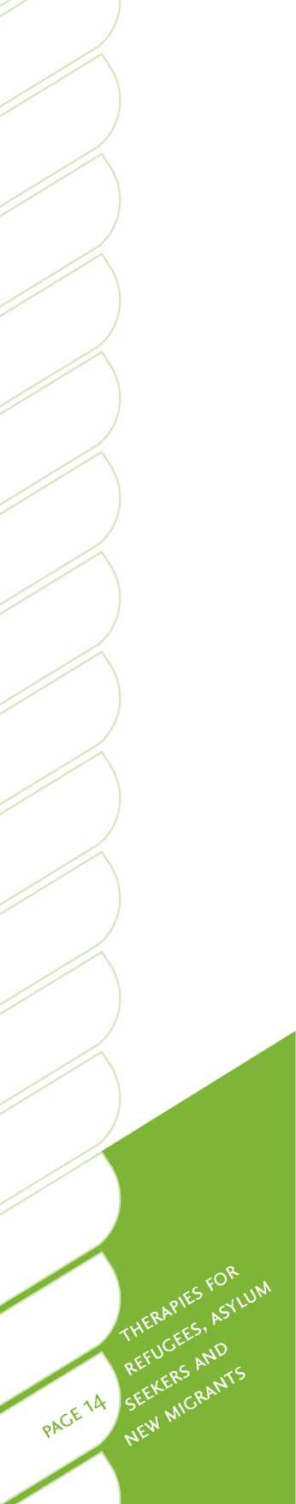Refugees

There are substantive differences between refugees and people who voluntarily migrate to a new country. Refugees include asylum seekers and often have histories of profound trauma caused by war, dislocation, flight, detention or torture. Refugees are likely to have suffered persecution, and are unable to return home. The United Nations defines refugees as people who:

*... owing to well-founded fear of being persecuted for reasons of race, religion, nationality, membership of a particular social group or political opinion, is outside the country of [their] nationality and is unable, or owing to such fear, is unwilling to avail [themselves] of the protection of that country; or who, not having a nationality and being outside the country of [their] former habitual residence as a result of such events, is unable or, owing to such fear, is unwilling to return to it*. (Page 4)10

Specific differences between refugees and migrants are summarised in Table 1. Refugees usually have no opportunity to plan their departure from their country of origin, and may have fled for their lives, with little thought of, or control over, their destination3, 11, 12. The travel itself can be physically and psychologically traumatic13, with some refugees being at constant risk of apprehension or violence, and having little certainty as to what awaits them at their immediate destination1 1 . The need to care for children or elderly or infirm family members may exacerbate these stressors.

There are about 16 million refugees and asylum seekers world-wide and 42 million internally displaced persons of concern4*. The United Nations High Commissioner for Refugees is charged with overseeing the international conventions that provide for the protection of refugees. Aotearoa/New Zealand is a signatory to the 1951 United Nations Convention Relating to the Status of Refugees4. The United Nation's [Convention Against Torture and Other Cruel, Inhuman or Degrading Treatment or](http://www.hrc.co.nz/home/hrc/internationalhumanrights/nzandtheinternationalinstruments/torture.php) [Punishment](http://www.hrc.co.nz/home/hrc/internationalhumanrights/nzandtheinternationalinstruments/torture.php) was signed by Aotearoa/New Zealand on 14 January 1986 and ratified on 10 December 19894. Table 2 summarises relevant laws pertaining to refugees.

| **Refugees** | **Migrants** |
| --- | --- |
| No options | Many options |
| Escape danger or risk | Plan ahead |
| No travel documents | Travel documents |
| No possessions | Possessions |
| Secretly leave | Say farewell |
| No contacts or visits | Can visit home again |
| Unlikely to return | Free to return |

Table 1: Differences between refugees and migrants

* Given the opportunity to do so, estimates suggest over 700 million people world-wide would migrate to a new country 14.

Table 2: International and domestic law relating to refugees

**International law**

• 1951 United Nations Convention Relating to the Status of Refugees

• 1967 Protocol Relating to the Status of Refugees

• 1984 International Convention Against Torture and Other Cruel, Inhumane or Degrading Treatment or Punishment

• The Universal Declaration of Human Rights, Article 14.1

**Domestic law**

• Immigration Advisers Licensing Act 2007

• Human Rights Act 2001

• Immigration Act 2009

In Aotearoa/New Zealand there are three legal categories of refugees - quota refugees, asylum seekers and convention refugees (see Table 3). Aotearoa/New Zealand accepts 750 quota refugees each year and allocates 300 places for family reunification. The annual number of asylum seeker claims varies (see Table 4). Each year up to 1,500 new refugees settle in Aotearoa/New Zealand and there are about 40,000 people in total living in Aotearoa/New Zealand who have refugee backgrounds15.

The largest number of recent refugees to Aotearoa/New Zealand are from Vietnam, Cambodia, Kosovo, Bosnia, Somalia, Afghanistan, Iraq, Myanmar (Burma), Sudan and Ethiopia. There are also communities of former refugees from Burundi, Congo, Columbia, Sri Lanka, Rwanda, Bhutan and Nepal.

| **Refugee categories16** | |
| --- | --- |
| Quota refugees | Those determined overseas by the United Nations High Commissioner for Refugees to be refugees and accepted for resettlement in Aotearoa/New Zealand *. |
| Asylum seekers | Persons who enter Aotearoa/New Zealand through legal or illegal means (such as false travel documents) and who declare asylum at the border or upon arrival in Aotearoa/New Zealand. |
| Convention refugees | Asylum seekers who have had their claims proved and are eligible for permanent residency as refugees pursuant to a determination by the Immigration and Protection Tribunalf. |
| * Approximately 1000 per year. f Pursuant to criteria of the 1951 United Nations Convention. | |

Table 3: Legal refugee categories in Aotearoa/New Zealand

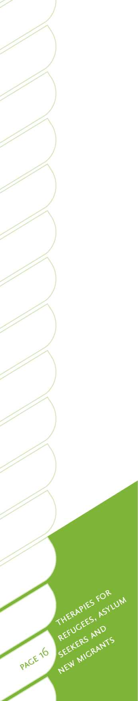Asylum seekers

Asylum seekers may arrive in Aotearoa/New Zealand under extreme and desperate conditions, such as through people smugglers or with false and illegal documentation. Asylum seekers are often portrayed by the media and politicians as queue jumpers. This is an inaccurate and unfortunate stereotype for people who have often been driven by desperation and extreme urgency to seek a safe place. The reality is only 30 to 50 per cent of asylum seekers will have their claims for refugee status approved as shown in Table 4.

The majority of asylum seekers will eventually be deported to their last port of call or country of origin. In many cases this could be to a country with a regime known to practice torture. Also, the departure and unexplained absence of asylum seekers in such circumstances may itself attract attention and suspicion of the military, police, agents or militia.

| **Year** | **Number of claims lodged** | **Number of approved claims** |
| --- | --- | --- |
| 2004 | 580 | 208 |
| 2005 | 348 | 209 |
| 2006 | 276 | 145 |
| 2007 | 248 | 113 |
| 2008 | 254 | 128 |
| 2009 | 319 | 93 |
| Total | 2025 | 896 |
| Source: Immigration NZ (2009) 16 | | |

Table 4: Aotearoa/New Zealand refugee claims

Most asylum seekers are housed in the community in Auckland, or in semi-secure detention at the national Refugee Reception Centre at Mangere. A few asylum seekers are held in secure detention at Mt Eden Prison in Auckland, if they are considered a potential security risk or their identity is seriously questioned.

The refugee claims and appeals process can be lengthy and stressful for asylum seekers and may take two to 24 months or more. During this time, the claimant may experience depression, panic or issues such as extreme concern about family members left in dangerous circumstances in their country of origin. The claimant may be challenged regarding the veracity of their story by immigration officials, and the re-telling of personal stories may trigger symptoms of disorder.

**The Aotearoa/New Zealand immigration process** The Aotearoa/New Zealand legislation on migrants and refugees is the Immigration Act 200916. The purpose of the Immigration Act is to:

• regulate border control and immigration policy and practice

• ensure Aotearoa/New Zealand complies with international conventions relating to human rights and refugees

• govern visas, residency and citizenship.

Government agencies that address migration issues include the Immigration and Protection Tribunal, Immigration New Zealand, the Department of Labour, the Department of Internal Affairs, and the Ministry of Social Development.

The Aotearoa/New Zealand quota refugee programme

Aotearoa/New Zealand fulfils its international humanitarian obligations through its United Nations Quota Refugee Programme, which is administered by Immigration New Zealand[6]. Aotearoa/New Zealand is one of 10 countries that formally accepts a quota17f. Aotearoa/New Zealand's annual quota includes a large proportion of high protection cases16. High protection cases include people who are immediately vulnerable or at-risk in refugee camps or transit countries, including medically disabled people, vulnerable women and children, and survivors of torture and trauma. Quota refugees who arrive in Aotearoa/New Zealand are therefore likely to have high and complex needs.

Under the Immigration Act 2009, quota refugees receive permanent residency status upon arrival in Aotearoa/New Zealand. In other words, they are no longer refugees but permanent residents of Aotearoa/New Zealand, with the same rights and responsibilities as other citizens.

Quota refugees arrive for assessment and orientation in Aotearoa/New Zealand at the national Mangere Refugee Resettlement Centre. The centre provides a unique assessment and orientation service during the first six weeks of people's arrival. A number of organisations work collaboratively at the centre, providing a range of services in a one-stop-shop, including:

* Immigration New Zealand
* Auckland Public Health Service (medical assessment and treatment)
* RASNZ (mental health assessment and treatment)
* Refugee Services Aotearoa New Zealand (social work and volunteer settlement support)
* Red Cross
* Auckland University of Technology (ESOL and education).

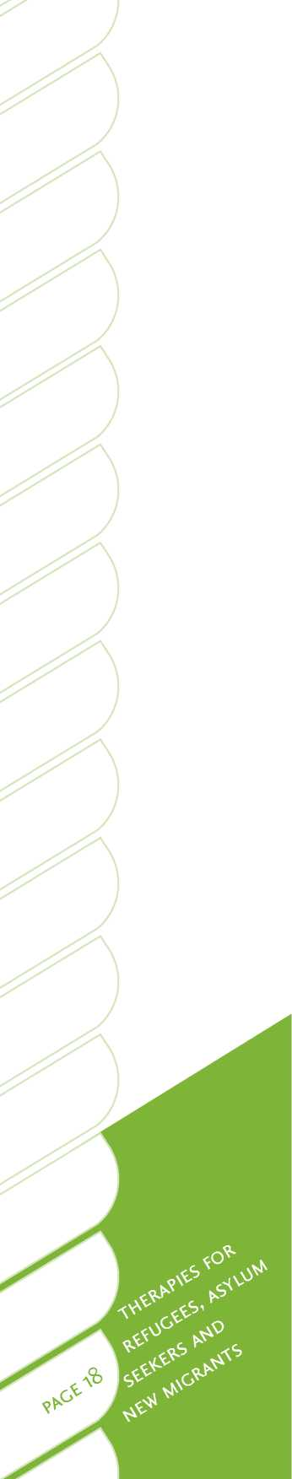From the Mangere centre, refugees are resettled around Aotearoa/New Zealand in Auckland, Hamilton, Wellington, Palmerston North, Nelson and Christchurch*. More than one-third of refugees were resettled in the Auckland region in 2007/2008+ t. Immigration New Zealand and other agencies aim to locate new arrivals in communities of their own nationality and culture. However, this is sometimes not possible due to practical constraints such as housing availability. It is important for refugees and migrants to establish links with their own cultural and social groups. Equally, new migrants can benefit from making new friends in Aotearoa/New Zealand mainstream society. Both connections enable them to learn from the experiences of those who have already established themselves in Aotearoa/New Zealand.

Placing people from the same nationality, ethnic group, tribal affiliation, language or political affiliation together can involve complex social issues. In some cases, people from the same country may have belonged to opposing and hostile groups. Some may have been involved in war or persecution of the other. Although there are examples where reconciliation has occurred and people have set aside such histories, it is often not a simple matter. Group hostilities and politics may affect the ability of a service user to seek and receive support from their community18.

There are specific issues for people who have been warehoused for long periods of time (sometimes for over 20 years or generations) in refugee camps19. Such refugees often arrive with personal, family and social dysfunction issues. It may be necessary to resettle people with such experiences in new and separate areas.

Common health issues for refugees and migrants

Health issues for new migrants

A recurring theme observed by staff working with refugees and migrants is the difficulty that culturally and linguistically diverse people in Aotearoa/New Zealand have in accessing health services 20, 21. Aside from accessing health services there has been little evidence that most newly arriving migrants have health issues different from the local resident population. Migrants are generally screened for good health prior to entry.

There has been little research focusing on the special health issues of migrants in Aotearoa/New Zealand. However, a recent needs assessment in Auckland22 has identified some emerging issues for South Asian, Middle Eastern, Latin American and African population groups, including:

* cardiovascular disease and diabetes[7] [8] [9] [10]
* sexual and reproductive health issues
* poor oral health
* a deterioration in health associated with acculturation.

Health issues for refugees

There is well-documented evidence that refugees and asylum seekers often present with a range of special health needs. A high prevalence of physical disability, severe dental problems and disease acquired in flight, refugee camps or detainment centres can be expected in refugee populations. Severe permanent physical damage, scarring and disability as a result of torture, war injury, landmines or major traumatic wounds during flight have been widely reported in refugee populations4, 23, 24. A number of refugees also have pre-existing disability conditions. A large proportion of female refugees, particularly those from some African countries, are survivors of systemic rape and mass sexual violence25. Refugee and internally displaced girls and women are particularly vulnerable to gender-based violence during armed conflict, civil war, ethnic genocide, or inside camps and detention centres.

A leading study on refugee health status in Aotearoa/New Zealand was carried out by the Auckland Regional Public Health Service at the National Mangere Refugee Resettlement Centre26. This study involved 2992 quota refugees who were screened and treated over a 10-year period. Infectious diseases screened and treated included tuberculosis, intestinal parasites and a small number of HIV cases. Non-infectious conditions included iron and vitamin D deficiency. Most of the illnesses were caused by parasitic or bacterial infection in contaminated water, unhygienic conditions, or malnutrition in camps or during transition. Virtually every refugee screened required some intervention. There were 349 cases of female genital mutilation reported. This is an important and very sensitive area of inquiry in the initial assessment phase.

Many refugee children arrive in Aotearoa/New Zealand with no birth certificate or other documentation about their date or place of birth. As a result, many refugees do not know their actual age. This has implications for developmental milestones, medical care (such as vaccinations), education and other legal considerations (such as obtaining a driver's licence). It is possible to estimate a person's age through non-intrusive assessments, such as mandible or lower jaw growth rates and dental measurements28.

These health issues can have profound impacts on people's mental health, recovery, and resettlement outcomes. Furthermore, language barriers and cultural factors can mean former refugees often have great difficulty in accessing primary health services, or in knowing how to use the Australian 27 and Aotearoa/New Zealand health care systems20, 21. This issue is discussed further on page 26.

Mental health issues for refugees and migrants

Mental health issues for migrants

Given that Aotearoa/New Zealand is significantly a nation of migrants, it is important to consider and better understand how migration experiences impact on mental health and well-being. There are challenges involved in crossing international borders and entering a new country. All new arrivals, whether short-term visitors, students or migrants, must also adapt to a different environment, society and culture. Shifting to a new place of residence involves losses, disruption to familiar life patterns, and exposure to new experiences and challenges. Acculturation (adaptation to the new culture), and maintenance of traditions and language have all been shown to impact on people's settlement outcomes3, 29, 30.

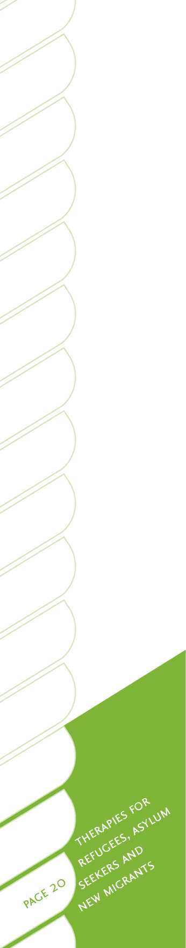Although the challenges for newcomers to Aotearoa/New Zealand can certainly be demanding and stressful, particularly in the early stages, it remains unclear whether this leads or contributes to increased mental health problems for migrants. A review of the literature concluded it was unclear if migrants have a higher risk of mental illness than the general population3. In a model proposed by Albee31, the impact of adverse life events depends in part on protective or adaptive factors in new migrant individuals, families and communities. Although stress and the challenges of adjustment in migration may be considerable, they do not necessarily result in mental health problems.

Evidence suggests several factors may impact on the mental health of migrants:

• older age has been found to reduce the risk of mental illness among Pacific and other migrants in Aotearoa/New Zealand 32

• low acculturation increased the prevalence of psychiatric morbidity among

Cambodian adults29*1^

* among skilled migrants from China, India and South Africa, unemployment increased the likelihood of poor mental health33§
* among Tongans, migration led to improved mental health, particularly for women and those with a history of poor mental health34
* maintaining close links with similar migrant communities promotes well­being and reduces risks during early resettlement3, 35
* those who move more frequently have a higher risk of separation or divorce, which may be explained in part by increased stress and relationship instability36.

Mental health issues for refugees

There is clear evidence that refugees and those from forced-departure backgrounds have a higher risk of mental health problems and resettlement difficulties. Refugees often experience stressors that relate specifically to their status as refugees. These stressors emerge from their experiences prior to flight from their country of origin, events during the time of transition, and the process of resettlement in the host country37. They include, but are not limited to:

* experiences of marginalisation, persecution or torture in the country of origin
* often long-term residence in harsh conditions inside refugee camps, or in a transitional state in the initial country of refuge1
* forced separation from community, friends and family members, and uncertainty as to the location and status of family members
* lack of control over futures and destiny
* social perceptions of refugees
* inability to return to the country regarded as home.

The prevalence of serious mental health problems is relatively high among refugees. An overview of the international literature shows a high incidence of post-traumatic stress disorder (PTSD) among refugees resettled in Western countries, as well as [11] [12] [13] [14]major depression, other anxiety and co-morbid disorders39. PTSD may be up to 10 times higher among refugee populations39*. The findings from several large-scale studies examining the prevalence of PTSD and depression among refugees are summarised in Table 5.

Table 5: Prevalence of PTSD and depression among refugees

**Findings**

• 39 per cent of 534 Bosnian refugees had a diagnosis of depression and 26 per cent PTSD40.

• Among 993 Cambodian refugees, 68 per cent had depression and 37 per cent PTSD41.

• Among 842 refugees from Kosovo, approximately 20 per cent had a major depressive disorder and just under half had PTSD42.

• In a clinical setting in Norway, of 231 refugees, 47 per cent had PTSD43f.

Refugees do not necessarily resemble typical sufferers of PTSD, as the stressors faced by refugees are often numerous and sustained, from traumatic events in the country of origin, through high levels of uncertainty during transition, to the issues involved in resettlement45. Rather than one discrete traumatic incident, refugees must cope with all or most of the events discussed above, often moving directly from one environment of extreme stress to another, with no time to recover.

In Aotearoa/New Zealand, Cheung and Spears examined the mental health of adult Cambodian refugees living in Dunedin29, 46, 47. The majority had experienced severe multiple trauma, including torture. The prevalence of psychological disorder was 16 per cent, and 12 per cent had been diagnosed with PTSD. Older adults had a higher prevalence of PTSD and mental health disorder[15] [16]2. Risk factors included being widowed, experiencing major life events during the past 12 months, experiencing chronic post-migration stressors, and having a poor individual coping style and weak social supports.

Children and adolescents

Some studies have investigated the prevalence, type and severity of psychological distress and mental health disorders among child and adolescent refugees48, 49. Symptoms and effects may be persistent and have long-term and intergenerational impacts48, 49. For example, among young Cambodian refugees traumatised as children, 38 per cent experienced PTSD and 14 per cent depression in a six-year follow-up50. Furthermore, the link between parental mental illness and childhood adjustment problems would appear to be as relevant for refugees as for other population groups51, 52, 53.

Survivors of torture

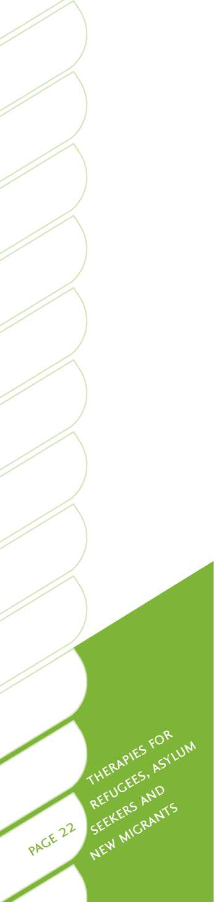Given that Aotearoa/New Zealand accepts high protection refugee cases, up to 20 per cent of quota refugees may be survivors of torture in each intake*. The torture may have been carried out by government agents, paramilitary groups, opposition parties, ethnic gangs during tribal conflict, or as part of ethnic cleansing operations by police, military or other officials4. Torture is used to create fear, destroy individuals and communities, and suppress unwanted political or religious views. The survivor of torture often endures severe and prolonged physical and psychological trauma12. For asylum seekers or quota refugees, new issues have been created in recent years by the availability of instant communications with family members overseas through such channels as the internet and text messaging. News from family members at home about extremely distressing real-time events, such as persecution, property seizure, detention and torture can result in mental health crises for service users in Aotearoa/New Zealand.

Post-settlement

Timing and post-resettlement stressors may substantially increase the risk of mental illness in refugees and migrants3, 37, 54. Cultural transition has its own psychological burdens13, including:

• linguistic barriers3, 11

• adjustment to a new culture11, 13

• attempting to maintain one's own culture3, 13, 55

• institutional and social racism, which can affect people's access to education and employment, and impact on their enjoyment of everyday activities3, 55.

In an Australian study of Tamil refugees56, pre-settlement factors accounted for 20 per cent and post-migration factors for 14 per cent of the variance in PTSD symptoms. PTSD and depression, often occurring co-morbidly, appear to have complex relationships with pre-resettlement trauma and post-resettlement social and adjustment difficulties57.

Most refugees arrive in Aotearoa/New Zealand with little in the way of financial resources, and as a population have high rates of unemployment. They are thus subject to the stressors that are experienced by members of all lower socioeconomic groups, which are in turn likely to elevate the risk of mental illness3, 13. These stressors include, but are not limited to:

• difficulties in covering basic needs

• financial uncertainty

• lack of sustained education

• concern about the future of themselves and their families

• dependency, sometimes inter-generational, on welfare agencies and charities, with related loss of dignity and control

• feelings of being unable to contribute to one's own community or to wider society.

Addiction issues for refugees and migrants

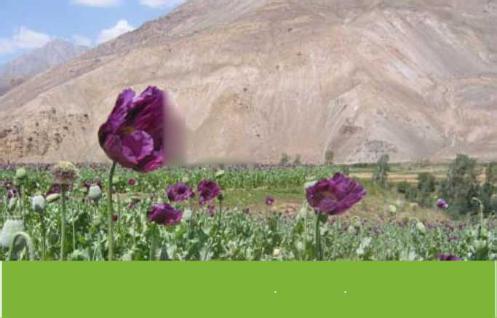Alcohol and other drugs

**gag**

Thousands of hectares of opium poppies growing in Afghanistan supply 90 per cent of the world's heroin production

**k**

**' ' V**

2.

Concurrent drug or alcohol dependence, particularly among those with PTSD, has frequently been reported in refugee populations58, 59, 60. There may be high rates of addiction in refugee camps and detainment centres, and among those resettling in Aotearoa/New Zealand. One of the authors witnessed severe and widespread heroin addiction on a massive scale among thousands of men, women and children inside refugee camps in Waziristan, Pakistan. In addition, the drugs that refugee populations use may be rare or unknown to Western mental health and addiction services, such as opium, ghat or betel abuse and dependency61, 62.

Alcohol and other drug use or abuse in any culture depends in part on access, mores, peer behaviours, customs and values. In some cases, the widespread availability of alcohol and other drugs in Western resettlement countries may create opportunities for abuse and addiction, which may be aggravated by a breakdown in traditional and family cultural values in first and subsequent generations62.

Coping responses to stress or adverse life conditions may influence the consumption of alcohol and other drugs following severe trauma. Research into specialised treatment for refugee and migrant people from culturally and linguistically diverse backgrounds, indicates that an understanding of how stress is culturally expressed and managed, and of underlying attitudes toward substance use and abuse, is important. For example, in a two-year study of Cambodian refugees, a very controlled coping style was normal, including emotional suppression, silent suffering and acting pleasantly toward others regardless of one's feelings63. In Khmer culture, sadness is to be kept “within the heart”64. Often, the act of not expressing feelings, such as fear, anger, grief or hostility, is associated with somatic problems (e.g. severe headache or stomach disorder), and is a culturally acceptable stress response.

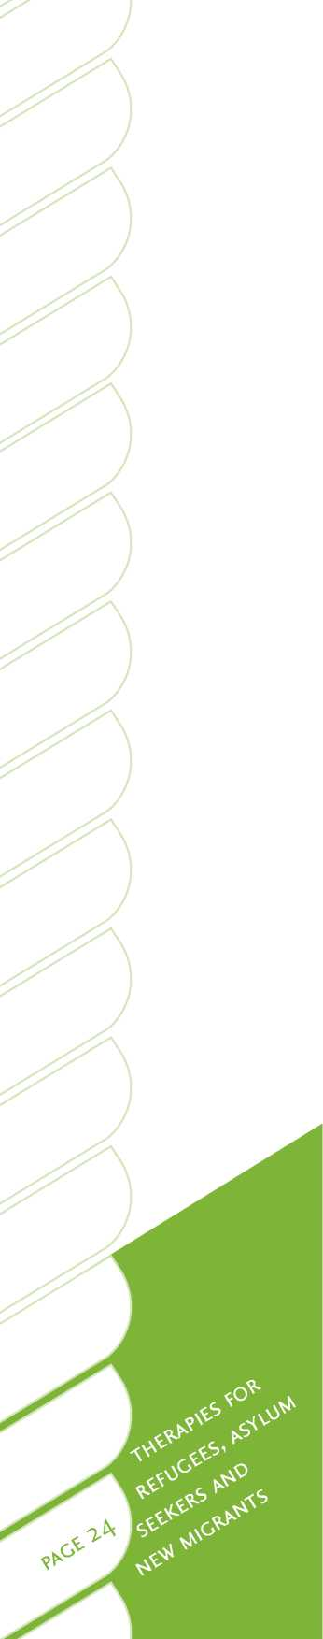Some cases of alcohol or other drug addiction may not be disclosed or detected[17]. In refugees and migrants, alcohol and other drug abuse may be deeply hidden in the community due to religious or cultural prohibitions, and the associated shame, stigma and ostracising that comes with acknowledging an addiction60, 65. This may be particularly so for refugees from Muslim countries, where alcohol use is banned or strongly discouraged. This highlights the importance of effective assessment and education about drug and alcohol related issues upon arrival in Aotearoa/ New Zealand.

Gambling

There may be a high prevalence of gambling among refugees and migrants. In a study of 96 refugees from Laos, Cambodia and Vietnam living in the United States there was a high prevalence of pathological gambling66. Problem gambling was also identified as an economic and settlement issue among Sudanese refugees in Canada65.

Some anecdotal evidence suggests gambling is a problem in Aotearoa/New Zealand. Tse, Wong and Kim67 observed and reported serious problem gambling among Asian migrants and refugees from Vietnam, Cambodia, Laos and Myanmar (Burma). Burmese community health workers in Auckland report that some Burmese women who arrived as refugees have lost much of their family gold as a result of compulsive casino gambling. This resulted in serious financial losses and family problems. In their home country, the women had engaged in harmless forms of gambling for small stakes as a past-time. In Aotearoa/New Zealand, the enticement of the lights and excitement of a gambling casino was too difficult to resist.

Former refugees have a higher risk of gambling problems for a range of reasons, including a history of trauma and a lack of boundaries in an environment that is foreign, novel and enticing (e.g. casinos, electronic poker machines and internet gambling). Gambling often provides migrants temporary relief and escape from personal or resettlement problems. Other risk factors include being male, divorced and younger.

It is important that new refugees and migrants to Aotearoa/New Zealand receive preventative education on the risks and pitfalls associated with gambling. At the National Refugee Resettlement Centre at Mangere, RASNZ provides group preventive health education sessions for incoming quota refugees. Education is provided through interpreters in relation to alcohol, drug and gambling issues (the latter is delivered in collaboration with the Problem Gambling Foundation). People often come forward for help in these sessions, and families are given information about where to go for assistance in the community.

Stigma about mental illness in refugees and migrants

Stigma in relation to mental illness has long been recognised in the mainstream Western literature as a barrier to prevention and early intervention. Previous research shows that people labeled with drug addiction are viewed as more blameworthy and dangerous than those with mental illness, who in turn are viewed more harshly than people with physical disabilities68. Over the past 25 years, public information campaigns appear to have had an effect on changing people's attitudes in developed Western countries69, 70. However, among new migrant and refugee population groups, stigma often remains entrenched.

Issues of stigma may be partially addressed by1, 2:

• developing culturally responsive, specialist services for refugees and new migrants

• locating mental health services in a neutral context in the community, such as in medical practices or shopping centres, or within centres for more traditional treatments, such as body therapy or related alternative practices

• providing community education about the common effects of stress, loneliness, depression, PTSD or other issues that may affect people who have experienced trauma, with the education designed and delivered by ethnic community health workers

• talking about emotions and practical problems as a starting point, rather than focusing on symptoms or pathology

• ensuring trust is built in the early stages of treatment, and that migrant and refugee clients' ideas and concepts of mind and body are understood and worked with.

Cultural world views of refugees and migrants

People from non-Western cultures often have differing conceptions of what mental health is and of how it is understood2, 38, 54, 71. Refugee and migrants will, therefore, often bring quite different beliefs around the origins and resolution of mental illnesses54. For example, in the UK, Franks and colleagues found that many people in migrant communities had different understandings of mental health than the service providers2. The concept of mental ill health can also frequently hold negative and stigmatising connotations for refugees and migrants54.

For many people from African, Asian or Middle Eastern countries, traditional beliefs about mental health are based on different concepts and assumptions than those held by Western health practitioners54. Western health practitioners have been immersed in the empirical method, with disease models focusing primarily on neurochemistry, behavioural science, and underlying biological or psychological foundations. By contrast, people from non-Western developing countries may base their views on the origins of, and effective remedies for, mental ill health on concepts such as fate, spirits and curses54.

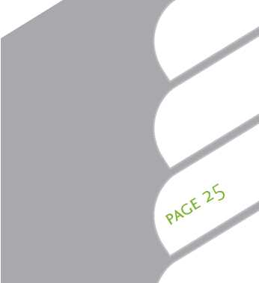Concern about one's psychological state is a luxury that is seldom available to those who are fleeing a country in fear, or living in environments such as refugee camps. As a result of this, and of culturally bound understandings of mental health54, refugees may be particularly reluctant to present as having mental health issues. Many will instead point to social, economic or physical illness explanations for their distress (Summerfield, cited in 55).

Access to mental health services

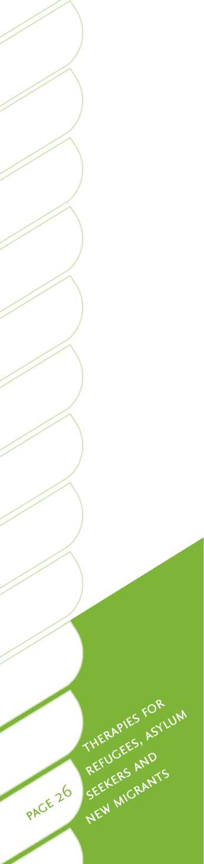A range of barriers can make it difficult for people from culturally and linguistically diverse backgrounds to access health services20, 21. Because of language and cultural barriers, former refugees in Aotearoa/New Zealand often experience difficulties in accessing primary health services, or in knowing how to use the local health care systems20, 21. Without an interpreter, refugees and migrants can also find it difficult to access specific services for mental illness or addiction.

Stigma can also have a profound effect upon people's willingness to seek or receive clinical help. Tse and colleagues67 found that shame and cultural stigma (loss of face) often prevented Asian problem gamblers and their families from seeking treatment until serious loss and damage to their lives had occurred.

Common barriers to accessing mental health services for migrants, refugees, and asylum seekers are1, [18] [19]:

• mental health is not a priority (practical issues of survival take precedence)

• mental illness is self-defined as complete mental breakdown, or as a psychotic episode

• depression, anxiety or PTSD symptoms are not recognised or understood

• stigma about coming to a mental health service may mean an entire family is labelled as cursed or crazy, and as a result marriage prospects for children may be severely diminished

• mental illness is the result of fate or karma, and must be suffered

• services are not accessible, culturally responsive or seen as trustworthy.

Aotearoa/New Zealand has developed some health services for population-specific groups, including Maori and Pacific people72*. There are, however, few specialist migrant and refugee services available. Most refugees have special health issues that differ from the general population and large increases in the numbers of migrants and refugees from diverse cultures in Asia, the Middle East, and Africa mean that mainstream health services need to respond, and learn to work effectively with these population groups. The increasing ethnic diversity of the general population, and of Auckland in particular, will have implications for future health policies and practices[20].

National evidence and knowledge gaps

There is very little Aotearoa/New Zealand specific research on refugee and migrant settlement programmes, mental health services or talking therapy approaches. Much of the current knowledge is based on international evidence, as well as on published and practical experience from trans-Tasman links with long-established programmes in Victoria (Victorian Foundation) and New South Wales (STARTTS Centre). There are substantial gaps in Aotearoa/New Zealand mental health research, and with respect to refugee and migrant issues specifically. However, a two-year evaluation of a community-based specialist refugee mental health service in metropolitan Auckland is reported on the Te Pou website and is in the process of being published74.

International evidence

There is limited international evidence about the efficacy of different treatment approaches for particular groups of refugees, asylum seekers and migrants. The information that is available is summarised and presented in Section Three of this guide. It is important to bear in mind that refugees, asylum seekers and new migrants are themselves linguistically and culturally diverse; therefore, the methods that are described as effective with one group may not necessarily be applicable or generalised in the same way to others. At the same time, there is a growing body of evidence that some general principles, approaches and specific therapies are likely to enhance settlement and mental health outcomes for these population groups.

|  |  |  |  |  |
| --- | --- | --- | --- | --- |
| **i** | bv-' * | * | **■**  - hp  **" fci mr .** | . . <  ■ • |
|  |  | ■ ■ . | **E J * 4 4 i** | cz |

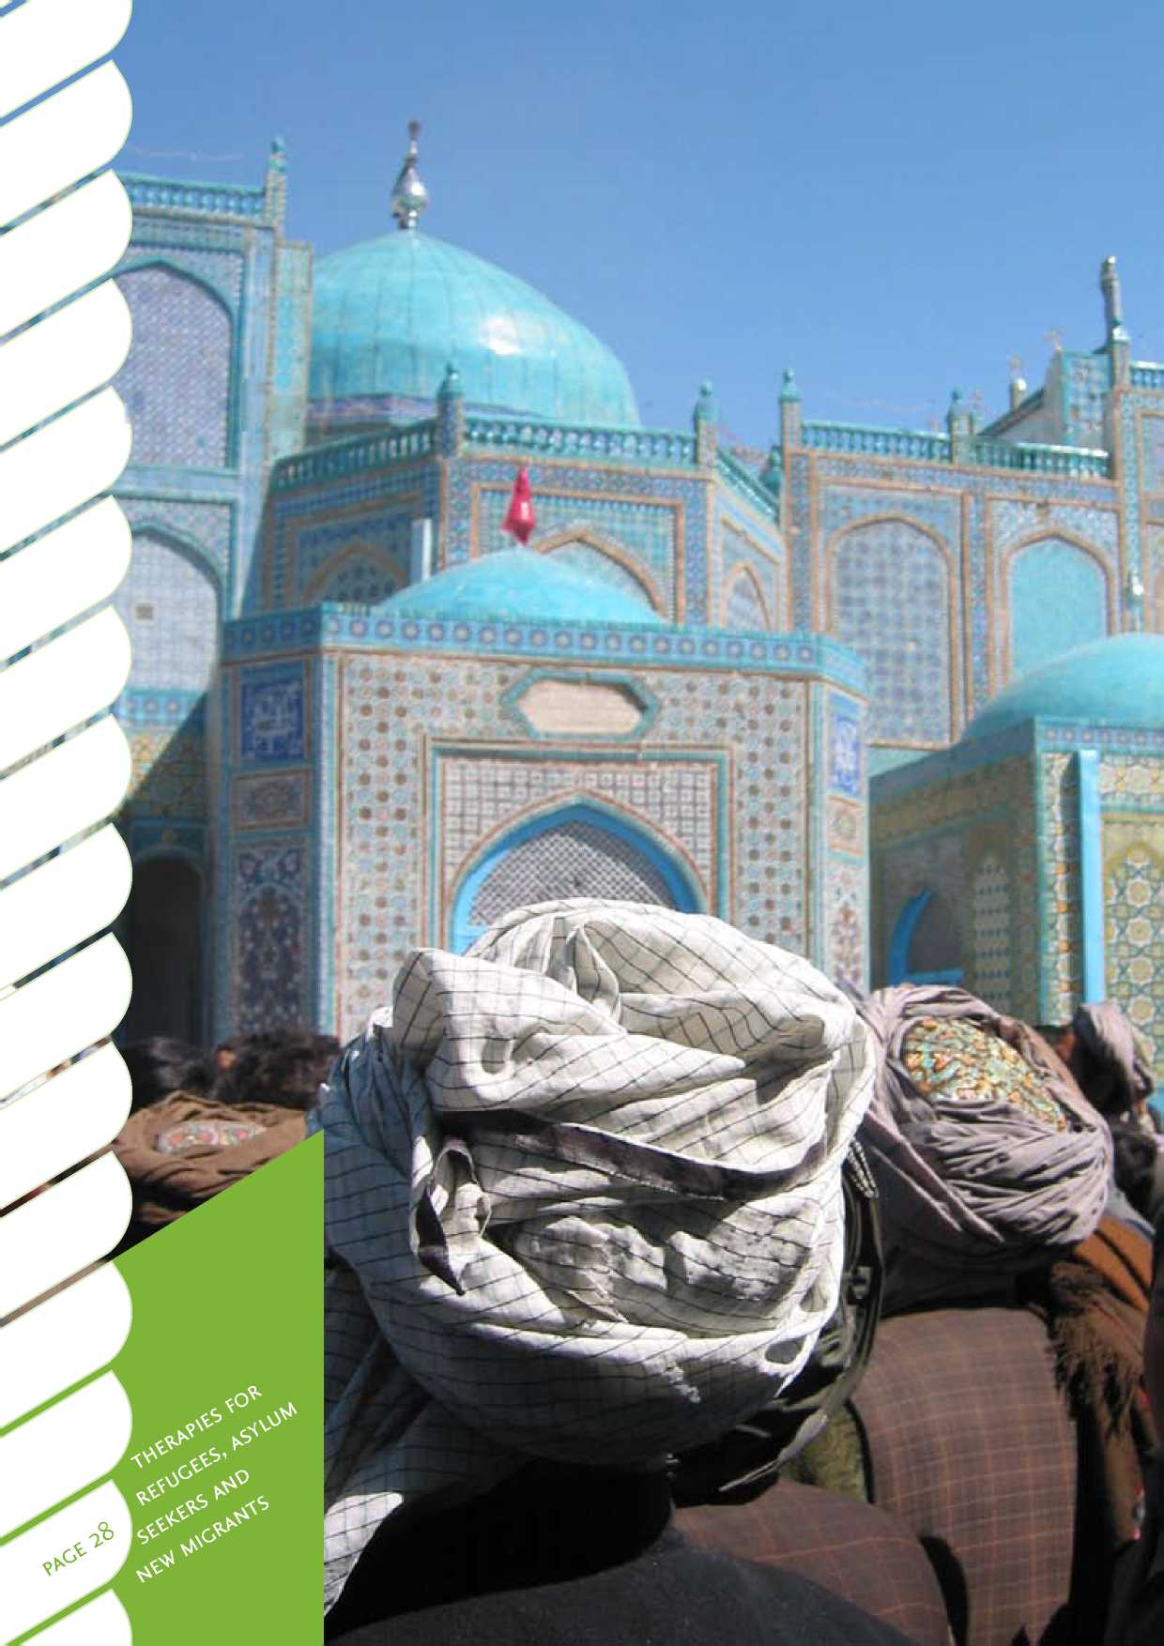

**Human rights**

**Service**

**Communities**

2. Principles of engagement

*Let's get real*

*Let's get real* is the Ministry of Health's framework describing the essential knowledge, skills and attitudes required to deliver effective mental health and addiction services in Aotearoa/New Zealand. It includes explicit expectations for people working in mental health and addiction services, irrespective of their role, discipline or position within an organisation. The following *Let's get real* values are particularly important when working with refugees and migrants, and their application is discussed throughout this section.

Table 6: Fundamental values underpinning *Let's get real* for mental health and addiction services

We strive to uphold the human rights of service users and their families. Human rights include, but are not limited to, the right to autonomy and self-determination, the right to be free from coercion, the right to be treated in a non- discriminatory way, the right to informed consent, and the right to receive care and support that responds to the physical, psychological, spiritual, intellectual and cultural needs of the service user.

We are committed to delivering an excellent service for all service users. This includes service user partnerships at all levels and phases of service delivery, including the choice of services available, as well as the actual delivery of service.

Service users are the focus of our practice. We respect the diversity of values of service users. The values of each service user and of their community are the starting point for all of our work.

We believe and hope that every service user can live a full and meaningful life in the presence or absence of their mental illness and/or addiction. We also understand that recovery is not only related to the mental illness and/or addiction itself, but also to all of the losses associated with it.

We seek to foster positive and authentic relationships in all spheres of activity, including relationships with all people who work within mental health and addiction, wider communities, and service users and their families/whanau.

*We* value communities - the many places in which we all live, move and have our being - as pivotal resources for the effective delivery of services and support for service users and their families/whanau.

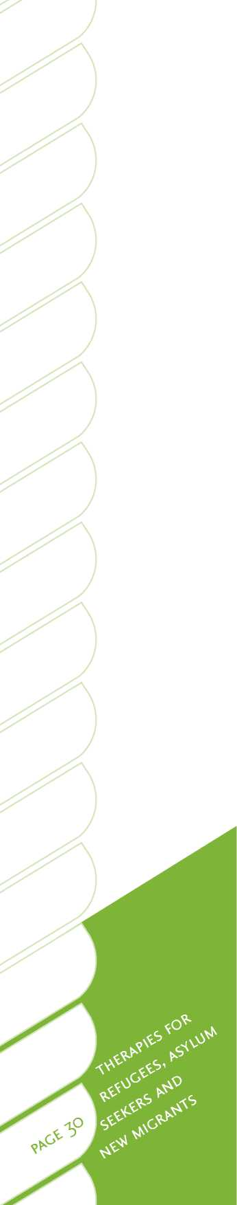Human rights and respect

A human rights approach to supporting people from refugee and migrant backgrounds is increasingly being recognised as the basis of sound cross-cultural practice.75 Under the human rights principle, access to culturally responsive and effective services is a requirement, not just a desirable option. As health practitioners, it is our responsibility to ensure that people from refugee and migrant backgrounds receive the services and support they need, in ways that make sense and are effective for them. For many refugees, this will be the first time they realise they do have rights and that these will be upheld. Service providers need to ensure interpreters, cross-cultural support workers, and ongoing training and up-skilling for staff are available*[21] [22].

A set of general principles for engaging with people from refugee or related backgrounds has been recommended by Changemakers, a Wellington-area refugee advocacy group76:

* human rights are the basis for policy development and services
* our focus is on strengths, not weaknesses
* people from refugee backgrounds bring with them knowledge and many useful skills
* a shared voice is a stronger voice
* trust and reciprocity are the basis of our relationships
* our goal/purpose for working together is clear and mutually agreed to
* our communication is open, honest and easy to understand
* our engagement is inclusive and fair to all parties involved
* people with refugee backgrounds are involved in all stages of our work together - defining the issue, planning, implementation and evaluation
* information is accurate and timely.

It is important to recognise that differences exist among service users from refugee and migrant backgrounds, and that these service users require respect to be reflected not only in words, but also action. The *Let's get real* value of respect indicates that the unique values of service users and their community become the starting point for treatment delivery. This requires a better understanding of the values, unique characteristics and needs of refugees and migrants. Additional training and being prepared to extend ourselves in our practice may be required.

Planning and delivering services for people from refugee and migrant backgrounds necessarily requires involving them in the process itself. “Nothing about us without us” is a theme of refugee and migrant advocacy groups, and resonates for many service users. Wherever possible, it is desirable to include and actively involve former refugees and migrants at every level, from board members to staff to volunteers. It is also very important for employers to actively encourage and help former refugees to acquire training and qualifications that will lead to becoming professional health practitioners themselves. This aligns with the *Let's get real* fundamental value of Service, where service user partnerships are promoted at all levels.

Cultural differences

All cross-cultural communication can potentially result in misunderstanding38,54. especially for mental health issues where symptoms are ill-defined and misdiagnoses may be made77. Health practitioners working with people from other cultures need a broad understanding of cultural differences to accurately perceive symptoms and diagnose illnesses54. Practitioners need to be aware of the small differences in preferred communication patterns, interaction, courtesy rules, and ways of showing agreement and disagreement. It is important that cultural differences are accepted and understood, rather than judged, in order to facilitate effective treatment54.

Cultural and linguistic competency is a set of congruent behaviours, attitudes and practices that come together in a system of care, enabling effective work in cross- cultural situations78, 79.

• Culture refers to integrated patterns of human behaviour, including the history, language, thoughts, communications, actions, customs, beliefs, values and institutions of racial, ethnic, religious, ability or social groups79.

• A working definition of cultural competence is “having the awareness, knowledge, and skill, necessary to perform a myriad of psychological tasks that recognises the diverse worldviews and practices of oneself and of clients from different ethnic/cultural backgrounds”73.

• Cultural competency does not mean giving up one's own cultural values or professional principles in order to be culturally sensitive.

Pedersen78 proposed four cognitive components to cultural competency, including (a) awareness, (b) attitude, (c) knowledge and (d) skills. Cultural competency is not necessarily knowing everything about a particular culture, liking or agreeing with it, or fluently speaking another language. A key part of the process of developing cultural competency is self-awareness of one's own cultural heritage and values79-81. For example, although European New Zealand culture is principally based on individualism, about 80 per cent of cultures around the world are collectivist79.

Where possible, it may be preferable to refer a refugee or migrant to a refugee, Asian or Pacific service. Where this is not possible, the engagement of a cross- cultural advisor will help achieve a better understanding of service user needs and appropriate responses. There are culturally and linguistically diverse training courses for health practitioners and a range of national and international resources available for practitioners. Aotearoa/New Zealand published resources are included in the resource list in Section Four and include resources about particular countries, cultures, languages, courtesies, special considerations and greetings, as well as general information.

People from culturally and linguistically diverse backgrounds generally appreciate sincere efforts by health practitioners to acquire a basic understanding of their culture. This may include simple greetings, protocols (such as handshakes, eye contact, or physical proximity) and a willingness to learn and respond54, 78. Culturally and linguistically diverse service users are usually tolerant of cultural mistakes by practitioners, and are eager to work together in developing a therapeutic relationship.

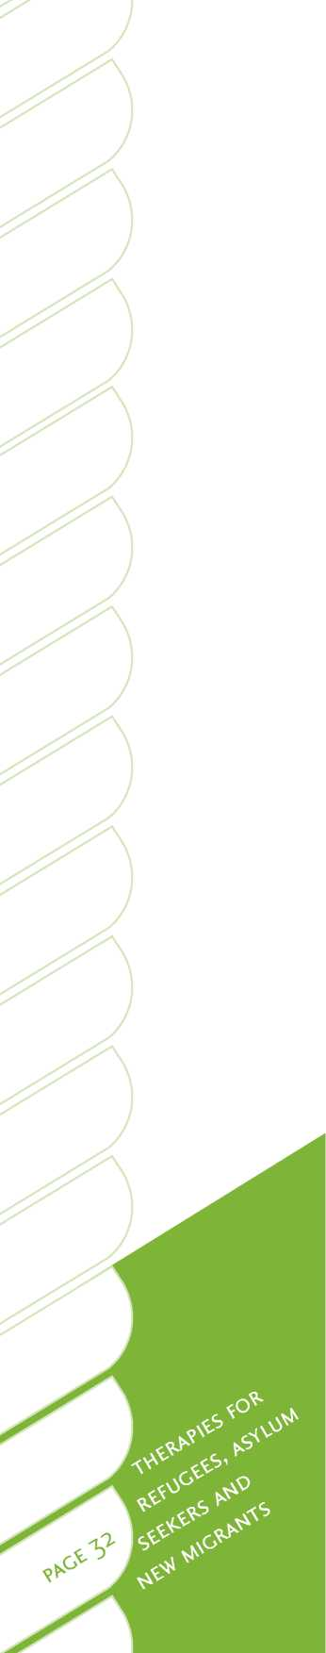Brief guidelines for working with and through interpreters

A skilled and experienced interpreter is often essential when working with culturally and linguistically diverse service users. Working with interpreters is a highly specialised skill requiring training, experience and supervision82. The selection of an interpreter that is right for the needs of the service user is paramount. NAATI (National Accreditation Authority for Training for Translators and Interpreters Australia) qualified or equivalent interpreters should be used wherever possible. See [www.naati.com.au/](http://www.naati.com.au/). Children should never be used for interpreting purposes, and great caution should be applied if family members or unqualified community members are put forward in an interpreting role82. NAATI trained and qualified interpreters have clear and specific ethical standards that they adhere to.

Some commentators83 have challenged whether psychological assessment and psychotherapy can be effectively carried out through interpreters. Two fundamental cornerstones of practice, language and communication, are affected by interpreter interaction84, 85. Translations and interpretations are not always exact, and errors may be made in omissions, additions and condensations. There may also be difficulties with finding precise translations for certain words and terms, the familiarity of the interpreter with mental health contexts, and their ability to make sense of a clinician's questions or intent. To counter such difficulties, introductory training in mental health, basic counselling terms and communication principles have been recommended84. It is essential to first confirm with the service user whether a particular interpreter is acceptable. The assumption that matching a person with an interpreter from his or her own community is the best option is sometimes wrong. In some cases, people express strong reservations about an interpreter from a close-knit and small community. For example, Afghan people speaking Dari may prefer to have an Iranian interpreter who speaks Farsi. Such reservations are often driven by concerns about confidentiality, and embarrassment when discussing personal and private family matters with people of the same community. It may also be important to consider the gender of the health practitioner and interpreter, especially for culturally and linguistically diverse service users from Muslim or other traditional societies82.

Interpreters are expected to convey everything said during a session accurately and precisely, including remarks considered colloquial or vulgar. No additions, omissions or alterations are allowed. Interpreters must convey non-verbal cues such as hesitations, sarcasm or authoritative commentary. If the interpreter does not know the meaning of a word or phrase, or understand a concept, they should stop and ask for clarification. It is imperative that interpreters interpret everything, even if they think the content is nonsensical or irrelevant. Interpreters also need to consider any relevant cultural issues, and advise the health practitioner and service user accordingly.

The health practitioner should establish rapport and communicate directly with the service user. The practitioner should avoid directing the interaction through the interpreter unless there is a need to pause and seek clarification. The interpreter is there to act principally as a communication tool and should not take on a co­therapist role. There should be a period of time for briefing between the practitioner and interpreter prior to the session. At this time, the facts of the case, history and presenting issues should be covered. Post-session debriefing sessions should also be held to review the session and for cultural advice to be provided and recorded

in case notes. Debriefing and supervision may be required to allow the interpreter an opportunity to talk about the impact of the client's story on him or her**.** Some interpreters may have personally experienced earlier trauma in their own lives, and re-traumatisation is a possibility to be considered, prevented and addressed.

Other points to keep in mind are:

* seating arrangements are important to the effectiveness of the session - in certain situations it may be important for the practitioner to invite the service user and their family to choose where to sit
* where appropriate, practitioners should avail themselves of the interpreter's knowledge of the cultural background and related factors
* practitioners should never seek an interpreter's views on a service user's progress or condition
* practitioners should speak in short segments, to enhance simplicity and accuracy, and avoid overloading the interpreter's short-term memory
* interpreters should not generally be involved in transport of service users or in escorting them to other locations before or after the session.

Engagement during assessment

Presenting problems

Refugees and migrants frequently do not manifest symptoms of mental illnesses in the same way as people from Western backgrounds*. For example, people from refugee backgrounds and traditional societies in Africa and Asia tend to express or manifest emotional distress as physical health problems11, 54. In Western terminology this is often referred to as somatising. For this reason, medical practitioners are often first to see refugees and treat them for their physical symptoms, which may have no physiological basis[23] [24]'.

Practitioners working in mental health and addiction services may be referred a service user from a migrant or refugee background who manifests severe distress and has special needs. It is important to be aware that cultural differences in illness expression can result in misdiagnosis or denial of access to mental health services.

A holistic assessment approach

A holistic approach in assessing the needs of former refugees and migrants is recommended. Health practitioners should move beyond rigid diagnostic categories of pathology to consider the whole person, including their strengths, personal and cultural resources, and aspirations.

The applicability and use of Western concepts^ with non-Western populations is internationally debated86,87. For example, the “applicability of PTSD, with its western ontology and values, is currently controversial” (p. 15)88. Practitioners should look beyond PTSD and refugee victimisation89, and consider the broader context, whole lives and experiences of the service user.

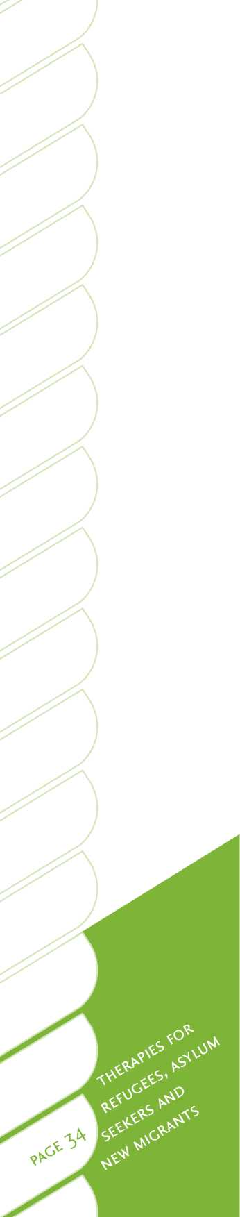Caution in the use of psychometrics

The use of psychometric mental health measures with refugees and migrants should be approached with considerable caution. Some measures have been translated and used in the international literature, including the General Health Questionnaire, Harvard Trauma Questionnaire, and Hopkins Symptom Checklist90. However, Western measures may not have appropriate norms for refugees, and there are issues in translating measures into other languages82, 88. Neuropsychological assessment and MRIs may nevertheless be required for people with a history of torture or head injuries.

The Istanbul Protocol

The Istanbul Protocol was a landmark step in recognising the importance of effective process in securing the rights of torture victims to rehabilitation, reparation and protection10. In 2003, the United Nations Commission on Human Rights drew the attention of governments to the principles of the Istanbul Protocol as a useful tool in addressing and preventing torture. This international convention contains detailed procedures, and practical advice for medical, mental health and legal specialists on how to recognise and document evidence that may assist in legal process and in rehabilitation, and should be referenced and followed by practitioners10.

Timing, information and confidentiality

Extra time and attention must be devoted to establishing rapport and building trust with refugees and migrants. Assessment issues are likely to be complex, requiring time to gain an understanding of the person and their family, culture and context. For former refugees and asylum seekers, building trust with health practitioners (or others viewed as authority figures) may be challenging. In addition, they may not speak English or have been exposed to Western health care practices or models of care.

The refugee may have been a survivor of torture or profound trauma. These experiences may have led them to no longer view the world “as a safe and benevolent place upon which they could have an impact” (p. 243)12. This outlook is likely to permeate all aspects of their mental health, and impact on how service users view mental health providers. Refugee histories may be marked by experiences in which revelations of their beliefs and opinions, especially in an interview context, have led to their persecution12. It is important that practitioners are sensitive to relationship power issues[25].

The therapist's professional ethics and role are the same as with other service users. However, some special considerations are required. Particular attention must be given to explaining a person's rights, such as consent to treatment, release of information, the therapist's role and the complaints process, and in establishing mutual goals and expected outcomes88.

Confidentiality of written records is a concern for most refugees and migrants. In many non-Western countries, the confidentiality of official documents is not maintained. For this reason, written note taking, particularly during initial sessions can be extremely sensitive. This will need to be thoroughly explored, explained and possibly limited.

Informed consent, confidentiality and ethical issues may be foreign and unfamiliar for people from refugee and migrant backgrounds. To some extent, individual confidentiality may be a Western concept91. Many refugees have not had the benefit of choice. Refugees have often been at the mercy of circumstance and had their fundamental rights violated. Their wishes and needs may not have been taken seriously by those charged with their welfare.

Education may be used as a therapeutic tool to give refugees and migrants a clear sense of possible choices available to them. Such an approach can optimise the therapeutic alliance, foster a sense of empowerment and autonomy, and engender respect. The demystification achieved by thorough explanation also increases the likelihood of treatment adherence.

Engagement during therapy for refugees and migrants

Strengths

When working with refugees and migrants it is useful to take a strengths-based approach. Despite traumatic experiences that would affect any ordinary person, and could lead to mental health problems, refugees have often learned how to survive and cope in profoundly difficult situations13, 92. People from refugee backgrounds are typically resilient, intelligent and adaptable, and have overcome extremely adverse life events. Some of the many positive qualities and characteristics of refugees and migrants may include:

• resilience

• courage

• creativity

• endurance and tenacity

• different cultural knowledge and wisdom

• diverse experience.

For many refugees and migrants, the term mental has negative connotations. It may be helpful to reframe the services in general health terms, and to explain and normalise the problems that a person is experiencing in relation to anyone who has survived such trauma and extreme experiences. It is important to provide education on trauma and mind health, and to show how such reactions as they may be experiencing are both normal and definitely recoverable. A strengths-based approach, with a focus on small, practical steps, is often the best way to help set the course on a way forward to a new life. This aligns with *Let's get real's* fundamental value of Recovery, which highlights that staff working in the mental health and addiction sector need to hold the hope that every service user can live a full and meaningful life. It is also important to remember that in opening the pages on the chapter to a new life, it is sometimes necessary to first close a previous chapter.

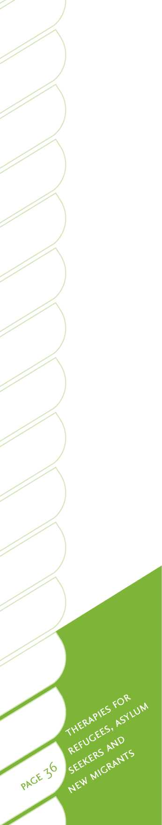Timing and pace

Working with survivors of torture and trauma is a specialised area and dissociation is possible in the early stages12, 19. Generally, a slow, progressive and cautious approach is required90. Some survivors need and wish to bear witness to what has happened and want to tell their stories. Others may wish to avoid all discussion, even when manifesting intrusive PTSD symptoms. At all times, the wishes and needs of service users must be respected and an appropriate pace followed.

The most appropriate time for intervention with refugees may be some time after their arrival in Aotearoa/New Zealand. Refugees will often prioritise their immediate needs over mental health issues during the initial resettlement period. Their housing, financial, educational and physical health needs require addressing first55. Due to the practical challenges faced, as well as stigma and cultural factors, refugees are most likely to request pragmatic solutions, rather than psychological assistance. Practitioners working with refugees should not discount pragmatic solutions, and this may require some advocacy91.

Practical support

The concept of successful practical support in resettlement is intertwined with good mental health for former refugees. The importance of this factor was clearly indicated in a two-year evaluation by the Auckland Regional Refugee Mobile Team74. Some factors have been consistently related to successful resettlement93, and refugees' key aims may include:

• employment

• educational advancement

• retention of one's own culture

• family reunification

• knowing one's rights and duties in the host society

• language acquisition in the host country, and reduction of negative stereotyping and barriers.

The provision of material support by host governments can result in significant mental health improvements45. This type of support is beyond the means and remits of mental health services. Nevertheless, in taking a holistic approach, the importance of material support in assisting mental health is important to recognise. It is useful to know what resources and services are available to assist refugees55. The provision of practical assistance is likely to impact on the willingness of refugees to accept the provision of mental health services55, 94.

During the first few months of settlement in Aotearoa/New Zealand, refugee settlement support agencies such as Refugee Settlement Services Aotearoa New Zealand, engage lay volunteers in the community and social workers to provide practical settlement support*. Health services may also need to network and develop relationships with other agencies such as Work and Income New Zealand, Housing New Zealand, Immigration New Zealand, education providers and other government and non-governmental agencies[26] [27].

Treatment of addiction

A study of Cambodian refugees63 found the following elements were important in maximising success in the treatment of addiction:

• use of a co-therapist clinical team to provide bilingual, bicultural counselling

• counselling carried out in native language

• education about addiction as a treatable and recoverable illness is needed for clients, their families, the community as a whole, and for refugee and immigrant human service staff

• treatment programmes must anticipate a significant proportion of clients will be dually diagnosed

• due to the severe stigma of alcoholism and drug addiction, treatment programmes must be sited in non-stigmatising settings

• immersion in traditional cultural practices, teachings and values plays an extremely important role in recovery

• clinicians used confrontation sparingly as a counselling method. Instead, they applied traditional Cambodian values of respect for family and community to increase client motivation for change. They explored the hopes and dreams that clients originally had about coming to a new country, and ways that clients were or were not able to fulfil those hopes and dreams in a new life

• exploration of ways that clients had coped with stressful, painful or dangerous situations in the past

• use of a primarily nonverbal treatment, such as acupuncture and traditional therapies, should be considered as one key complementary element of a treatment programme.

Medication

This discussion has been written by Dr Grant Galpin, consultant psychiatrist, and Pratima Devi Prasad, clinical nurse specialist for RASNZ. Key medication issues that practitioners need to be aware of when delivering therapies to people from a refugee, asylum seeker, or culturally and linguistically diverse migrant background are presented. Appendix A provides a more detailed overview of the key psychopharmacology issues for these groups. The authors intend this information to be an initial contribution towards filling a large gap in the refugee and migrant psychopharmacology literature. There are real problems in applying Western diagnostic concepts to non-Western populations and assuming that they are valid. In particular, there is limited gold- standard evidence about the efficacy of using psychotropic medications with refugees*. In addition, extrapolating findings from non-refugee populations is problematic, given the unique characteristics of refugees and the social context of their treatment. Refugees' responses to medications, independent of psychosocial interventions, have not been quantified and therefore cannot be categorically pronounced. While it is the practice of psychiatrists working in this area to be relatively conservative with medications, especially with respect to refugees, many service users from these groups do respond to medication. See Appendix A for detailed discussion.

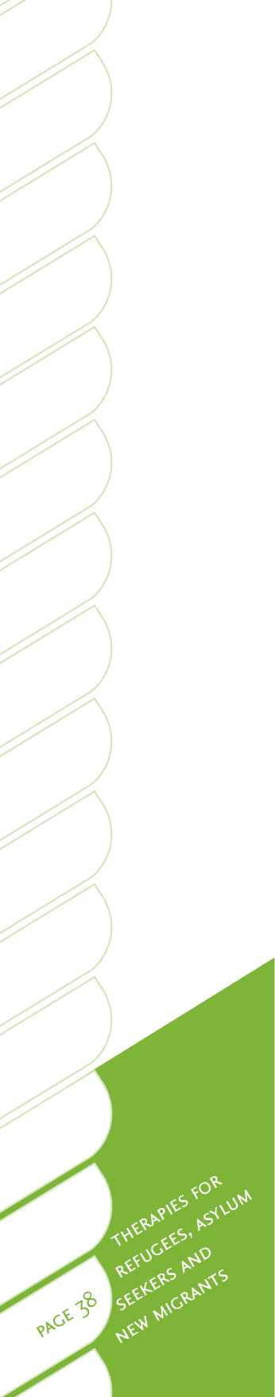The management of medications for non-English speaking refugees and migrants requires special attention and cultural sensitivity, particularly around informed consent95. It is also necessary to work with psychiatrists and GPs to closely monitor any side-effects and re-emphasise dosage instructions. Refugees and migrants may not be used to taking psychotropic medications or understand their purpose or effects. People sometimes stop taking medication without disclosing this. Others may take more than the prescribed level. It is important to give sufficient time and attention to ensure that information is understood. Accurate translation about the purpose and the details of prescribed medication is important.

Traditional therapies

Many refugees may have sought and received some form of treatment prior to resettlement in Aotearoa/New Zealand, either in refugee camps or in the countries where they have been living temporarily. These may have been Western treatments, traditional therapies, or healing through prayer and worship. Often these treatments may have been administered by traditional healers or by non-government organisations. The effectiveness of traditional therapies is not well documented. Furthermore, their use varies from culture to culture and sometimes in relation to religious beliefs. When delivering a therapy the best option is to work alongside these beliefs as much as possible, because such beliefs are often seen as being correct and helpful within a person's community. They may also allow the person to accept further treatment. Somatising symptoms may respond well to massage and other physical therapies, as many cultures are familiar with massage. There is some anecdotal evidence that yoga has been effective in treating gender-based violence in Rwanda (Project Air, personal communication by Deidre Summerbell).

Working with asylum seekers

The role of a practitioner in working with an asylum seeker can be exceptionally challenging and complex. The initial responsibility is often to provide anodyne or palliative support during the lengthy refugee claims and appeals process. Lawyers acting for an asylum seeker may pressure a practitioner into providing evidence or testimony to the Refugee Tribunal in support of a claim. The practitioner must be clear about their role, and seek supervision and guidance in this process. In some cases, the practitioner may recommend that an independent opinion be sought, and remain in a therapeutic or supportive role12, 88. In other instances, a practitioner may feel compelled to provide information, with the informed consent of the service user. In writing a report or in giving evidence before the Tribunal, the protocols and practices are similar to the Criminal, Youth or Family Courts.* A report must be supported by facts and objective observations, and have a clear scope and stated limitations12, 88. Having the service user's lawyer provide specific questions may be helpful in preparing for the assessment and report. Opinion about whether the presentation of a service user is consistent with those typically seen in a victim of torture, trauma or persecution should be supported by assessment, case notes and relevant research literature90.

Psychologists and psychiatrists should be duly cautious about becoming directly engaged in the debate around the veracity of a person's story. Evidence put forward will be challenged by Immigration New Zealand officials. The treatment record, personal history, trauma symptoms, mental health issues, physical injuries and medication will be relevant, as well as traumatic memories and related factors. The final determination made by the Tribunal will be based upon the 1951 United Nations Convention Relating to the Status of Refugees, and whether the claimant has a “well-founded fear” that return to their country of origin will likely result in persecution, torture or harm.

It can be traumatic for both asylum seekers and practitioners when a service user loses an appeal resulting in forced deportation[28]. A practitioner may require debriefing, supervision and self-care practices. Equally, when an asylum seeker has a claim approved there is elation and celebration^ However, following approval, asylum seekers do not receive the same level of support in settlement as quota refugees and may require longer-term follow-up support. The most productive therapeutic work often begins once a person's refugee status has been determined and resolved.

Family reunification

Impact on mental health

Family reunification (or lack of it) is often a key issue for people with forced migrant backgrounds and can profoundly impact on their mental health and resettlement.

* Family members may be missing, dead, or remain in their home country or in a refugee camp, and be in danger or experiencing hardship.
* People from culturally and linguistically diverse migrant backgrounds may frequently have a different understanding of family, which extends beyond Western concepts.
* Family reunification can contribute substantially to mental health outcomes, but may have associated challenges, particularly after long and traumatic separations.

Because of the often chaotic contexts in which flight occurs, refugee families may become separated, with obvious mental health consequences3, 11, 12, 38, 93. While some outcomes associated with separation may be predictable, others may be less clear to practitioners. In some cultures, for example, older members of the extended family, community leaders, or other members of the wider community may fulfil specific roles, such as advisor or counsellor. Separation from important family members or social groups may leave refugees bereft of anyone to consult when emotionally troubled or experiencing family conflict71.

Achieving family reunification can be difficult, frustrating and a long process for refugees to go through. There are occasions when children are reunited with family members after prolonged absences. A protocol has now been developed to support positive family reunification (RASNZ, Refugee Services Aotearoa New Zealand, and Immigration New Zealand). If family reunification is not achieved, there can be issues of guilt, fear and grief that can affect both mental health and resettlement. When family reunification is achieved, this can be a joyous experience. At the same time however, complex adjustment issues may arisen

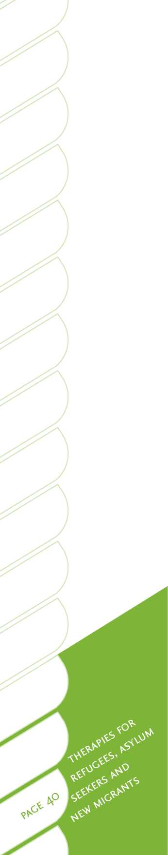Adjustment

In some cases, families have not been separated but forced to relocate to societies where family life may be considerably different and at odds with one's own cultural values96, 97. This issue may be particularly salient for refugees who have not been able to choose the country they move to.

Acquiring a basic knowledge of the host country's language is a key milestone19 that can ease adjustment challenges. Typically, children and young people in new migrant families will acquire language faster than older family members. Many young people may take on a de facto interpretation role, which can lead to family dynamic and intergenerational issues.

Refugees and migrants may experience adjustments in gender roles, and parenting styles and practices. Family violence is an issue for people from all cultures in Aotearoa/New Zealand, and refugees and migrants are no exception. Information on Aotearoa/New Zealand law and values is provided to quota refugees at the Mangere Refugee Resettlement Centre, as well as intervention and referral assistance for family violence.

Advocacy and support

Advocacy in family reunification matters may be required for forced migrants. Help in locating missing family members in war zones or unsafe transit havens overseas can be provided through the Red Cross or Red Crescent*. Many refugees may seek assistance in understanding Immigration New Zealand's family reunification processes. Although health practitioners may provide advocacy and support, it is important to bear in mind that only licenced immigration consultants or lawyers may legally provide advice under the Immigration Practitioner Act 2009 (see [www.iaa.govt.nz/](http://www.iaa.govt.nz/)).

Community support

New arrivals in foreign and unfamiliar environments will naturally seek and gravitate towards others who share the same language, nationality, religious and cultural backgrounds. Community support is vitally important for refugees and migrants in Aotearoa/New Zealand, as isolation in the resettlement phase is known to be a major contributor to mental health issues for these people3, 18, 19.

Networking is important in almost all spheres of health services, but is particularly so in relation to assisting people from refugee and migrant backgrounds. This may often involve developing and maintaining contacts in Work and Income New Zealand, Housing New Zealand, Immigration New Zealand, education providers and other government and non-governmental agencies. Refugee settlement support agencies such as Refugee Settlement Services Aotearoa New Zealand engage lay volunteers in the community and social workers to offer practical assistance during the first six months after a person's arrival. This includes assistance in areas such as housing, furniture, education and English language lessons (ESOL). Some volunteers develop long-term relationships with refugees.



It is important to also include leaders of the diverse communities being served when seeking advice around service development, delivery, research and evaluation. Some of the best outcomes are achieved when former service users who have recovered and settled well, then go on to become engaged as providers themselves.

Individual therapy may be necessary and appropriate in many cases. It is also important to bear in mind that many migrant and refugee service users come from collective cultures. For this reason, the involvement of community members and support workers from their own cultural and linguistic backgrounds in treatment may be important. The *Let's get real* communities value highlights community as a pivotal resource for effective delivery of services. It is often essential that health practitioners seek consultation and support from specialist services and cultural advisors.

A community psychology approach, as discussed in Section Three, can be a useful way to involve the wider community in the delivery of treatment to refugees and migrants. See page 58 of this guide for further discussion about this approach.



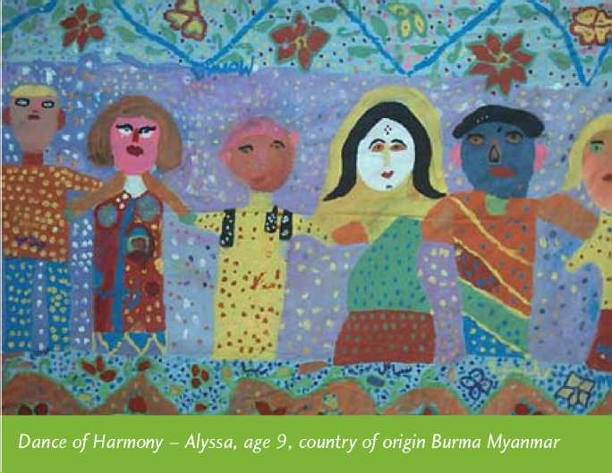

3. The therapies

**1 \***

**J**

**3 '**

**■ ■ • ■**

1 * * - o

Ju • - Lj

* **r^t \***
* .<»

**•dt * ’**

Key issues in treatment

Cultural consultation

Diagnosis and treatment of refugees and new migrants in the mainstream Western context can frequently prove problematic. Cultural constraints and expectations may influence symptom presentation; symptoms can have different and separate meanings within the refugee culture of origin. Diagnoses from a medical model may inspire pharmaceutical treatments or therapeutic interventions that are proven to be effective within Western contexts, but may not be effective with refugees. On the other hand, they may work very well.

It is important to try to learn as much as possible about the person's home culture before treatment, as well as about the historical events that took place before the person had to leave their country. Cultural consultation is therefore the cornerstone of all treatment formulations and plans, as well as a good assessment. Even then the stated problems may elude the therapist and the cultural consultant, and the real problems may not unfold for some time, so patience is advocated. Assessment may thus take time and unfold over many months and there may be a need to focus on more than one disorder. It is important not to confuse non-Western cultural beliefs and behaviours with psychopathology. Some behaviour and symptoms may be ignored or explained as being cultural, rather than symptoms of mental ill health. However, psychopathology may be missed if credence is given only to cultural explanations18. Underlying biological responses support the theory that there may be cross-cultural commonalities in terms of treatment for symptomatic presentation98, 99.

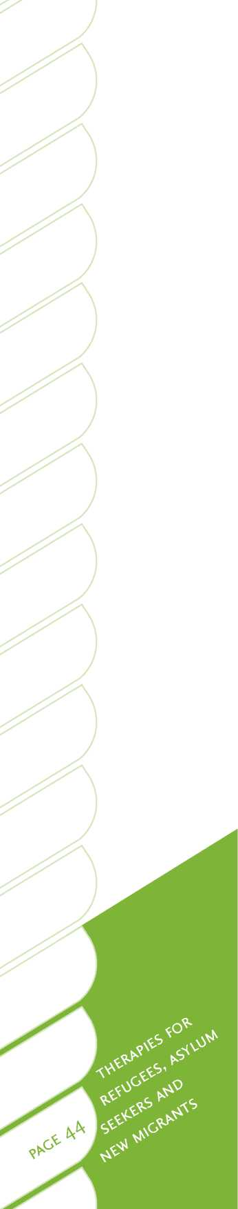The challenges of resettlement may supersede all attempts at therapy for months, and sometimes years, and the therapist may need to be a trustworthy person who is consistent for some time before anything else happens. Relationship, as always, is the key to therapeutic outcome, as is the actual art of therapy. It may be important to abandon traditional models of therapy and try to respond to what is being presented. When using talking therapies with refugees and migrants a therapist must consider whether the service user has been exposed to the use of psychological torture by political regimes as a means of oppression77. Any therapies that involve a talking remedy need to be approached with this possibility in mind. This is important since those with the greatest need (i.e. those who have suffered psychological or physical torture) may be most likely to avoid situations that resemble interviews or interrogations. Sometimes, non-talking therapies, such as body therapy, can be offered first, to assist in relieving trauma and help a person to establish the comfort level and trust required to then engage in a talking therapy.

Language

Language may be another barrier to effective assessment and treatment. Unless a refugee has good English much of the treatment will require the use of an interpreter. A good knowledge of how to work effectively with an interpreter is important (see discussion in Section Two) as well as training in working with people from culturally and linguistically diverse backgrounds.

Common presenting needs and key themes

The effects of previous trauma and torture are often at the fore, but the effects of forced migration and resettlement are also strong. Presenting needs may include disrupted sleep patterns, PTSD, depression, bereavement, loss, somatic complaints (often seen in medical practices), relationship and martial issues, domestic violence, problems with children and adolescents at home, violence, issues specific to women and men, suicidal thoughts and actions, psychosis, substance misuse, chronic pain and head injuries.

Key themes may include culture shock, acculturation needs and unmet expectations in the new country, social role disruption, intergenerational conflicts, unemployment, family values, kinship disruption, insecurity or instability, practical needs, poverty, housing issues and racism. Some refugees may come to the country with specialist health needs, such as deafness, intellectual disability, damage to internal organs and limbs, HIV and congenital abnormalities. They may be moving through the health system, or be too frightened to do so, or abandon specialist appointment letters that are too hard to understand.

Protective factors

It is important to note that there may be some key protective factors that can assist therapy, and equally may hinder therapeutic processes if they are absent. These include factors such as resilience, contact with other family members or family reunification, social support, links with local community groups, a strong religious or political ideology, and a proactive problem-solving style. It is possible that talking therapies may need to occur in conjunction with psychopharmacology to reduce the discomfort of intrusive symptoms (refer to the medications discussion in Section Two and Appendix A for more detail), as well as with some non-talking therapies, such as body therapy. Multi-modal support may need to be in place to deal with settlement issues in terms of extending social supports, community support work and cultural liaison. It is also important for therapists to remember the value of ensuring a client's personal and physical well-being, including access to food, shelter, warmth, safety, exercise and meaningful daily activities.

In all work with migrant and refugee clients it is important to acknowledge their survival and their journey to the new country. The strengths that assisted their survival may stand them in great stead for the next challenge.

Overview of therapies

| **Therapy** | **For treatment**  **of** | **Research evidence** | **Expert opinion** |
| --- | --- | --- | --- |
| Acceptance and commitment therapy | Anxiety and depression | Tentative evidence in Western populations. | Used by some therapists in Aotearoa/New Zealand. There may be some applicability for service users, due to similarities with Eastern philosophies. |
| Bibliotherapy | Mild levels of depression and anxiety | Some evidence in Western populations. | Not currently used. May not be helpful with these populations considering the language constraints. |
| Body therapies | Acute and chronic body pain, chronic fatigue,  PTSD, mood disorders (anxiety, depression, anger, poor concentration), sleep problems | Some research undertaken with non­refugee population samples, presenting with similar clinical symptoms to refugee and migrant populations. No refugee or migrant-specific research noted. | Therapists find that physical therapy has been shown to be effective irrespective of culture or age. Few contraindications if person is willing. Most people report at least some improvement in body or mind symptoms. |

Table 7: Overview of evidence for use of different therapies with Refugee, Asylum Seekers and New Migrants.

|  |  |  |  |
| --- | --- | --- | --- |
| **Therapy** | **For treatment**  **of** | **Research evidence** | **Expert opinion** |
| Cognitive behaviour therapy (CBT) | PTSD, depression, anxiety, psychosis, sleep disorders, addiction, eating disorders, problem gambling | A range of evidence of effectiveness in Western and in some refugee populations. No migrant-specific research noted. | There is a large body of empirical evidence available to support CBT as being a very effective therapy for refugees, often in conjunction with other modalities, such as culturally adapted CBT and exposure therapy.  Very commonly used in Aotearoa/New Zealand with migrant and refugee service users, often with cultural adaptations. |
| Computerised cognitive behaviour therapy | Mild anxiety and depression | Some evidence in Western populations. No refugee or migrant-specific research noted. | No known relevant application. |
| Counselling | Depression, anxiety, addiction, life issues, sleep disorders | Some evidence in Western populations. No refugee or migrant-specific research noted. | Commonly used in Aotearoa/New Zealand with most service users by most therapists as part of an overall package of treatment with these populations. |
| Dialectical behaviour therapy | Self-harm behaviour, borderline personality disorder | There is initial evidence from controlled research in Western populations. No refugee or migrant-specific research noted. | Occasionally used with service users with these specific needs. |
| Eye movement desensitisation and reprocessing | Depression, anxiety | Treatment resistant combat veterans from Desert Storm, the Vietnam War, Korean War, and World War II showed distinct improvement in PTSD symptoms. | Initially developed to treat traumatic memories, studies have shown the therapy's effectiveness in treating other mental health disorders. Emotional Freedom Technique is also gaining some credence. |
| Family therapy | Depression, anxiety, addiction, anorexia nervosa, marital problems, child management issues | A range of evidence in Western populations.  No refugee or migrant-specific research noted. | Very useful for including family members in components of treatment. This is frequently used in Aotearoa/New Zealand with service users. Considered useful and acceptable for refugee and migrant families. |

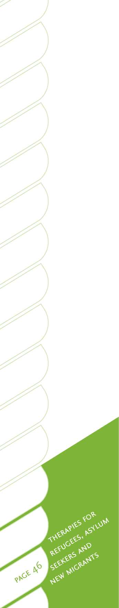

|  |  |  |  |
| --- | --- | --- | --- |
| **Therapy** | **For treatment**  **of** | **Research evidence** | **Expert opinion** |
| Group therapy | PTSD, depression, anxiety, psychosis, sleep disorders | Evidence varied. No evidence that group exposure is useful, as this may invoke uncontrolled emotions in some populations. | Effective components appear to be mutual support and psycho education. Difficult to gain trust, working with more than two interpreters can be difficult. |
| Interpersonal psychotherapy | Depression, anxiety, bulimia and a range of other diagnoses and life issues | A range of evidence in Western populations.  No refugee or migrant-specific research noted. | No known application with refugee populations. |
| Motivational interviewing | Addiction, problem gambling, also used in mental health | Some evidence of reduced addiction in Western populations. No refugee or migrant-specific research noted. | Widely used in Aotearoa/New Zealand with substance abuse and gambling issues, and used with this population with some effect. |
| Multisystemic therapy | Problem behaviour in adolescence | Some evidence in Western populations. No refugee or migrant-specific research noted. | Used in Aotearoa/ New Zealand for adolescents who have a number of issues, often those in Child, Youth and Family's care. May have application for this population. |
| Neurofeedback | Tinnitus, PTSD, anxiety disorders, pain management, brain injury, attention deficit hyperactivity disorder (ADHD) | No refugee or migrant-specific research noted. | Growing usage by some therapists. |
| Problem­solving therapy | Depression, anxiety, addiction, life issues | Some evidence in Western populations. No refugee or migrant-specific research noted. | A number of therapists are using this approach with these populations. |
| Psychotherapy | Life issues, depression, anxiety, addiction, PTSD, abuse, eating disorders, problem gambling | A range of evidence in Western populations.  No refugee or migrant-specific research noted. | Appears to be occasionally used by some therapists in Aotearoa/New Zealand for these populations. |
| Psychotherapy with children | Childhood emotional and behavioural disturbances, PTSD, grief | Some evidence in Western populations. | Used at times with some children from these populations. |



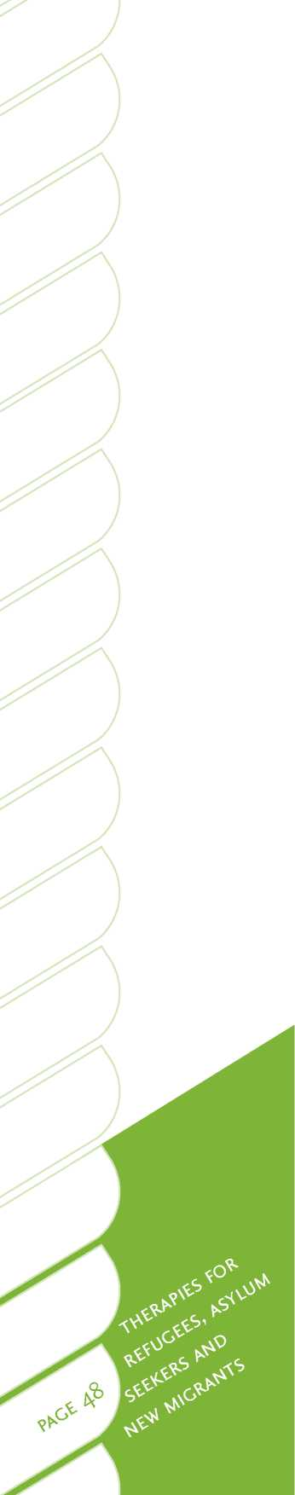Treatment efficacy

There is very little, if any, empirically validated treatment research with refugee and new migrant populations available from Aotearoa/New Zealand sources, although there are a number of studies from other countries. International research has assessed a variety of therapeutic interventions for their effectiveness in treating PTSD. Systematic reviews have compared the relative benefits of CBT, eye movement desensitisation and reprocessing, exposure therapies, narrative therapies, psycho­education and relaxation techniques for PTSD in largely non-refugee populations, however some refugee populations have been included100, 101. CBT, cognitive therapy and exposure therapy were found to be equally successful at improving clinical symptoms and reducing drop-out100. Eye movement desensitisation and reprocessing and Biofeedback are other promising therapies, but not enough research exists to conclude whether it they are effective as CBT or other therapies100. Bessel van der Kolk99 reports useful results in trauma treatment using neurofeedback and heart rate variability as part of a package of treatment that includes yoga, CBT and Qigong.

Most of the research acknowledges that a variety of therapeutic approaches are helpful for treating mental health and addiction problems, as summarised in Table 7. Following is a review of these therapies and their application for refugees and migrant service users.

Cognitive behaviour therapy

Cognitive behaviour therapy (CBT) is a form of therapy that aims to adapt thought patterns in order to create more adaptive emotional and behavioural outcomes. Sessions are highly structured and focus on practical solutions to problems. They may be provided in group or one-on-one formats102.

Why this therapy is used

CBT is a therapy that can be used in the treatment of alcohol, drug, smoking and gambling issues, anxiety, depression, eating disorders, long-term illnesses, chronic pain, obsessive compulsive behaviour, phobias, PTSD, self-harming, symptoms of bipolar disorder, and symptoms of schizophrenia, for example for psychosis. Families and couples can also benefit from this approach.

Some research has looked specifically at refugee populations when investigating treatment options for PTSD. These studies have noted clinical improvements from a range of therapies, e.g. narrative exposure therapy, trauma counselling and CBT101, 103, 104, 105, 106. In particular, a randomised-controlled trial of CBT noted significant improvements in PTSD symptoms, anxiety scores, and culturally-associated physical symptoms, for Cambodian refugee service users with PTSD and panic attack conditions, relative to wait-list controls104.

A randomised-controlled trial with African refugees noted that both CBT and narrative exposure therapy was more effective at alleviating PTSD symptoms than supportive therapy or brief psycho-education106. Large improvements were observed on all PTSD measures for those who received CBT or narrative exposure therapy, these results maintained at the six-month follow-up.

Ehntholt107 had good results with school-based CBT groups, as did Barrett et al108 with young refugees. Ehntholt and Yule109 provide a very good review of assessment and treatment of refugee children and adolescents who have experienced war-related trauma. They outline a sound treatment approach that involves establishing safetyand trust, carrying out trauma-focussed therapy or treatment (CBT, testimonial psychotherapy, narrative exposure therapy, and eye movement desensitisation and reprocessing, with medication used only as a back-stop), and assisting reintegration. Michelson and Sclare1 1 0 compared treatment effectiveness for young refugees and unaccompanied minors, undertaking stabilisation work (legal, housing assistance, various types of liaison with schools and social workers, leisure activities) and a variety of therapies (CBT, systemic, parent or carer training, psycho-education, anxiety management, grief-focused work, and trauma). While these are multi-modal studies meaning it is more difficult to determine how much CBT was contributing to the improvements in mental health found, they do indicate that CBT can be a useful part of a treatment delivery package for refugees.

Culturally adapted CBT was found to be effective at improving symptoms of PTSD, depression, anxiety and physical symptoms associated with PTSD in Vietnamese and Cambodian refugees104, 105. Cultural adaption of this intervention included gathering cultural support and translation from Vietnamese and Cambodian social workers, including mindfulness relaxation techniques, and using cultural imagery, i.e. the lotus flower as a metaphor105. However research has not been undertaken to ascertain whether cultural adaptation is superior to non-adapted CBT.

Cognitive processing therapy is a CBT and exposure-based treatment, which appears to have relevance to a number of cultural groups and can be effective with or without interpreters1 1 1 .

Potential issues

Pictorial representation can be used with children and adults to aid communication of key concepts. It is important to take into account cultural beliefs (culturally adapted CBT is explained well in Hinton104, 105). For example, some key aspects of CBT that may be incongruent with some cultural values are:

• the focus on individual needs over and above what is best for others in the family

• the promotion of and education in assertiveness skills

• the focus on rational thinking and seeking objective evidence for service users who are strongly spiritual.

Reference material

The following articles are useful resources when delivering CBT to refugee and new migrants.

* *Assessment and treatment of refugee children and adolescents who have experienced war-related trauma*109

This document describes how to integrate CBT with other therapies. One example is cognitive processing therapy, which can be adapted as an amalgamation of CBT and exposure therapy. Manuals for cognitive processing therapy can be sourced though the following references1 1 1 , 112 .

* *Cognitive behaviour therapy with refugees and asylum seekers experiencing traumatic stress symptoms*103

An excellent clinical pathway discussion incorporating narrative exposure therapy and testimony in a CBT approach.

* *A randomized controlled trial of cognitive behaviour therapy for Cambodian refugees with treatment-resistant PTSD and panic attacks: A cross-over design*104 Culturally adapted CBT, with good improvement noted for PTSD and panic attacks.
* 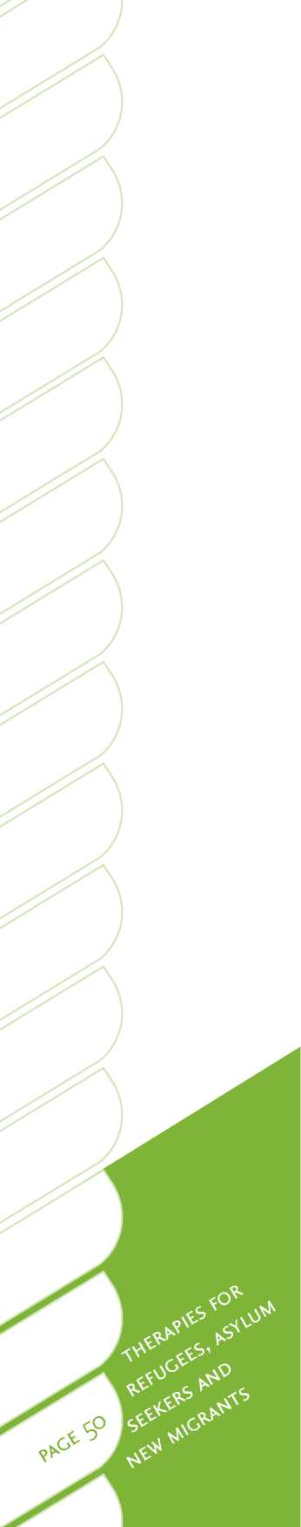*CBT for Vietnamese refugees with treatment-resistant PTSD and panic attacks: A pilot study*105

Culturally adapted CBT for refugees with treatment-resistant PTSD and panic attack.

* *The FRIENDS program for young former-Yugoslavian refugees in Australia: A pilot study*108

Anxiety-reduction programme that reported significantly lower internalising symptoms.

* *School-based cognitive-behavioural therapy group intervention for refugee children who have experienced war-related trauma*107

CBT showed statistically significant, but clinically modest, improvements post-intervention, and significant improvements overall for behavioural difficulties and emotional symptoms.

Counselling

Counselling aims to improve a person's understanding of themselves and their relationships with others, and identify ways of bringing about positive sustainable change102. Counselling therapy can employ a range of techniques according to the therapist's training. Counselling can be undertaken for an individual, couples, families or groups.

Why this therapy is used

Counselling can be useful for alcohol, drug, smoking and gambling issues, depression, anxiety, family violence, life changes, relationship issues, sexual abuse and personal development102.

While counselling is employed with refugees and new migrants, there is little research into the effectiveness of counselling with migrant and refugee communities. This may be due to the diverse nature of counselling, where counsellors tend to employ a wide variety of therapeutic techniques.

Potential issues

Language difficulties may mean that counselling, like other techniques, is difficult to use with migrants from culturally and linguistically diverse backgrounds, even when working with a good interpreter. Art, drawing, sand-trays and other tactile methods can be used to explore problems, particularly grief, when language makes it difficult to explore an issue in depth through talking.

Counselling techniques that aim for immediate solutions and respect different cultural views and goals are likely to be most effective for migrant and refugee people.

As with all types of therapy, differences in religious or philosophical views between a service user and the therapist need to be considered. This may be particularly important if therapists are providing advice to service users as part of the counselling process.

Family therapy

Family therapy describes therapy provided in the context of the family. It typically includes methods used in other therapies, with the aim of improving communication, and supporting family strengths and using these as a mechanism for change102.

Why this therapy is used

In Western cultures, research demonstrates that family approaches to therapy can be effective. Family therapy has been widely employed in Japanese, Chinese and Indian populations, both in their home countries and in migrant populations115, 116, 117, 118. In migrant populations, it may be particularly useful for discussing and addressing issues of inter-generational conflict caused by differences in acculturation and values between migrant parents and their children. Family-wide education about the health system and anti-stigma is likely to be more effective than individual education on these topics. Readers may also like to refer to the *Talking therapies for Asian people* guide, which can be accessed from the Te Pou website [www.tepou.co.nz](http://www.tepou.co.nz), for a further discussion about how this therapy can be applied for migrants from Asian backgrounds.

Very little controlled research studies have been undertaken on the effectiveness of family therapy for refugee service users.

Potential issues

It is important to consider intergenerational acculturation issues, family roles and possible value differences between members of a family, particularly when children are more adapted to the new country. Traditional roles of women also need to be taken into consideration.

Problem-solving therapy

Problem-solving therapy is a step-by-step brief psychological intervention, usually lasting between four and eight sessions. Therapy can involve identifying issues, and developing approaches to solving these specific issues, as well as building long-term problem-solving skills102.

Why this therapy is used

Research with general populations shows that this form of therapy is useful for depression, anxiety, chronic illness, suicidal thoughts and behaviour, behaviour change and personal growth102.

Elements of this therapy are used by many therapists working with migrant and refugee service users in Aotearoa/New Zealand, with reportedly good effect, as long as cultural considerations are taken into account.

Potential issues

There appears to be no research on the effectiveness of problem-solving therapy with refugee and migrant service users.

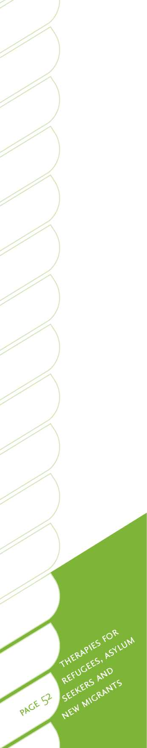Psychotherapy with children

Psychotherapy with children often involves the use of play, drama and drawing to explore and analyse a child's symptoms, thoughts, feelings or behaviour102.

Why this therapy is used

Former refugee children have often personally experienced or witnessed extreme violence and trauma (torture, murder, rape, imprisonment, privation). They may have had close family members die or be lost to them in a variety of ways. They may be alone (unaccompanied minors), separated from all family or with extended family members. They may have been co-opted to perform acts of war, either as child soldiers or by their captors. In order to survive they may have, amongst other possibilities, engaged in theft, child labour or prostitution, and may have had involvement with drugs or alcohol. They may also have observed their parents doing these things. Most arrive in the country without any possessions that are familiar to them, sometimes without any education. Language acquisition may be slow and school may become difficult for them.

Hence refugee children will possibly be suffering, as do their parents, from PTSD, depression, anxiety, grief and loss. Their behavioural manifestations may include some forms of acting out, such as violent behaviour, somatisation, poor sleep, and intense distress as a response to seemingly innocuous stimuli, amongst other behaviours. They may be disobedient or overly compliant, withdrawn, dissociative or appear to be hyperactive.

Therapy takes the form of addressing these symptoms, as well as dealing with the past traumas. One of the aims of therapy is to include the fostering of resilience by building capability in the child. It is useful to work with the family, as well as the child individually, in order to ascertain the coping strategies they have used to survive the traumatic experiences. School and social groups also need to be considered and interlinked if at all possible.

Family therapy interventions are helpful to assist the child to feel contained within the family unit and to assist the child's caregivers to manage the child. They are also helpful to ensure that the family survives as a unit within their culture. However, it is important to see the child on their own, in order to exclude any possible current violent situations. The use of art therapy methodologies (such as painting and sand­tray work) has proven very useful in the Mangere Reception Centre in Auckland as part of assessment and treatment.

Potential issues

Unlike their families children may not have a previous point of reference, in terms of life before refugee status. In addition, they are unable to express themselves as well as most adults. Restoration of safety is a prerequisite with all people, but with children is the first priority.

Limitations of the therapy may be related to the availability of experienced art or child therapists, training or equipment.

Reference material

The following articles have informed the discussion above and are useful resources for psychotherapy with children.

* *The FRIENDS program for young former-Yugoslavian refugees in Australia: A pilot study*108
* *Practitioner review: Assessment and treatment of refugee children and adolescents who have experienced war-related trauma*109
* *School-based cognitive-behavioural therapy group intervention for refugee children who have experienced war-related trauma*107

Other useful therapies

Narrative therapy and collaborative narrative practice

Narrative approaches focus on helping people identify and use their existing skills, competencies, beliefs, values and abilities to address problems. Narrative therapy helps facilitate the telling and retelling of stories in ways that acknowledge the personal, historical, social, cultural and political context of people's experiences. Collaborative narrative practice is a collaborative endeavour with clients and communities.

Why this therapy is used

Narrative methodologies are being found to be beneficial by therapists and cultural workers across refugee and migrant communities, because they do not require people to understand or have skill in engaging with traditional Western approaches to counselling. They are used for treating groups and individuals who have had experiences of trauma and torture, anxiety, stress, depression and PTSD. Narrative therapies are particularly useful for refugee service users in helping them to contextualise their experiences of trauma, as well as their coping skills and competencies.

Narrative approaches have been developed to be used with children, young people and adults. The narrative use of language, storytelling and metaphors is effective with refugee communities who are generally more familiar with using story as a method of personal and collective change and development. Narrative therapy acknowledges that therapy is not culturally resonant for the majority of refugee communities. It also pays attention to the collective nature of trauma and the profound social suffering that can occur as a consequence of social injustice. Narrative therapy focuses on alternative discourses of resilience, hope and competence within reported experiences of trauma.

Although many narrative practitioners work with individuals, couples and families, some narrative practitioners work with whole communities, focusing on developing collective practices that are often focused on social as well as individual change.

The Dulwich Centre in Adelaide, Australia has developed a range of narrative methodologies in collaboration with refugees and other groups that are experiencing hardship. Practices are simple and easy to use in a range of community settings, and include group work, collective documents, and “tree of life”, “team of life”, “river of memory” and narrative song writing.

Potential issues

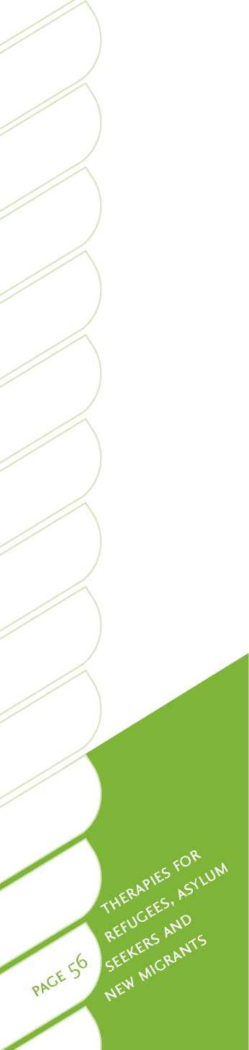Some refugee service users may find it initially difficult to participate in collaborative conversation, if their experience of treatment has involved being the recipient of expert advice. Some critics also suggest that a lack of confidence, intellectual capacity, or poor articulation skills are barriers to people engaging in narrative approaches, due to hindered self-expression. Research for evidence-based outcomes with narrative approaches are increasingly being conducted and future publication of results will included significant studies using narrative approaches with refugee communities (see the Dulwich Centre's webpage on research, evidence and narrative practice: [www.dulwichcentre.com.au/narrative-therapy-research.html](http://www.dulwichcentre.com.au/narrative-therapy-research.html)).

Reference material

The following articles have informed the discussion above and are useful resources when applying narrative therapy.

• Trauma: Narrative responses to traumatic experience1 1 9

* *Collective narrative practice: Responding to individuals, groups, and communities who have experienced trauma*120
* Community song writing and narrative practice121

• Strengthening resistance: The use of narrative practices in working with genocide survivors122

* *What is narrative therapy: An easy to read introduction123*
* *The Tree of Life Project: Using narrative ideas in work with vulnerable children in Southern Africa124*

• *A narrative theatre approach to working with communities affected by* trauma, conflict and war*125*

• *Working with people who are suffering the consequences of multiple trauma: A narrative perspective126*

Training

• *Masters of Counselling, University of Waikato: [http://edlinked.soe.waikato.](http://edlinked.soe.waikato.ac.nz/index.php?tier2_id=14) [ac.nz/index.php?tier2_id=14](http://edlinked.soe.waikato.ac.nz/index.php?tier2_id=14)*

• *Postgraduate Diploma Discursive Therapies, Massey University: [http://](http://therapy.massey.ac.nz/) [therapy.massey.ac.nz/](http://therapy.massey.ac.nz/)*

• Short courses and graduate certificate, Dulwich Centre, Adelaide, Australia: *[www.dulwichcentre.com.au/training-in-narrative-therapy.](http://www.dulwichcentre.com.au/training-in-narrative-therapy.html%23international-training-program) [html#international-training-program](http://www.dulwichcentre.com.au/training-in-narrative-therapy.html%23international-training-program)*

Narrative exposure therapy and testimonial psychotherapy

Narrative exposure therapy has been developed particularly for the treatment of the psychological sequelae of war, torture and organised violence. It is a community-based treatment approach - a standardised short-term strictly manualised approach, based on principles of cognitive behavioural exposure therapy, adapted to meet the needs of traumatised survivors of war and torture. The person constructs a narration of his or her life from birth to present day, focusing on detailed exploration of traumatic events and experiences.

Testimonial psychotherapy borrows from exposure and desensitisation, relaxation training and cognitive restructuring, as well as therapeutic relationship, ritual and narrative techniques. It is a multi-modal therapy, and depends upon the cultural acceptance of sharing personal stories. It is a brief individual intervention for those who have suffered from torture and severe trauma, producing a written testimony that transforms the experiences and pain into a different entity altogether, thereby allowing the person dignity, distance, and the ability to understand their own courage and survival.

Why this therapy is used

A study with African refugees noted that narrative exposure therapy was as effective as CBT and more effective at alleviating PTSD symptoms than supportive therapy or brief psycho-education106. Studies have also indicated that lay counsellors can effectively provide narrative exposure therapy in a naturalistic setting for refugees in developing countries that are resource-poor 101.

Testimonial psychotherapy is useful in communities where talking therapies are uncommon and stigmatised. This may be useful within ex-refugee communities in the country of settlement but this has yet to be fully explored in Aotearoa/New Zealand.

Reference material

The following articles are useful resources when applying narrative exposure techniques.

* *Testimonial psychotherapy for adolescent refugees: A case series127*
* *Cognitive processing therapy for rape victims: A treatment manual112*
* *Narrative exposure therapy: A short term intervention for traumatic stress disorders after war, terror or torture*128
* *The effectiveness of cognitive processing therapy for PTSD with refugees in a community setting*111

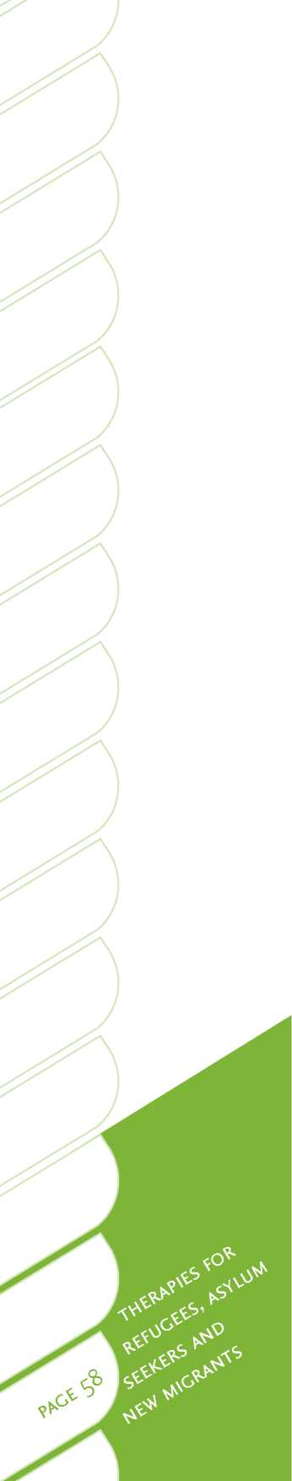A community psychology approach

Community psychology is an approach that attempts to recognise the social and political realities of refugee and new migrant communities. Macro analysis of problems is preferred to identify social and interactional causes. Service delivery is proactive, community-based and prevention-focused. Community psychologists prefer to share, develop and use psychological knowledge and skills with communities, to help address social and political injustice that impacts on community well-being. Community psychologists develop services for refugee communities that are more fitting with their own cultural constructions of well-being. They draw on existing social and cultural processes within refugee communities to identify problems and develop solutions that are culturally acceptable and understood. This might include helping mitigate stigma associated with mental health by acknowledging the social and political causes of psychological distress experienced by refugees.

Why community psychology is used

A community psychology approach is not considered to be a talking therapy. However, community psychology has a great deal to offer service planners and funders responsible for mental health service delivery for migrant and refugee communities. Community psychology is fundamentally concerned with the relationship between social systems and individual well-being in the community context. This is important for refugee communities for whom settlement stressors, including language difficulties, lack of employment, poor housing, access to education and racism, are reported as major contributors to mental health problems.

Community psychologists are therefore interested in helping refugee communities take control over their environment and their lives in ways that will also contribute to a greater psychological sense of community. This is characterised by people from refugee backgrounds: living dignified and self-determining lives; being able to develop personally and socially; being able to prevent mental health problems before they start; and being able to access appropriate help when needed129.

Potential issues

A community psychology approach will begin by seeking to understand refugee communities' experiences of mental health problems. These understandings can then form the basis for planning culturally useful service delivery. A direct outcome of this consultation approach is the development of working relationships between service providers and refugee communities. However, this assumes a shared notion of community, when many refugees find themselves isolated from their cultural communities due to mistrust, political divisions and stigma around mental health.

In consultations with refugee communities there can also be difficulties ensuring equitable participation. Due to social position, in some cultures it might be difficult for everyone to participate in defining their own problems and accessing resources to develop satisfactory solutions to them. For example, women, children and the elderly may be excluded from participation. Often refugee communities are also either reluctant to engage with traditional clinical services or rely heavily on them to provide quick cures for problems. These attitudes can be based on previous experience of traditional medical services for treating illness, and a lack of experience with alternative therapeutic interventions. Community psychologists might address these difficulties by working with refugee community leaders and volunteers toprovide training, support and supervision, with the aim of strengthening culturally appropriate and inclusive service provision.

Some key issues to consider when applying this approach are as follows.

• Resettlement stress contributes to poor mental health for refugee communities. Community psychology is interested in supporting refugees to regain a sense of control and influence over their environment during stressful cultural transition experiences.

• Social and political advocacy plays an important role in community psychology practice. Addressing social inequalities and facilitating social action are considered to be as important as supporting individual empowerment and healing.

• Within traditional clinical funding models it is difficult to develop collective responses to mental health, in which refugee communities define their own mental health needs and ways of addressing them.

Reference material

The following articles have informed the discussion above and are useful resources when applying community psychology.

* *Can community psychology meet the needs of refugees?'29*
* *Effectiveness of a community-based advocacy and learning program for Hmong refugees'30*
* *Integrating diversity and fostering interdependence: Ecological lessons learned about refugee participation in multiethnic communities131*
* *The mental health of refugees: Ecological approaches to healing and adaptation'32*
* *Community psychology133*
* *International community psychology: History and theories'34*

Training

* *Post-Graduate Diploma Community Psychology, Waikato University: [www.waikato.ac.nz/wfass/subjects/psychology/commpsych/handbook/](http://www.waikato.ac.nz/wfass/subjects/psychology/commpsych/handbook/intro.shtml) [intro.shtml](http://www.waikato.ac.nz/wfass/subjects/psychology/commpsych/handbook/intro.shtml)*

• *Masters in Psychology (Community Psychology), Edith Cowan University, Perth, Australia: [www.psychology.ecu.edu.au/courses/psychology/](http://www.psychology.ecu.edu.au/courses/psychology/postgraduate.php) [postgraduate.php](http://www.psychology.ecu.edu.au/courses/psychology/postgraduate.php)*

• *Master of Applied Psychology (Community Psychology), Victoria University, Australia: [www.vu.edu.au](http://www.vu.edu.au)*

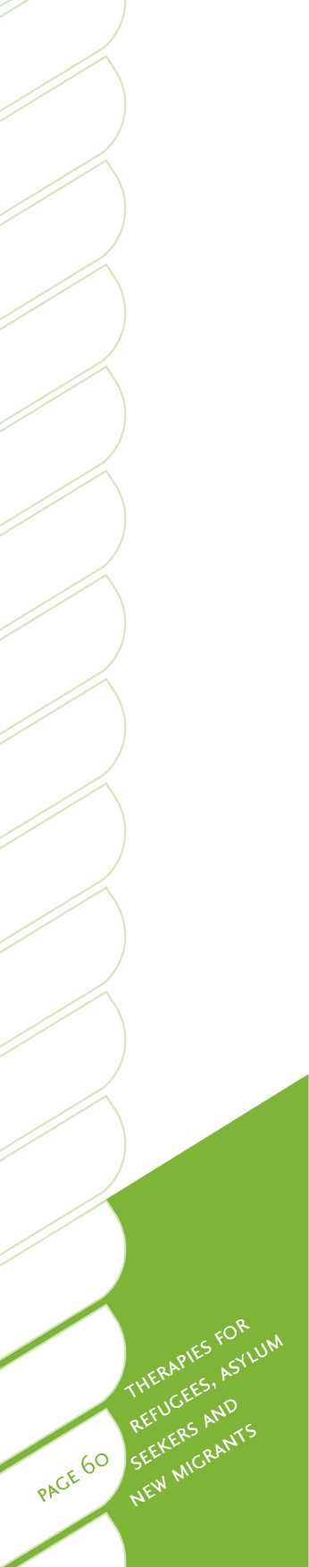Body therapies

Body therapies cover a wide range of practices, including traditional massage (which in itself varies from culture to culture), Bowen technique, Feldenkrais method, neuromuscular therapy (NMT), and body-mind practices, such as emotional freedom therapy, yoga, Qigong and T'ai Chi.

Why this therapy is used

Due to the diversity of techniques used within body therapies, it is inappropriate to make generalised statements regarding their efficacy. In this guide, massage has been selected as the primary focus, due to its near universality across cultures and the predominance of research studies in this therapeutic modality.

A further limitation to being unequivocal regarding the efficacy of body therapies, is that there has been little quality research undertaken to assess their benefits when working with traumatised refugee or migrant populations. However, there has been a substantial amount of research undertaken with non-refugee populations, which may be generalised, as these populations did present with clinical symptoms very similar to traumatised refugee and migrant populations. Clearly though, caution must be exercised in extrapolating from this general research, given the cultural and contextual uniqueness and diversity of the refugee, asylum seeker and migrant populations.

It is well-known and documented that, due to the body-mind connection, emotional distress and anxiety can greatly heighten the person's subjective perception of pain, and vice versa135 . Therefore, any decrease in anxiety and hyper-arousal that massage can induce in the person will often lead to amelioration in perceived pain levels. Conversely, a decrease in the perceived level of bodily pain and discomfort, will often lead to a decrease in negative emotions, such as anxiety, sadness and anger136. Massage can lead to reductions in anxiety and arousal and improve health. Specific examples include decreases in cortisol, catecholamines, norepinephrine, heart rate, blood pressure and general sympathetic nervous system activity, and increases in serotonin, dopamine, parasympathetic activity, alpha and theta brain waves, and in natural killer cell numbers135, 137-140.

Research and clinical practice have demonstrated that various forms of massage can prove very helpful with people who present with the following issues:

* acute and chronic body pain141, 142
* poor body awareness, body satisfaction and interoception138
* sleep difficulties136

• anxiety143, 144

* depression and low mood145
* a range of symptoms inherent in PTSD145
* experience of gender-based violence146
* attention difficulties147

• anger and hostility148.

Regarding highly traumatised refugee service users, Van der Kolk99 has repeatedly established that interventions must initially focus on improving the person's bodily awareness and interoception, gradually assisting the person to perceive, tolerate and eventually befriend his or her own body. Key to this process is helping the person de-arouse, and thereby to gradually bring back online higher-order brain centresin the pre-frontal cortex. Van der Kolk99 emphasises the centrality of various body therapies in achieving this (approaches particularly recommended as effective include massage, emotional freedom therapy, Qigong, T'ai Chi and yoga).

For further research findings, particularly in terms of massage, see the website of the Touch Research Institute at the Miami University School of Medicine: [www6.miami.edu/touch-research/Research.html](http://www6.miami.edu/touch-research/Research.html).

Potential issues

Extensive clinical experience with a wide range of refugees has produced very little in the way of apparent limitations or contra-indications for massage. That is, people most often report at least some improvements in body or mind symptoms. Differences in age, culture and previous exposure to massage seem to have little or no impact on results. Further, it is rare for people to miss appointments or to drop out of treatment.

At the same time, clinicians note that it is important to discuss service user expectations of therapy before commencing treatment and to enquire as to previous exposure to any form of body therapy and the outcomes achieve. Prior poor or undesired outcomes may hamper the person's ability to trust the treatment and therapist.

The key guiding principle is for the therapist and service user to share expectations and to negotiate a mutually-agreed course of treatment. This is essentially a subjective attuning of the therapist with the person.

Due to experiences of trauma and torture, some individuals can be hyper-aroused and experience dissociation, constriction, or helplessness149. Such people may only respond favourably to gentle, relaxing massage, or to Bowen technique. Firm treatment in this case would only increase hyper-arousal, resulting in a very agitated nervous system. Therefore, it is imperative that the therapist is able to determine if a person is becoming hyper-aroused, and to monitor this throughout the session. It is also important to have the person identify areas of the body that are perceived as safe for therapy.

Prior to arrival in Aotearoa/New Zealand, many refugees have lived for extended periods in sub-standard conditions with inadequate diet, hydration or exercise. This can have a deleterious effect on their soft tissue and thereby impede their response to treatment.

When working with refugees it is generally helpful if the therapist is of the same sex as the service user, due to prevailing cultural norms. In some cultures it may not be appropriate for a younger therapist to touch an older person, or for the person to expose skin to a stranger.

It is important to remember that there are individual differences in responses to body therapies. Often longer courses of treatment are required for more chronic physical and emotional problems. In addition, the ability to continue treatment in the community is sometimes compromised, owing to factors such as a lack of finances, transportation difficulties, or an ambivalent relationship with the interpreter or therapist.

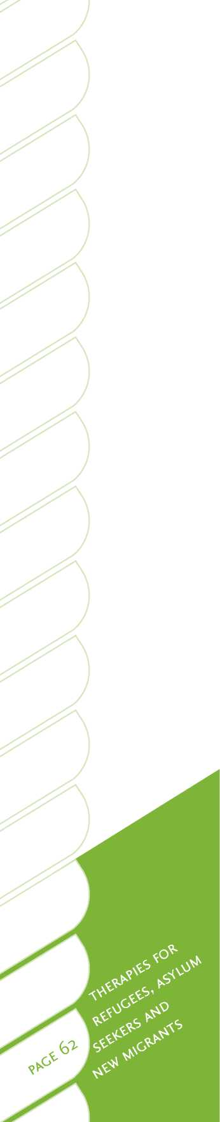Some reference materials

Following are information sources for some of the body therapies available:

**Bowen technique**

• Wilks, J. (2007). *The Bowen Technique*. Dorset: CYMA Ltd.

• Bowen website for Australia and the world: [www.bowtech.com](http://www.bowtech.com).

• New Zealand Bowen Therapy Incorporated, telephone: 64 9 534-3476.

**Emotional freedom therapy**

• Techniques: [www.emofree.com](http://www.emofree.com).

**General trauma**

• Levine, P. A. (1997) Waking the tiger, healing trauma. Berkley: North Atlantic Books.

**Training**

• Bachelor of Health Studies in Massage and Neuromuscular Therapy, New Zealand. College of Massage, email: [info@massagecollege.ac.nz](mailto:info@massagecollege.ac.nz), website: [www.massagecollege.ac.nz](http://www.massagecollege.ac.nz).

Eye movement desensitisation and reprocessing

Eye movement desensitisation and reprocessing was developed by Francine Shapiro to reduce distress associated with traumatic memories and has subsequently been established as an effective treatment of PTSD. It has the ability to facilitate intense therapeutic change in less time, and controlled studies have shown 77 to 90 per cent reduction in PTSD symptoms in general populations in a few sessions150.

In eye movement desensitisation and reprocessing, after a thorough service user history and preparation for the therapy sessions, the person visualises the targeted traumatic event in their mind. Alongside this, the person selects the sensory image that best represents the traumatic memory with a negative belief (e.g. “I am in danger”) while simultaneously focussing on bilateral stimulation. The person is then asked to rate the disturbance level on a Subjective Units of Distress (SUDs) Scale, which ranges from 0 to 10, with 0 being no disturbance and 10 being extreme disturbance. The person is then encouraged to visually follow the therapist's finger until the SUDs rating falls to 0, thus helping to process the traumatic memory and enable the person to reach an adaptive resolution. Aside from eye movements, other forms of stimulation like tones or finger tapping have also been used. Butterfly hugs are a form of dual stimulation, which have been used to treat traumatised children in refugee camps (Wilson et al., 2000, cited in150).



Why this therapy is used

Often people experience extreme distress in discussing details of the trauma, or are unable to recall the details of the traumatic incidences. In order to use eye movement desensitisation and reprocessing it is not essential to know the details of the trauma. It can help in processing the distressing memories and allow a natural healing process of assimilation and adjustment to function.

Sangita Wadnerkar has successfully used eye movement desensitisation and reprocessing with three refugee service users from different countries who presented with symptoms of PTSD and depression. All of them were sexually abused, had been exposed to multiple traumas, and experienced profound grief, as well as having encountered ongoing personal stressors during the treatment. Post-treatment there was a 90 per cent reduction of PTSD symptoms, such as nightmares, flashbacks and intrusive memories, and a decrease in symptoms of depression with service users experiencing better coping abilities.

Potential issues

Sometimes refugee service users migrate from countries where stigma about mental illness is present and awareness about mental health professionals and interventions is very limited. Also, occasionally, people can misinterpret the therapist's action of conducting eye movements or finger tapping to be black magic. Thus it is very helpful to provide a simplified explanation about the background of eye movement desensitisation and reprocessing. Furthermore, it helps when people are presented with case examples and read letters written by past service users who have experienced positive improvements in their life with eye movement desensitisation and reprocessing treatment.

While using interpreters, it is very helpful to train them in the procedures of conducting eye movement desensitisation and reprocessing before this information is shared with the service users. This helps the interpreters in explaining the procedures to the service users more effectively.

Further research needs to be done on the effectiveness of eye movement desensitisation and reprocessing for people suffering from PTSD and other mental disorders using larger populations, and carefully designed and randomised-controlled studies. More research also needs to be conducted in order to understand the mechanism underlying the information processing. To date, there is extremely limited research available on the use of this technique with refugee populations.

Reference material

* *Eye movement desensitization and reprocessing: Basic principles, protocols and procedures1*50
* *Through the eyes of a child: EMDR with children151*

Training

*Training in eye movement desensitisation and reprocessing is widely available in Australia, with many of these trainers willing to conduct training in Aotearoa/New Zealand for groups of mental health professionals.*

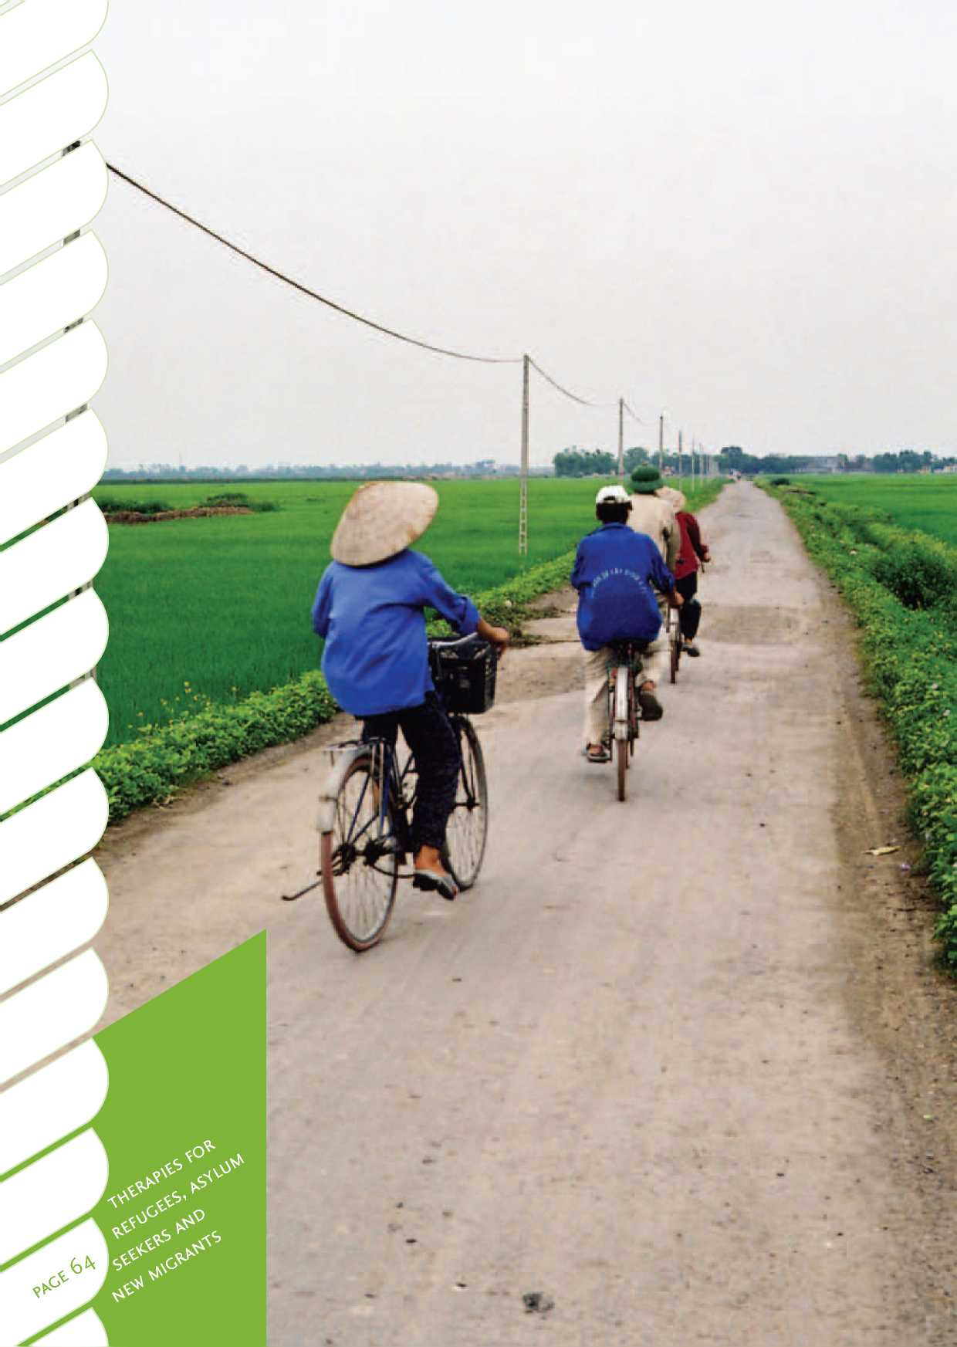

• J

Promising new approaches

Neurofeedback

Neurofeedback is a type of [biofeedback](http://en.wikipedia.org/wiki/Biofeedback) that uses [electroencephalography](http://en.wikipedia.org/wiki/Electroencephalography) to provide a signal that can be used by a person to receive feedback about brain activity. It uses real-time displays of [electroencephalography](http://en.wikipedia.org/wiki/Electroencephalography) to illustrate brain activity, often with a goal of controlling [central nervous system](http://en.wikipedia.org/wiki/Central_nervous_system) activity.

Neurofeedback with electroencephalograph and heart rate variability applications is a newly emerging therapy that is showing promise for treatment of a range of conditions including tinnitus, anxiety disorders, pain management, brain injury and ADHD. Neurofeedback is being trialled in Sydney through Mirjana Askovic at the STARRTS Centre. A recent publication152 examines its efficacy in the treatment of ADHD, which, although not directly related to trauma, indicates the success of the methodology with a disorder that is not very amenable to psychotherapy, talking or behavioural interventions.

Potential issues

Further research needs to be done on the effectiveness of neurofeedback with people suffering from PTSD and other mental disorders using larger populations, and carefully designed and randomised-controlled studies. More research also needs to be conducted in order to understand the mechanism underlying its effects. There is presently no published research available on the use of this technique with refugee populations. Potential issues could include cultural effects, paranoia, or panic about electrodes and wires. The service user would need to be very well-informed and consenting prior to the physical placement of electrodes, particularly about the head, to insure that it is culturally acceptable. For people from some cultural backgrounds, the touching of the head or other particular areas of the body is considered sacred and could be an issue that would be prohibitive or require caution. In the case of survivors of torture, it would be important to ensure that the application of electrodes and technology is not likely to lead to a flashback to an earlier experience.

Reference material

Additional research articles, some specific to trauma, can be found at [www.isnr.org](http://www.isnr.org) (bibliography) and at [www.eegspectrum.com](http://www.eegspectrum.com).

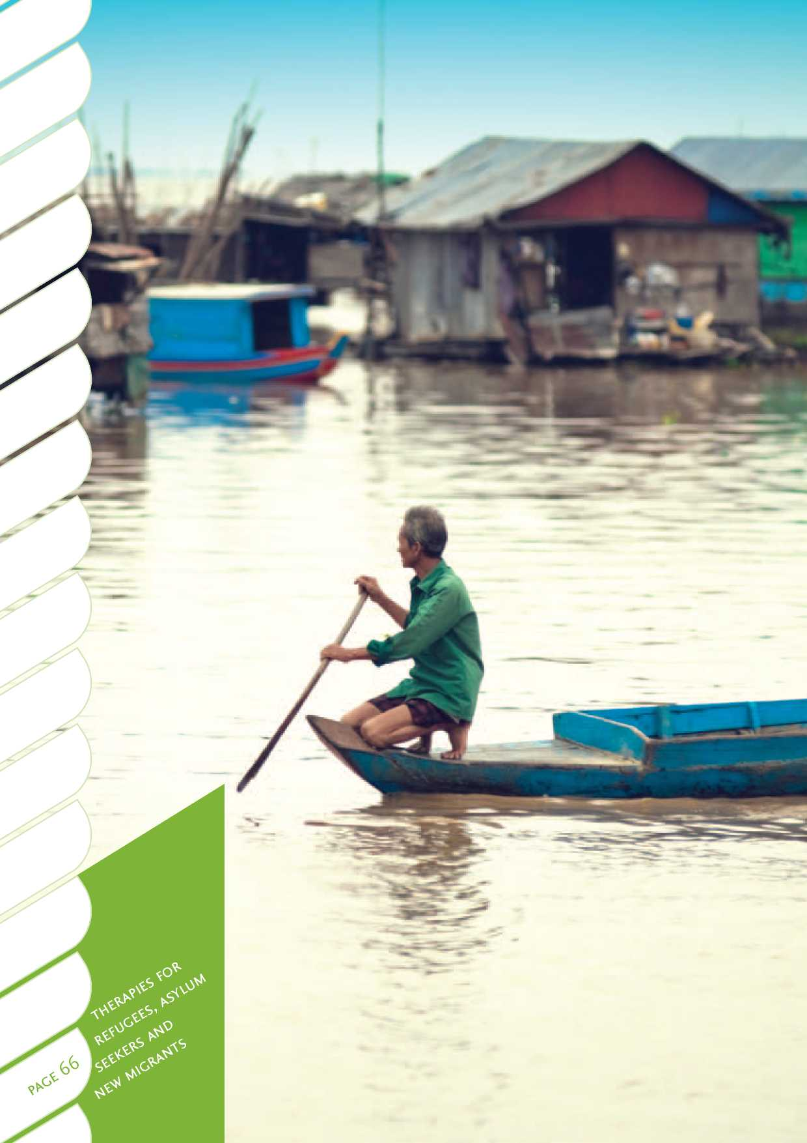

Less widely used therapies Acceptance and commitment therapy

[Acceptance and commitment therapy](http://en.wikipedia.org/wiki/Acceptance_and_commitment_therapy) uses strategies of mindfulness, acceptance, commitment and behaviour change to increase cognitive flexibility. [Acceptance and](http://en.wikipedia.org/wiki/Acceptance_and_commitment_therapy) [commitment therapy](http://en.wikipedia.org/wiki/Acceptance_and_commitment_therapy) focuses on teaching people to notice their thoughts, feelings and sensations (rather than trying to control these), and to use this knowledge to guide and motivate them to get more out of activities that they value.

Why this therapy is used

There is promising evidence for the effectiveness of [acceptance and commitment](http://en.wikipedia.org/wiki/Acceptance_and_commitment_therapy) [therapy](http://en.wikipedia.org/wiki/Acceptance_and_commitment_therapy). In a recent meta-analytic review, [acceptance and commitment therapy](http://en.wikipedia.org/wiki/Acceptance_and_commitment_therapy) was found to be more useful than no treatment, or treatment as usual, for a variety of mental health conditions, such as psychosis, and for physical conditions, such as chronic pain. Evidence was weakest for anxiety and depression, where the therapy was not seen as superior to control conditions. Overall, the meta-analysis concluded that [acceptance and commitment therapy](http://en.wikipedia.org/wiki/Acceptance_and_commitment_therapy) does not appear to be more effective than other established treatments, such as CBT, cognitive therapy, problem-solving therapy and systematic desensitisation15 3 .

[Acceptance and commitment therapy](http://en.wikipedia.org/wiki/Acceptance_and_commitment_therapy) shares similarities with Buddhist philosophy and on a theoretical basis may be more acceptable to some migrant and refugee communities than other types of therapy. The philosophy behind [acceptance and](http://en.wikipedia.org/wiki/Acceptance_and_commitment_therapy) [commitment therapy](http://en.wikipedia.org/wiki/Acceptance_and_commitment_therapy) argues that human suffering is an inevitable part of existence and should be tolerated154. Such tolerance of distress is a valued trait in many cultures.

Potential issues

There is no specific research available for the refugee and migrant population.

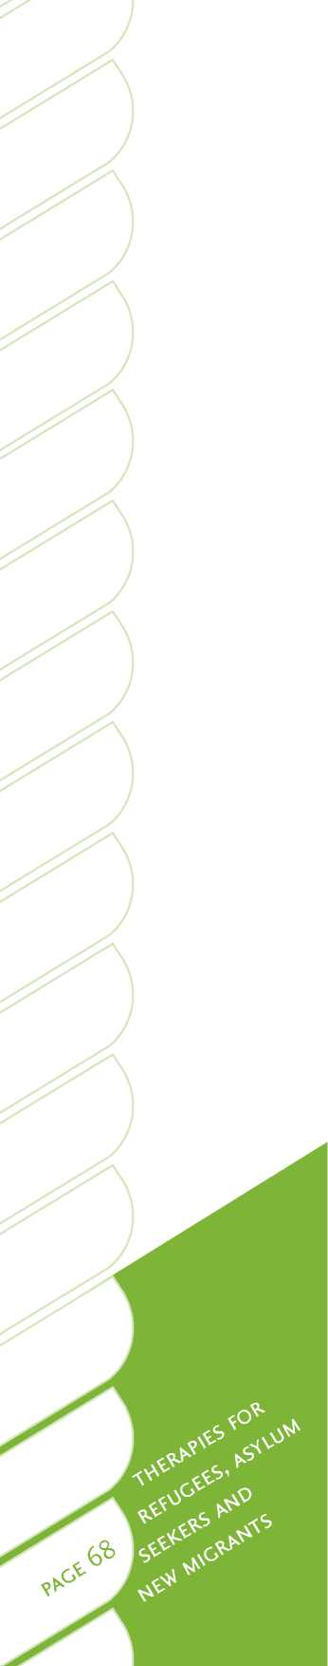Bibliotherapy

Bibliotherapy involves the use of books, printed material, audio tapes, play scripts, pamphlets and other resources as self-help for personal growth102. Therapists can prescribe the use of these tools, and service users and community members may also personally seek them out.

Why this therapy is used

Evidence conducted in Western populations indicates that bibliotherapy is useful for mild to moderate depression155. There is also evidence to support the use of bibliotherapy with anxiety disorders, self-harm156, personal development, managing long-term illness and helping children and young people with issues like bullying and divorce102. There is limited evidence of the therapy's effectiveness with alcoholism and few studies with more clinically severe populations156 .

Bibliotherapy does not appear to be used with refugee and migrant communities in Aotearoa/New Zealand or other countries as a stand-alone treatment.

Potential issues

For bibliotherapy resources to be effective, they need to be in the appropriate language and culturally relevant. These resources are scarce and would need to be developed before bibliotherapy could be widely used with refugees and migrants from culturally diverse backgrounds. In addition, the people using these resources would need to be literate and motivated to engage in self-directed therapeutic actions.

Bibliotherapy may be effective for some people with mild conditions who have high levels of acculturation and English skills. It may also be useful for people who are visiting a therapist that shares a common language, where the therapist is aware of books and resources that are appropriate for the person's language and culture.

Bibliotherapy is also not considered suitable for people with low self-motivation, or as a stand-alone therapy for people with moderate or severe mental illness.

Computerised cognitive behaviour therapy

Computerised cognitive behaviour therapy is CBT provided using a website, CD or DVD format.

Why this therapy is used

There is tentative evidence that some computerised CBT programmes are effective for treating mild anxiety and depression in general populations157. However, computerised CBT is only recommended as a stand-alone therapy for very mild disorders. None of the research on the effectiveness of computerised CBT appears to have focused on migrant or refugee communities. While there are no online programmes available in Aotearoa/New Zealand for refugees and migrants with culturally and linguistically diverse backgrounds, there are a number of websites for English speaking people, for example the Lowdown (for youth), [www.thelowdown.co.nz](http://www.thelowdown.co.nz), and the Journal, www. depression.org.nz.

Potential issues

This type of therapy may not be practical for people with low levels of English, or who hold strongly traditional cultural values. Service user engagement is most likely when the online CBT programme is in their first language (or a language they are very fluent in).

Dialectic behaviour therapy

Dialectic behaviour therapy aims to improve interpersonal, self-regulation and distress tolerance skills by integrating behaviour strategies and mindfulness practices158. The dialectic aspect of therapy refers to its focus on validating the service user's acceptance of themselves as they are, whilst creating motivation for change158. Dialectic behaviour therapy is a relatively new form of therapy, designed for use with people with borderline personality disorder for which other modes of therapy have had little success. Dialectic behaviour therapy delivered in outpatient settings typically involves individual psychotherapy, group skills training, and telephone counselling. Consultation teams are often established to maintain therapist resilience and commitment to best practice158.

Why this therapy is used

There are promising results for the effectiveness of dialectic behaviour therapy at reducing self-harming behaviours in people with borderline personality disorders159. However, as this form of therapy is relatively new, there are only limited controlled studies of its effectiveness.

The highly structured nature of dialectic behaviour therapy, and its incorporation of mindfulness concepts and distress tolerance, mean that this type of therapy may potentially be effective with some migrant and refugee service users who may not have developed strong skills in these areas.

Potential issues

There is no specific research available for the refugee and migrant population. However, some therapists do use some of the components of dialectic behaviour therapy with very distressed clients.

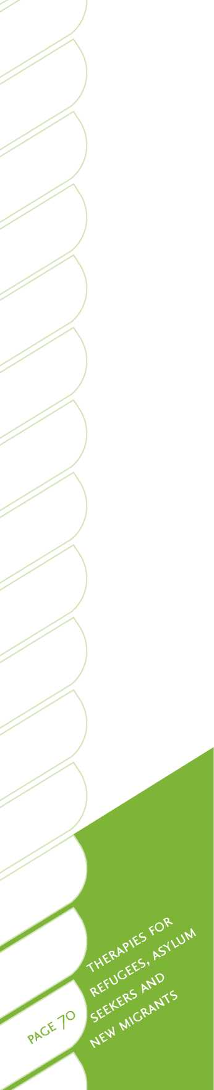Interpersonal psychotherapy

Interpersonal therapy focuses on interpersonal interactions and social roles102. It focuses on exploring expressions of emotion, recurring patterns of emotions, thoughts, behaviour and events, discussion of relationships and past experiences160. Interpersonal psychotherapy is considered most useful when relationships or social roles are central to the distress experienced by a service user.

Why this therapy is used

The therapy aims to improve relationships and interpersonal roles, and there is evidence for its effectiveness in addressing depression, anxiety, anorexia nervosa and relationship issues in general populations102.

Potential issues

While this therapy may be useful when working with refugees and migrants, there appears to be no research on the effectiveness of interpersonal psychotherapy with refugee and migrant service users.

Motivational interviewing

Motivational interviewing is a brief counselling-style therapy. It assists service users to realise and confront attitudes, beliefs and issues that are preventing behaviour change. It draws on a broad range of counselling techniques to assist service users to explore ambivalence, build commitment to change and plan steps to achieve the desired change161 .

Why this therapy is used

Motivational interviewing is commonly used with general populations in drug, alcohol, gambling and short intervention practices. It is a brief intervention and is flexible for use alongside other forms of therapy. For instance, it can be used to build motivation to address emotional distress or engage in other forms of therapy. Motivational interviewing is used to assist people to make health and lifestyle changes. It has traditionally been applied in alcohol, drug, smoking and gambling services. It is also increasingly used in mental health and general health services in Aotearoa/New Zealand.

Potential issues

There appears to be no research on the effectiveness of motivational interviewing with refugee and migrant service users. However, it is often used with migrant populations in the gambling and alcohol fields, with anecdotal reports of good effect.

Motivational interviewing relies on a strong level of rapport between service users and their therapists161, which may take some time to build if the cultural and communication norms and treatment goals of the therapist and service user are different.



Multisystemic therapy

Multisystemic therapy is a form of treatment aimed at addressing anti-social behaviour in adolescents through intensive family and community intervention. Multisystemic therapy focuses on a young person as part of an inter-connected arrangement of self, family, peer, school and neighbour systems, and may intervene by drawing on the existing strengths in one or more of these systems102.

Why this therapy is used

This form of therapy is used in Aotearoa/New Zealand with young people with complex issues, who are often in care.

Potential issues

There does not appear to be any research on the use of multi-systemic therapy with refugee and migrant communities, although it may be appropriate in some circumstances, when youth have a variety of forensic and family difficulties.

Psychotherapy

Psychotherapy refers to a range of techniques that can be used to treat emotional issues and mental health issues. Techniques typically focus on experiential relationship building, communication and behaviour102. Psychotherapy can be undertaken in an individual or group setting.

Why this therapy is used

Psychotherapy is typically applied when emotional issues have built up over many years. Therapeutic outcomes are often attributed to the quality of the therapeutic relationship. This therapy is occasionally used by some therapists with refugee and migrant service users in Aotearoa/New Zealand.

Potential issues

While there is some evidence for its effectiveness with Western communities102, there is no research on this therapy's outcomes for refugee and migrant service users.

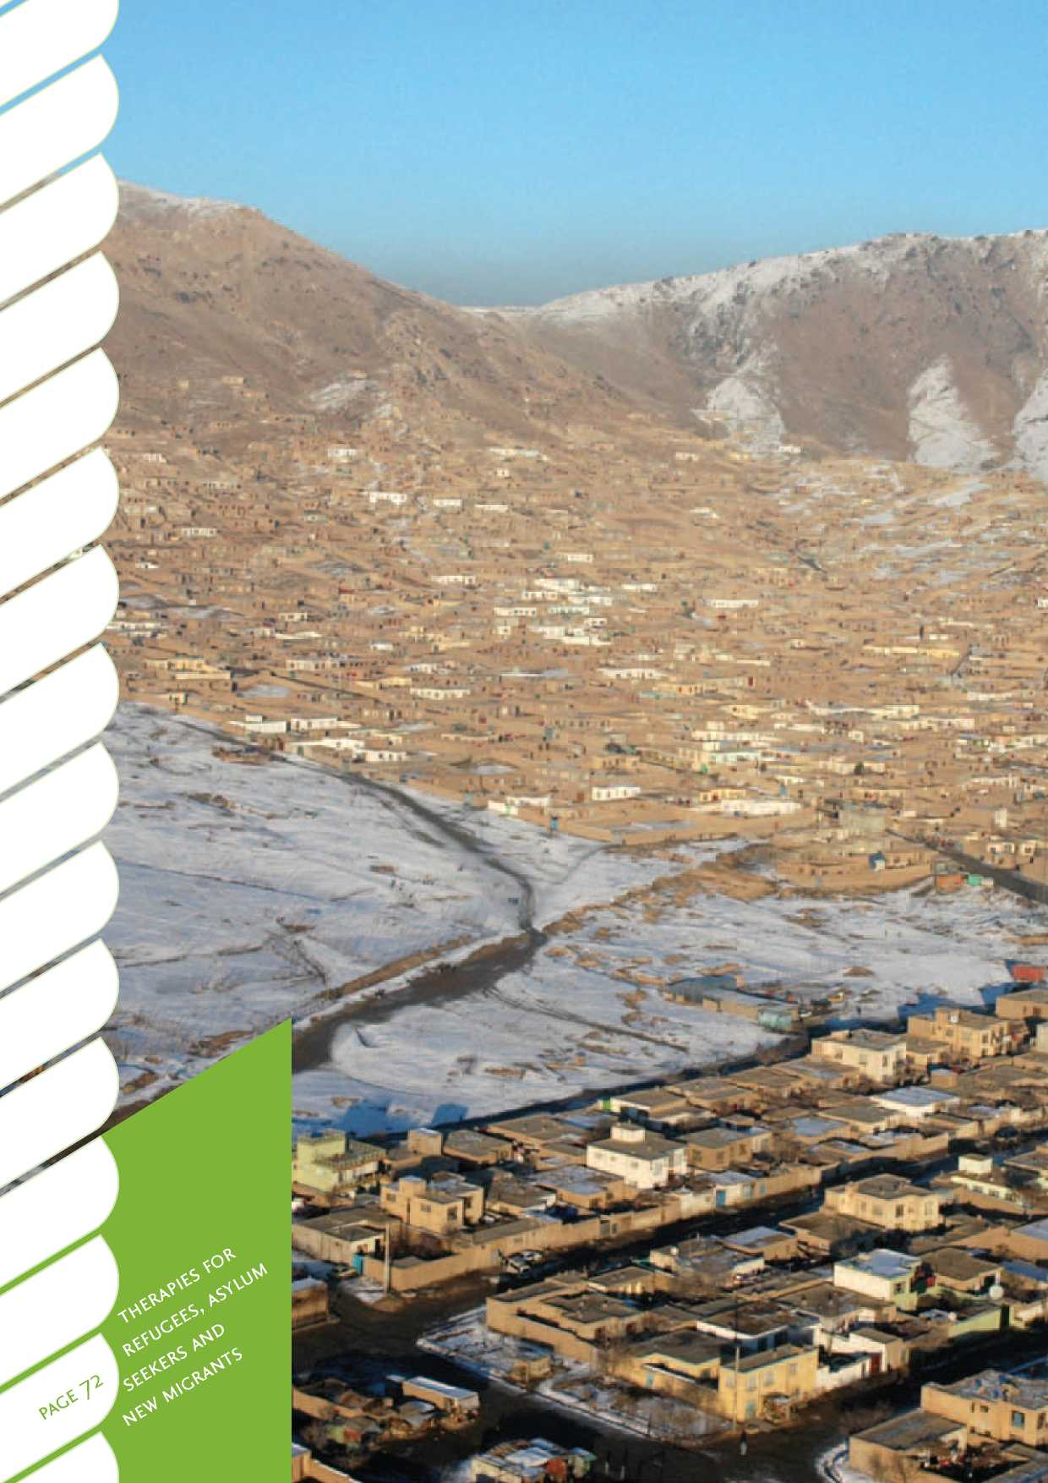

Summary

In brief summary, working in the area of refugee and migrant mental health in Aotearoa/New Zealand can be highly rewarding and challenging. The aim is to assist migrants and refugees to overcome obstacles and enhance their resettlement success. There are constant opportunities to learn about new cultures and concepts of mental health and different customs and ways of life. With an attitude of sincerity, openness and flexibility, and a willingness to learn, a practitioner may acquire the skills and experience to be effective in helping people from a wide variety of countries, cultures, backgrounds and needs.

In working with culturally and linguistically diverse service users, it is important to continue training and supervision, but particularly to seek specialist cultural advice in the process of assessment and case management. Working with people who have come from backgrounds of severe trauma can be challenging, and the practitioner must particularly pay close attention to potential issues of vicarious traumatisation, transference and role clarity. Attention to self-care practices, peer support, supervision and debriefing are particularly important for working in this area of specialised practice. There is a range of resources available for reference and there is continuing professional development training available in Aotearoa/New Zealand and from overseas. Some of these resources are detailed in Section Four.

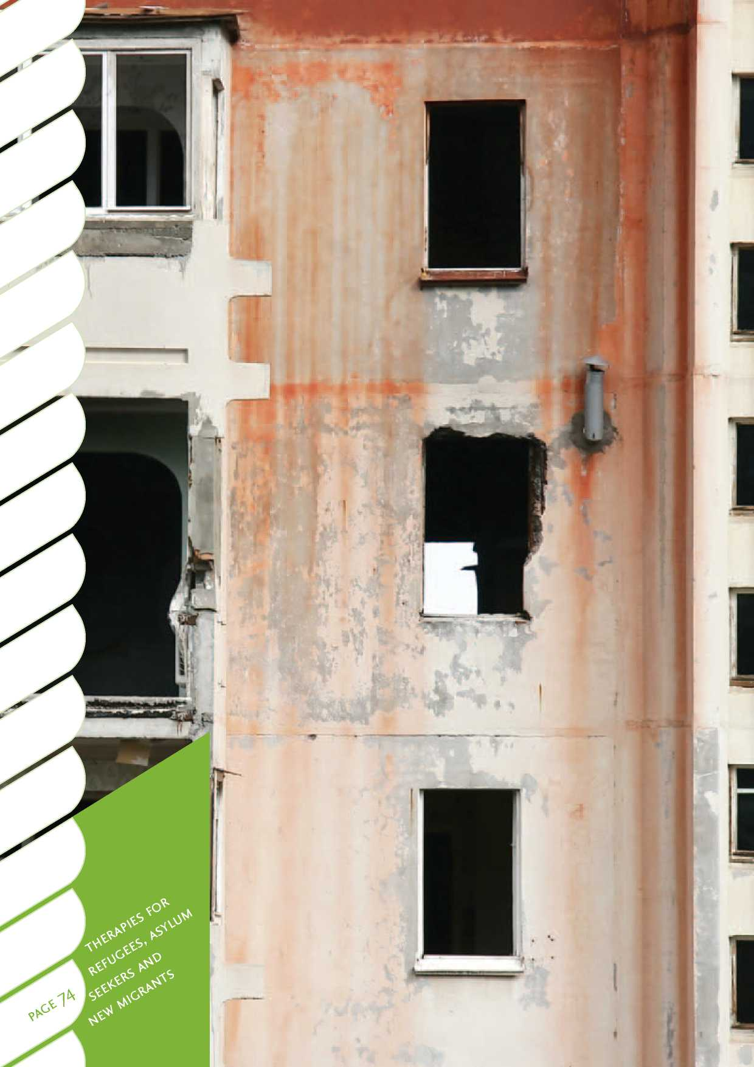



4. Resources and links

Resources and links relevant to asylum seekers

•

Cross-cultural training links and resources

•

Law and legal information and resources and links

•

Refugee and migrant specialist health services, resources and links

•

Refugee rights and advocacy organisations

•

Refugee settlement and support

•

Migrant settlement support and information and referral

•

ESOL and language assistance

•

Paper presented at symposium sponsored by Psychology in the Public Interest 43rd APS Annual Conference, Hobart, September 2008: [Asylum seekers, social](http://www.psychology.org.au/Assets/Files/Refugee-Conference-paper-2008.pdf) [policy, and psychologists](http://www.psychology.org.au/Assets/Files/Refugee-Conference-paper-2008.pdf) (140kb) and [www.psychology.org.au/Assets/Files/](http://www.psychology.org.au/Assets/Files/Refugee-Conference-paper-2008.pdf) [Refugee-Conference-paper-2008.pdf](http://www.psychology.org.au/Assets/Files/Refugee-Conference-paper-2008.pdf) Researchers for Asylum Seekers: [www.ras.](http://www.ras.unimelb.edu.au) [unimelb.edu.au](http://www.ras.unimelb.edu.au)

Australian Asylum Seekers Resource Centre: [www.asrc.org.au](http://www.asrc.org.au)

Culturally and linguistically diverse (CALD) resources and training: *Cultural Competencies for Health Practitioners in Working With Migrants and Refugees* (RASNZ and Waitemata District Health Board, 2008). Order from [admin@rasnz.co.nz](mailto:admin@rasnz.co.nz) or [www.cald.org.nz](http://www.cald.org.nz). Centre for Refugee Studies, University of New South Wales: [www.crr.unsw.edu.au/](http://www.crr.unsw.edu.au/) Cultural Detectives: [http://www.](http://www.culturaldetective.com/) [culturaldetective.com/](http://www.culturaldetective.com/)

Immigration Act 2009: [www.dol.govt.nz/](http://www.dol.govt.nz/actreview/) [actreview/](http://www.dol.govt.nz/actreview/)

Istanbul Protocol: [www.ohchr.org/](http://www.ohchr.org/Documents/Publications/training)

[Documents/Publications/training](http://www.ohchr.org/Documents/Publications/training)

NZ Refugee Law website: [www.refugee.org.nz](http://www.refugee.org.nz)

Refugees As Survivors New Zealand (RASNZ) website: [www.rasnz.co.nz](http://www.rasnz.co.nz)

International Rehabilitation Council for Torture Victims: [www.irct.org/home](http://www.irct.org/home) Interpreters and NAATI: [www.naati.com.au/](http://www.naati.com.au/) STARTTS Centre, Sydney: [www.startts.org.au](http://www.startts.org.au) Victorian Foundation: [www.foundationhouse.](http://www.foundationhouse.org.au/home/index.htm) [org.au/home/index.htm](http://www.foundationhouse.org.au/home/index.htm)

Refugees as Survivors Wellington Trust: [www.](http://www.wnras.org.nz) [wnras.org.nz](http://www.wnras.org.nz)

Christchurch Resettlement Services: 283 Lincoln Road, Christchurch, phone 03-335­0311

Victorian Transcultural Psychiatry Unit, translated psychometric instruments: [www.](http://www.vtpu.org.au/resources/translatedintruments) [vtpu.org.au/resources/translatedintruments](http://www.vtpu.org.au/resources/translatedintruments)

NZ Human Rights Commission, Te Punanga refugee focus network: [www.hrc.co.nz/home/](http://www.hrc.co.nz/home/hrc/racerelations/tengirathenzdiversityactionprogramme/tepunangarefugeeissues.php) [hrc/racerelations/](http://www.hrc.co.nz/home/hrc/racerelations/tengirathenzdiversityactionprogramme/tepunangarefugeeissues.php) [tengirathenzdiversityactionprogramme /](http://www.hrc.co.nz/home/hrc/racerelations/tengirathenzdiversityactionprogramme/tepunangarefugeeissues.php) [tepunangarefugeeissues.php](http://www.hrc.co.nz/home/hrc/racerelations/tengirathenzdiversityactionprogramme/tepunangarefugeeissues.php)

Refugee Council of New Zealand: [www.rc.org.](http://www.rc.org.nz/) [nz/](http://www.rc.org.nz/)

Changemakers Refugee Forum: [www.crf.org.](http://www.crf.org.nz/) [nz/](http://www.crf.org.nz/)

Psychologists for Peace interest group: [www.](http://www.groups.psychology.org.au/pfp/) [groups.psychology.org.au/pfp/](http://www.groups.psychology.org.au/pfp/)

Refugee Services Aotearoa New Zealand: [www.refugeeservices.org.nz/](http://www.refugeeservices.org.nz/)

AUT Centre for Refugee Education: [https://](https://oldwww.aut.ac.nz/schools/languages/center_for_refugee_education/) [oldwww.aut.ac.nz/schools/languages/](https://oldwww.aut.ac.nz/schools/languages/center_for_refugee_education/) [center_for_refugee_education/](https://oldwww.aut.ac.nz/schools/languages/center_for_refugee_education/)

PEETO The Multi-Cultural Learning Centre, Christchurch: [www.peeto.ac.nz/](http://www.peeto.ac.nz/)

Ministry of Social Development, Settling In, migrant social services and community development: [www.familyservices.govt.nz/](http://www.familyservices.govt.nz/working-with-us/programmes-services/connected-services/settling-in-refugee-migrant-social-services.html) [working-with-us/programmes-services/](http://www.familyservices.govt.nz/working-with-us/programmes-services/connected-services/settling-in-refugee-migrant-social-services.html) [connected-services/settling-in-refugee-](http://www.familyservices.govt.nz/working-with-us/programmes-services/connected-services/settling-in-refugee-migrant-social-services.html) [migrant-social-services.html](http://www.familyservices.govt.nz/working-with-us/programmes-services/connected-services/settling-in-refugee-migrant-social-services.html) Auckland Migrant Resource Centre: [www.](http://www.arms-mrc.org.nz/) [arms-mrc.org.nz/](http://www.arms-mrc.org.nz/)

Ministry of Ethnic Affairs, Language Line: [www.ethnicaffairs.govt.nz/oeawebsite.nsf/](http://www.ethnicaffairs.govt.nz/oeawebsite.nsf/wpg_URL/language-line-Index) [wpg_URL/language-line-Index](http://www.ethnicaffairs.govt.nz/oeawebsite.nsf/wpg_URL/language-line-Index)

English Language Partners New Zealand: [www.esolht.org.nz/](http://www.esolht.org.nz/)

|  |  |  |  |  |
| --- | --- | --- | --- | --- |
|  | |  |  | * w  r- |
| 1 | wuas — |  | **r** | **• *^£ 1** |

|  |  |  |  |
| --- | --- | --- | --- |
|  | y-y** ■ |  |  |
|  |  |  | |
| ! L !■ >. vA | | **■** |  |
|  |  | I | |
|  | - | **JS H** |  |
|  | !.' ll |  | |

|  |  |  |  |  |  |  |
| --- | --- | --- | --- | --- | --- | --- |
| **i-Wu.TI** | |  | **> l3lJSI | |  | |
|  |  |  |  |  |  |  |

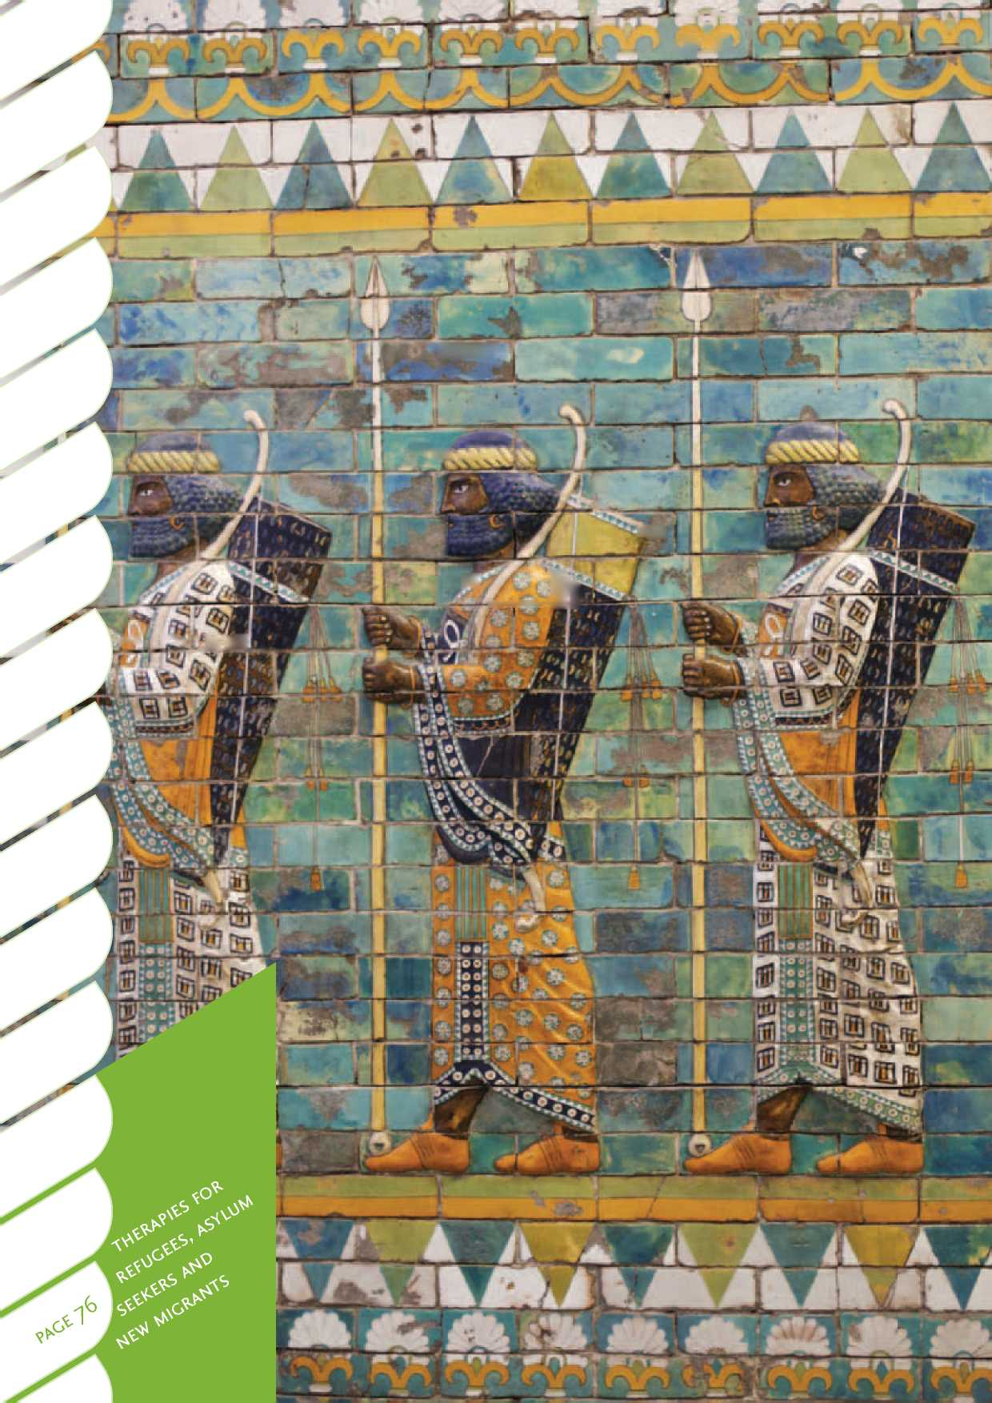

Appendix A: Medication

This psychopharmacology review has been written by Dr Grant Galpin, consultant psychiatrist and Pratima Devi Prasad, clinical nurse specialist for RASNZ. It provides an overview of the key issues and recommendations for use of psychopharmacology with refugees.

As far as the authors are aware, this is the first time this information has been compiled and it is therefore an important contribution to the refugee and migrant literature. The information may be particularly useful for GPs and psychiatrists who need to prescribe medication for people with a refugee background. Other mental health and addiction staff may also find this information useful in raising their awareness of medication issues for refugees. However, this summary is not intended to provide guidelines for prescribing medication, but instead highlights key issues. Staff should always consult with a GP or psychiatrist regarding medication.

PTSD

The evidence about PTSD in non-refugee populations (which might provide some guidance for refugees and migrants) stems primarily from research on war veterans and survivors of sexual assault. Even in these populations, drug treatment is poorly studied162, but from the data, positive symptoms (e.g. nightmares, intrusive recollections etc) respond better to medications, than do negative symptoms (e.g. social withdrawal, avoidance of exposure to cues that remind the sufferer of the traumatic event etc). Interestingly, chronic PTSD has a very poor response rate to placebo. Selective Serotonin Reuptake Inhibitor (SSRI) medications have been shown to be effective, but long-term studies are limited. SSRI medications have also been shown to have an improved effect, as opposed to placebo, for relapse prevention over a 6 to 12-month period. However, high doses of a serotonergic drug for longer periods of time are deemed necessary, as opposed to the treatment of uncomplicated depression. Relapse rates and symptom recurrence is high if treatment is discontinued.

SSRIs

Meta-analysis163 provides definitive evidence for the efficacy of SSRIs for PTSD. In terms of the specific SSRI medications that have been studied, Sertraline has been relatively well studied, but is not Pharmac funded for use in Aotearoa/New Zealand, and therefore is not discussed further here.

Paroxetine has been shown164 to be effective in both males and females with PTSD in a large double-blind placebo-controlled trial of over 500 people. It has also been shown to be effective in a number of open trials. There is a randomised-controlled trial of just over 50 adults where a beneficial effect on dissociation is noted164.

Fluoxetine has been shown to be superior to placebo for PTSD in a randomised- controlled double-control placebo-controlled trial of a six-month duration165. It has also been shown to be effective in relapse prevention in open trials.

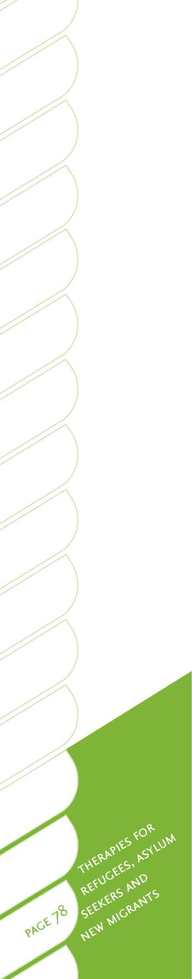Citalopram has a more limited evidence base and has been effective in various case reports. In these authors' practise, its use is disproportionate to its evidence base, given its relatively favourable side-effect profile, especially when considering the propensity towards somatisation and difficulties with side-effects that is encountered with certain refugee populations.

Other antidepressant medications

Although the antidepressant Venlafaxine has a relatively robust evidence base in a randomised control of 329 people164, it is not available for post-traumatic stress disorder in Aotearoa/New Zealand. However, it is available for treatment-resistant depression.

The antidepressant Mirtazapine, which is also Pharmac funded in Aotearoa/New Zealand for treatment-resistant depression (but not PTSD), has an effect on some symptoms of PTSD and is well tolerated. It is ironic that there is in fact some specific evidence with respect to use of Mirtazapine for PTSD in refugees166; in over 300 patients in a Chicago-based community link serving refugees, Mirtazapine was reported to be particularly helpful in mitigating the pervasive sleep disturbance of PTSD and suppressing nightmare activity, or in blocking the memory of the dream state upon wakening. While exact figures were not available, it was estimated that 75 per cent of participants reported improvement, with a “substantial minority” reporting the total absence of dreams related to traumatic events. Clearly this is a study that requires replication in a more rigorous evidence-based format. It should be noted that evidence is available for the efficacy of Mirtazapine at randomised- control trial level in a study of 100 Korean veterans with PTSD167.

There are also various open labelled studies that look at the efficacy of Sodium Valporate, tricyclic antidepressants and a range of other treatments, including Carbamazepine and Clonadine. These studies have not generally been replicated and are small numbered open labelled trials162 .

Antipsychotic medications

Atypical antipsychotic medications are generally not considered effective. However, in a meta-analysis published16 8 , pooled data from seven randomised-controlled trials involving a total of 192 patients (not refugees) with PTSD showed that the atypical antipsychotic medications Olanzapine and Risperidone may have a beneficial effect in the treatment of PTSD, in particular for the intrusive phenomena of PTSD, but also for global PTSD symptoms.

It was not possible to draw clear conclusions from these trials as to whether adding atypical antipsychotic medications to the existing antidepressant treatment or mono­therapy is superior. However, in Aotearoa/New Zealand, Olanzapine is only funded by Pharmac for treating the psychosis of schizophrenia. The antipsychotic Quetiapine has demonstrated a number of encouraging signs of efficacy in open, non-placebo controlled trials, and there is a similar level of evidence supporting the efficacy of Aripiprazole. Interestingly, an eight-week randomised-control double-blind placebo trial of 47 patients who were randomly allocated either to Sertraline, or Sertraline and Quetiapine, showed a significant reduction in the later adjunct group169.

Depression

In terms of the treatment for depression, meaning unipolar depression without psychosis, studies specifically for refugee populations are lacking; data has to be extrapolated from evidence from non-refugee populations. As described above, the unique situation for refugees and their psychosocial needs argues for psychosocial interventions. Anecdotal and epidemiological evidence suggests that the depression is tied in with the complex psychosocial situation of the refugee, namely displaced people who have been homeless and stateless for long periods of time. Loss of relatives and trauma histories are common. Depression is commonly tied in with a history of trauma and associated with PTSD. Hence the treatment for depression in refugees is often intricately related to the treatment for PTSD. Treatment in Auckland most often occurs within the framework of CBT and eye movement desensitisation therapy. This is consistent with the data from non-refugee populations, which shows that depression is more likely to respond to a combination of SSRIs and CBT.

SSRI antidepressants are the first choice medications for depression, given their safety in overdose and improved side-effect profile. Citalopram is a well-established first-line antidepressant shown to be effective and well-tolerated in a review of 30 randomised-control trials where it demonstrated superiority to placebo170. Fluoxetine also has a clear evidence base, in terms of its superiority to placebo in randomised- control trials, and has been shown to be superior to tricyclic antidepressants, with significantly fewer dropouts in a meta-analysis of 30 trials171 . The SSRI Paroxetine, which is also available in Aotearoa/New Zealand, is widely used, but has problems with respect to discontinuation effects due to its relatively short half-life.

Tricyclic antidepressants have been demonstrated to be clearly superior to placebo, but are used with caution given their propensity for cardio-toxicity and overdose172, and are therefore generally not recommended as first-line treatments. An ECG is recommended in prescribing them for those at risk of cardiovascular disease. Nortriptyline has the advantage of being mildly sedative, relative to other tricyclics, with lower cardio-toxic potential. It is suitable for once-daily administration and blood-level monitoring can assist in achieving the optimising dosage. It is said that for treatment-resistant depression, 40 per cent of people may respond to Nortriptyline, although tolerability of the medication is an issue174 . Amitriptyline has been subject to a Cochrane systematic review, which concluded that it is at least as effective as other antidepressants, but has a higher side-effect profile173 .

It is beyond the scope of this review to go into details about the various other drugs and combinations that are available and that have been researched for treatment­resistant depression. Strategies include lithium and antidepressants, and Mirtazapine with Venlafaxine or SSRIs.

Appendix B: Aotearoa/ New Zealand Refugee Quota 2006-2009

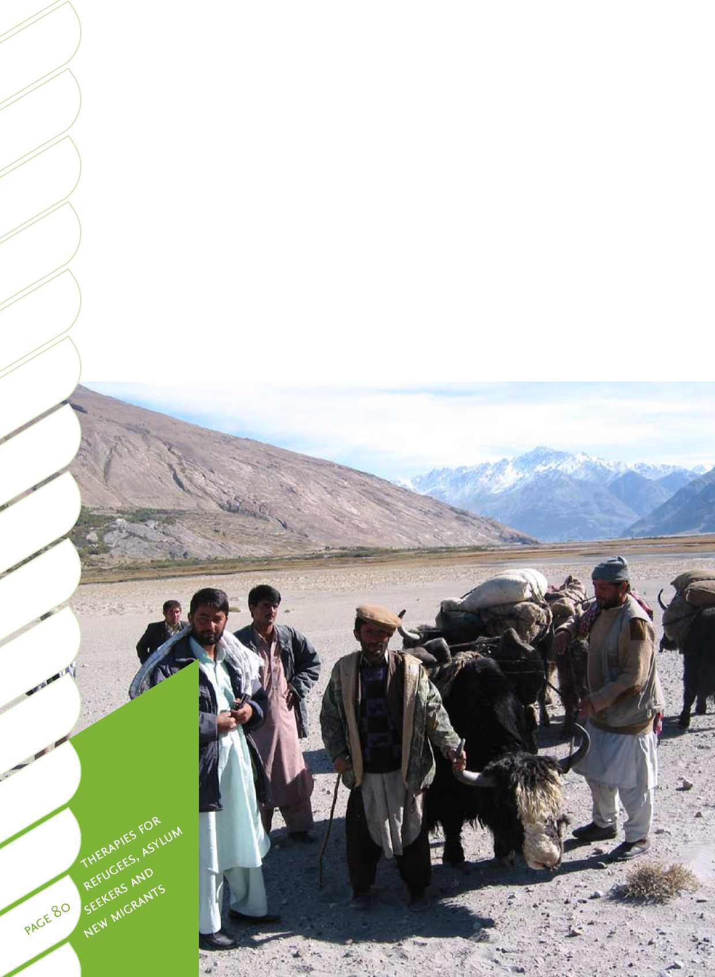

|  |  |  |  |
| --- | --- | --- | --- |
|  | **New Zealand refugee quota** | **2006-2007** | **TOTAL *2006-*** |
| **Intake** | c_ 0) 2 C- 3 Z  c .£ o £> a a*  — □ -< < ® O O O O o  O’ ■M *4 | IM o o |
|  | **BY NATIONALITY** | | |
| Afghanistan | 7 6 1 43 81 61 | 199 |
| Algerian |  | o |
| Armenian |  | o |
| Burundi |  | o |
| Bhutan |  | o |
| China | 8 3 | 11 |
| Republic of Congo (Brazzaville) | 3 | 3 |
|  | Colombia |  | o |
| Congo, Dem. Rep of | 6 8 2 6 |  |
| Djibouti |  | o |
| Eritrea | 1 | 1 |
| Ethiopia | 6 1 | 7 |
| Indian | 3 3 2 | 10 |
| Indonesian |  | 0 |
| Iran | 1 8 1 | 10 |
| Iraq | 2 2 2 | 6 |
| Mauritania |  | o |
| Myanmar | 77 98 75 78 35 34 | 397 |
| Nepal | 5 | 6 |
| Palestinian | 2 | 3 |
| Pakistan |  | o |
| Rwanda |  | o |
|  | Somalia |  | o |
| Sri Lanka | 3 | 3 |
| Sudan | 10 1 | 11 |
| Turkey | 1 | 1 |
| Vietnam | 7 | 7 |
| TOTAL BY NATIONALITY 87 128 109 139 128 106 697 | | |

**2007-2008**

|  |  |  |  |  |
| --- | --- | --- | --- | --- |
|  | **TOTAL 2007-i** | **2008-2009** | **TOTAL 2008-** | **Total July 06-1** |
| **g ? »**  **O O o**  **00 00 00** | **2008** | **c_ 0) 2 C- 3 Z**  **c .£ o £> a a\***  **® o o o o o**  **00 00 00 CD CD** | IM o o \D | 4 o \D |
|  |  | | | |
| 17 | 66 | 8 16 1 4 | 29 | 294 |
|  | 5 |  | 0 | 5 |
| 6 | 6 |  | 0 | 6 |
|  | **0** | 1 5 | 6 | 6 |
| 40 35 | 75 | 26 27 57 67 18 | 195 | **270** |
|  | **0** | 1 3 4 | 8 | **19** |
|  | 0 |  | 0 | 3 |
| 3 | 29 | 13 24 11 | 48 | **77** |
| 7 3 | 21 | 37 18 | 55 | 98 |
| 3 | **3** |  | 0 | 3 |
| 33 21 22 | 76 | 30 17 1 1 | 49 | 126 |
| 2 4 | 12 | 3 | 3 | 22 |
|  | 3 | 1 | 1 | 14 |
| 4 | **4** | 1 | 1 | **5** |
| 11 | **11** | 1 1 | 2 | **23** |
| 51 13 17 | 90 | 5 38 58 66 | 113 | **209** |
|  | 10 | 0 | 0 | 10 |
| 27 34 9 | 251 | 33 15 12 8 35 49 | 152 | **800** |
| 5 | **5** | 1 | 1 | 12 |
|  | 5 | 22 7 | 29 | 37 |
| 1 | 1 |  | 0 | 1 |
| 3 | 25 | 4 | 4 | 29 |
| 13 | 18 |  | 0 | 18 |
|  | **4** | 2 | 2 | 9 |
|  | **30** | 2 | 2 | 43 |
|  | 0 |  | 0 | 1 |
|  | 0 |  | 0 | 7 |
| 123 136 125 750 113 126 118 134 119 90 700 | | | | 2147 |

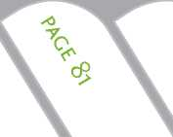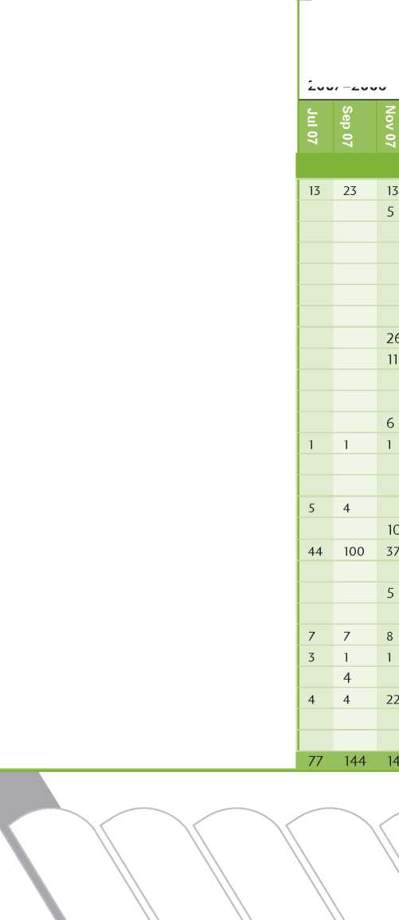

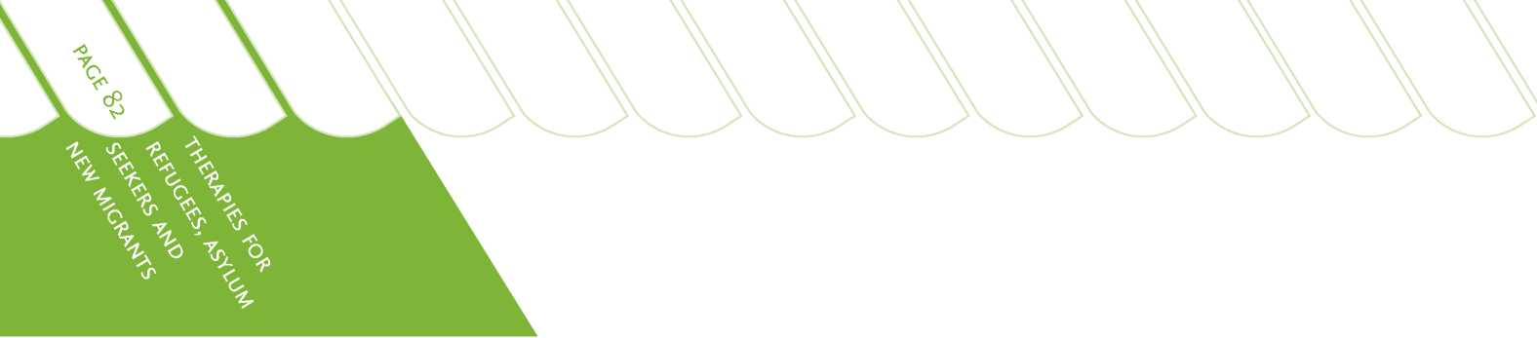

|  |  |  |  |  |  |  |  |  |  |  |  |  |  |  |  |  |  |  |  |  |  |  |
| --- | --- | --- | --- | --- | --- | --- | --- | --- | --- | --- | --- | --- | --- | --- | --- | --- | --- | --- | --- | --- | --- | --- |
| **New Zealand refugee quota** | **2006-2007** | | | | | | **TOTAL 2006-2007** | **2007-2008** | | | | | | **TOTAL 2007-2008** | **2008-2009** | | | | | | **TOTAL 2008-2009** | **Total July 06-May C** |
| **Intake** | Jul 06 | Sep 06 | Nov 06 | Jan 07 | Mar 07 | May 07 |  | Jul 07 | Sep 07 | Nov 07 | Jan 08 | Mar 08 | May 08 |  | Jul 08 | Sep 08 | Nov 08 | Jan 09 | Mar 09 | May 09 |  | **\D** |
| **CATEGORIES** | | | | | | | | 8 | | | | | |  | | | | | | | | |
| Medical / disabled |  |  | 2 | 10 | 3 | 4 | 19 | 4 | 6 | 15 | 7 | 15 | 11 | 58 |  |  | 15 | 8 | 5 | 12 | 40 | **117** |
| Protection | 76 | 107 | 82 | 115 | 94 | 94 | 568 | 32 | 103 | 58 | 45 | 77 | 70 | 385 | 23 | 79 | 81 | 96 | 104 | 65 | 498 | **1451** |
| Women at risk | 3 | 4 | 12 | 5 | 21 | 6 | 5! |  | 4 | 25 | 60 | 38 | 15 | 142 | 24 | 30 | 6 | 24 | 6 | 1 | 91 | **284** |
| Family reunion | 8 | 17 | 11 | 8 | 10 | 2 | 56 | 41 | 31 | 47 | 11 | 6 | 29 | 165 | 16 | 17 | 16 | 6 | 3 | 11 | 69 | **290** |
| Emergency |  |  | 2 | 1 |  |  | 3 |  | | | | | | o |  |  |  |  | 1 | 1 | 2 | **5** |
| TOTAL BY CATEGORY | 87 | 128 | 109 | 139 | 128 | 106 | 697 | 77 | 144 | 145 | 123 | 136 | 125 | 750 | 113 | 126 | 118 | 134 | 119 | 90 | 700 | 2147 | |
| aces | | | | | | | | | | | | | | | | | | | | | | |
| 0-4 | 13 | 16 | 11 | 16 | 12 | 18 | 86 | 15 | 18 | 23 | 12 | 15 | 13 | 96 | 12 | 6 | 20 | 14 | 12 | 12 | 76 | **258** |
| 5-12 | 10 | 18 | 9 | 16 | 15 | 16 | 84 | 9 | 25 | 20 | 16 | 27 | 11 | 108 | 12 | 23 | 19 | 29 | 17 | 14 | 114 | 306 |
| 13 - 17 | 12 | 18 | 11 | 20 | 22 | 7 | 90 | 14 | 27 | 22 | 21 | 25 | 18 | 127 | 20 | 15 | 19 | 15 | 14 | 10 | 93 | **310** |
| 18-60 | 52 | 76 | 78 | 87 | 79 | 65 | 437 | 39 | 74 | 80 | 74 | 69 | 83 | 419 | 69 | 76 | 60 | 72 | 70 | 50 | 397 | **1253** |
| 60+ |  | | | | | |  |  | | | | | |  |  | 6 |  | 4 | 6 | 4 | 20 | 20 |
| TOTAL BY AGE | 87 | 128 | 109 | 139 | 128 | 106 | 697 | 77 | 144 | 145 | 123 | 136 | 125 | 750 | 113 | 126 | 118 | 134 | 119 | 90 | 700 | 2147 |
| **GENDER** | | | | | | | | | | | | | | | | | | | | | |  |
| Female | 42 | 57 | 44 | 68 | 68 | 54 | 333 | 38 | 70 | 69 | 75 | 72 | 67 | 391 | 54 | 75 | 56 | 69 | 54 | 45 | 353 | **1077** |
| Male | 45 | 71 | 65 | 71 | 60 | 52 | 364 | 39 | 74 | 76 | 48 | 64 | 58 | 359 | 59 | 51 | 62 | 65 | 65 | 45 | 347 | **1070** |
| TOTAL BY GENDER | 87 | 128 | 109 | 139 | 128 | 106 | 697 | 77 | 144 | 145 | 123 | 136 | 125 | 750 | 113 | 126 | 118 | 134 | 119 | 90 | 700 | 2147 | |

**COUNTRY OF REFUGE**

|  |  |  |
| --- | --- | --- |
| Afghanistan | 7 | 7 |
| Algeria | 6 3 | 9 |
| Armenia |  | 0 |
| Congo, Dem. Rep of |  | 0 |
| Bangladesh |  | 0 |
| Cambodia | 2 | 2 |
| Cameroon |  | 0 |
| Ecuador |  | 0 |
| Egypt |  | **0** |
| Eritrea | 1 | 1 |
| Ethiopia | 2 3 | **5** |
| India | 47 88 71 | **206** |
| Iran | 1 2 | 3 |
| Iraq |  | 0 |
| Indonesia | 1 | 1 |
| Italy |  | **0** |
| Jordan | 8 | 8 |
| Kenya | 7 8 11 | 17 |
| Lebanon |  | 0 |
| Malaysia | 79 37 27 14 16 11 | 184 |
| Malawi |  | **0** |
| Nepal |  | 0 |
| Norway |  | 0 |
| Pakistan | 6 6 | 12 |
| Russia | 2 | 2 |
| Senegal |  | 0 |
| Sudan | 7 | 7 |
| Syria |  | 0 |
| Thailand | 69 60 70 13 20 | 232 |
| Turkey | 1 | 1 |
| Uganda |  | **0** |
| Yemen |  | 0 |
| TOTAL BY COUNTRY |  |  |
| OF REFUGE | 87 128 109 139 128 106 | 697 |

|  |  |  |  |  |  |  |  |
| --- | --- | --- | --- | --- | --- | --- | --- |
| 7 | 16 | 27 | 5 | 15 | 2 | 22 | 56 |
|  | | 0 | 0 | | | | 9 |
| 6 | | 6 | 0 | | | | 6 |
| 6 | | 6 |  |  | 2 | 2 | 8 |
|  | | 0 | 23 |  | 5 | 28 | 28 |
|  | | 0 |  | 1 | 1 | 2 | 4 |
|  | | 0 | 1 |  |  | 1 | 1 |
| 26 3 | | 29 |  | 13 | 24 11 | 48 | **77** |
|  | | 1 | 0 | | | | 1 |
|  | | 0 | 0 | | | | 1 |
| 1 | 13 *7 7* | 31 | 7 |  |  | 7 | 43 |
| 9 | 6 | 28 |  |  | 4 1 | 5 | 239 |
| 3 | | **3** | 3 | 5 |  | 8 | 14 |
| 11 | | **11** |  |  | 1 | 1 | 12 |
| 21 | | **21** | 1 |  | 6 6 | 13 | **35** |
|  | | 5 | 0 | | | | 5 |
| 4 | 7 | 11 | 3 | 7 |  | 10 | 29 |
| 11 | 25 3 3 | 42 | 2 |  |  | 2 | 61 |
|  | | 0 |  |  | 1 | 1 | **1** |
| 82 | 40 19 35 5 | 204 | 12 | 8 12 | 26 34 | 92 | **480** |
|  | | 7 | 0 | | | | 7 |
| 5 40 35 | | 80 | 27 | 27 | 57 67 18 | 196 | **276** |
|  | |  |  |  | 1 | 1 | 1 |
| 8 | 4 1 | **13** | 1 |  |  | 1 | 26 |
|  | | 0 | 0 | | | | 2 |
| 10 | | 10 | 0 | | | | 10 |
| 3 33 23 22 | | 81 | 26 | 17 | 1 | 44 | 132 |
| 2 51 | | 53 | 2 | 31 54 |  | 87 | 140 |
| 22 | 7 9 5 4 | 65 |  | 7 | 21 18 20 | 66 | **363** |
|  | | 0 | 0 | | | | 1 |
|  | | 3 |  | 47 | 16 | 63 | 66 |
| 13 | | 13 | 0 | | | | 13 |
| 144 | 145 123 136 125 | 750 | 113 | 126 118 | 134 119 90 | 700 | 2147 |



|  |  |  |  |  |
| --- | --- | --- | --- | --- |
| r ■ | > |  | | * 1 £ ,  * |
|  |  | ■ |  |  |

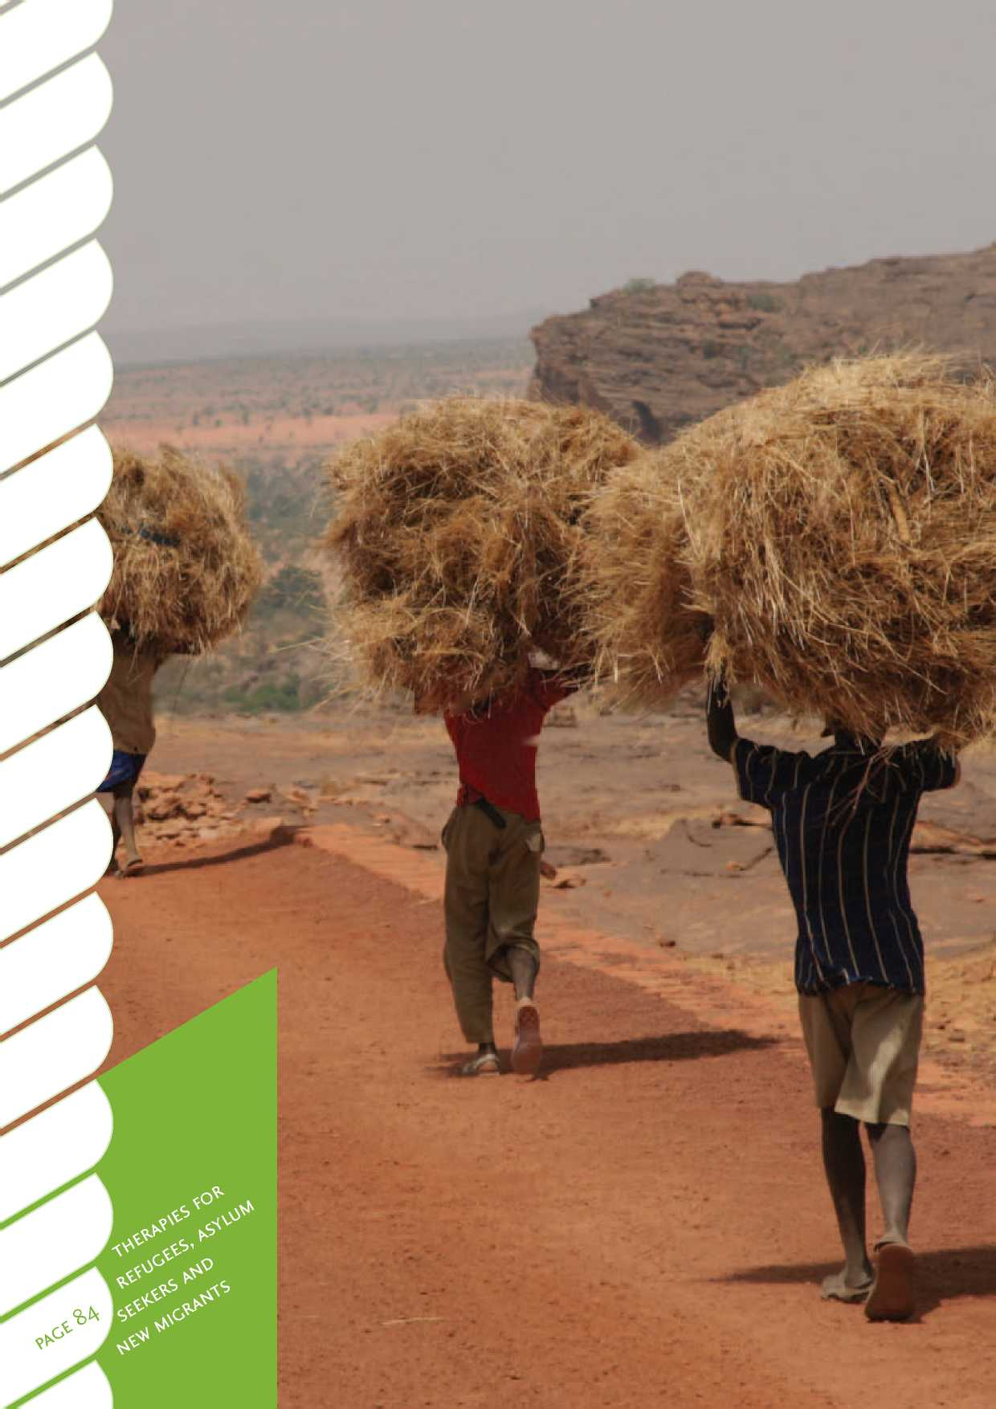

References

1. Palmer, D. (2007). Caught between inequality and stigma: The impact of psychosocial factors and stigma on the mental health of Somali forced migrants in the London borough of Camden. *Diversity in health & social care, 4(3), 177-191.*
2. *Franks, W., Gawn, N., and Bowden, G. (2007). Barriers to access to mental*

*health services for migrant workers, refugees and asylum seekers. Journal of public mental health, 6(1), 33-41.*

1. *Abbott, M. (1997). Refugees and immigrants: Public health report number 3:*

*Mental health in New Zealand from a public health perspective. Wellington: Ministry of Health.*

1. *United Nations High Commissioner for Refugees. (2009). 2008 global trends:*

*Refugees, asylum-seekers, returnees, internally displaced and stateless persons.* Retrieved from [www.unhcr.org/pages/49c3646c4d6.html](http://www.unhcr.org/pages/49c3646c4d6.html).

1. International Organisation for Migration. (2008). Retrieved from [www.iom.int](http://www.iom.int).

jahia/Jahia/lang/en/pid/241.

1. Sluzki, C. E. (1985). *Migration and family conflict: Coping with life crisis: New*

*perspectives*. New York: Plenum.

1. Sluzki, C. E. (1992). Disruption and reconstruction of networks following

migration/relocation. *Family systems medicine, 10*(4), 359-363.

1. Statistics New Zealand. (2002). *2001 Census: People born overseas*. Retrieved

from <http://search.stats.govt.nz/search?af=ctype%3Ainfoaboutstats+&w> =Percentage+Foreign+Born&date=&button.x=24&button.y=8.

1. Statistics New Zealand. (2010). *Longitudinal immigration survey: New Zealand*

*- survey information.* Wellington: Statistics NZ. Retrieved from [www.stats](http://www.stats). govt.nz/browse for stats/population/migration/lisnz-survey-information. aspx.

1. United Nations Office of the High Commissioner for Human Rights. (2004).

*The Istanbul Protocol, professional training series.* Retrieved from [www.ohchr](http://www.ohchr). org/Documents/Publications/training8Rev1en.pdf.

1. Tribe, R. (1999). Therapeutic work with refugees living in exile: Observations

on clinical practice. *Counselling psychology quarterly, 12*(3), 233-243.

1. Tribe, R. (2002). Mental health of refugees and asylum-seekers. *Advances in*

*psychiatric treatment, 8*(4), 240-247.

1. Pumariega, A. J., Rothe, E., and Pumariega, J. A. B. (2005). Mental health of

immigrants and refugees. *Community mental health journal, 41*(5), 581­597.

1. Gallup. (2009). *700 million worldwide desire to migrate permanently*. Retrieved

from [www.gallup.com/poll/124028/700-Million-Worldwide-Desire- Migrate-Permanently.aspx](http://www.gallup.com/poll/124028/700-Million-Worldwide-Desire-Migrate-Permanently.aspx).

1. New Zealand Immigration Service. (2004). *Refugee voices: A journey towards*

*resettlement.* Retrieved from [www.immigration.govt.nz/community/general/](http://www.immigration.govt.nz/community/general/) generalinformation/research/generalresearch/refugees/Refugee+Voices/.

1. Immigration New Zealand. (2009). *Asylum claims 2004-2009.* Wellington:

Immigration New Zealand.

1. United Nations. (2009). I*nternational migration report: A global assessment*.

New York: United Nations, Department of Economic and Social Affairs, Population Division.

1. 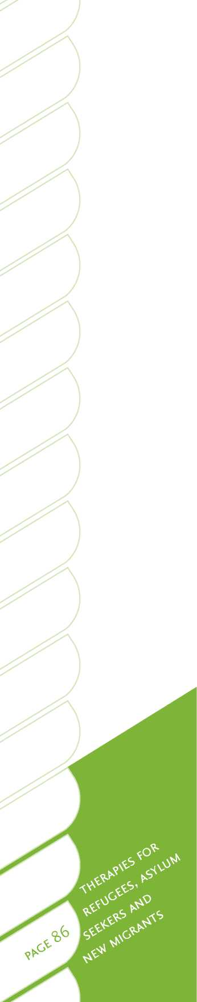Andary, L., Stolk, Y., and Klimidis, S. (2003). *Assessing mental health across cultures*. Melbourne: Australian Academic Press Pty Ltd.
2. Basoglu, M. (2006). Rehabilitation of traumatised refugees and survivors of torture. *British medical journal, 333,* 1230-1231.
3. Scragg, R., and Maitra, A. (2005). *Asian health in Aotearoa: An analysis of the*

*2 002-2 0 03 New Zealand health survey.* Auckland: The Asian Network Incorporated.

1. Mortensen, A. (2009). *Refugees as others: Social and cultural citizenship rights*

*for refugees in New Zealand health services*. Palmerston North: Massey University.

1. Gala, G. (2008). Health needs assessment for Asian people in Counties

Manukau. In S. Tse, A. Sobrun-Maharaj, S. Garg, M. E. Hoque & Y. Ratnasabapathy (Eds.), *Building healthy communities. Proceedings of the Third International Asian Health and Wellbeing Conference, September 8-9* (pp. 81- 84). Auckland, New Zealand: University of Auckland.

1. Gavagan, T. B. L. (1998). Medical care for immigrants and refugees. *Am Fam*

*Physician, 57*(5), 1061-1068.

1. Chester, B., and Holtan, N. (1992). Working with refugee survivors of torture.

*Western Journal of Medicine, 157*(3), 301.

1. Hynes, M., and Cardozo, B. L. (2000). Observations from the CDC: Sexual

violence against refugee women. *Journal of women's health & gender-based medicine, 9*(8), 819-823.

1. McLeod, A., and Reeve, M. (2005). The health status of quota refugees

screened by New Zealand's Auckland Public Health Service between 1995 and 2000. *Journal of the New Zealand Medical Association, 118*(1224), 1-17.

1. Lamb, C., and Smith, M. (2002). Problems refugees face when accessing

health services. *New South Wales Public Health Bulletin, 13*(7), 161-163.

1. Benson, J., and Williams, J. (2008). *Age determination in refugee children:*

*Australian family physician*. Adelaide: Royal Australian College of General Practitioners.

1. Cheung, P. (1995). Acculturation and psychiatric morbidity among

Cambodian refugees in New Zealand. *International journal of social psychiatry, 41*(2), 108-119.

1. Williams, C. I., and Berry, J. W. (1991). Primary prevention of acculturative

stress among refugees: Application of psychological theory and practice. *American journal of psychology, 46*(632D41).

1. Albee, G. W. (1984). Prologue: A model for classifying prevention

programmes. In J. M. Joffe, G. W. Albee, and L. D. Kelly (Eds), *Readings in the primary prevention of psychopathology*. London: University Press of New England.

1. Kokaua, J., Schaaf, D., Wells, J. E., and Foliaki, S. A. (2009). Twelve-month prevalence, severity, and treatment contact of mental disorders in New Zealand born and migrant Pacific participants in Te Rau Hinengaro: The New Zealand mental health survey. *Pacific health dialogue, 75* (1), 9-17.
2. Pernice, R., Trlin, A., Henderson, A., North, N., and Skinner, M. (2009).

Employment status, duration of residence and mental health among skilled migrants to New Zealand: Results of a longitudinal study. *The international journal of social psychiatry, 55*(3), 272-287.

1. Stillman, S., McKenzie, D., and Gibson, J. (2009). Migration and mental

health: Evidence from a natural experiment. *Journal of health economics [serial online], 28*(3), 677-687.

1. Pernice, R., and Brook, J. (1994). Relationship of migrant status (refugee or

immigrant) to mental health. *International journal of social psychiatry, 20*(5), 177-188.

1. Boyle, P.J., Kulu, H., Cooke, T., Gayle, V., and Mulder. C. H. (2006). *The effect*

*of moving on union dissolution: MPIDR Working Paper, WP-2 0 06-002.* Rostock: Max Planck Institute for Demographic Research. Retrieved from [www.demogr.mpg.de/papers/working/wp-2006-002.pdf](http://www.demogr.mpg.de/papers/working/wp-2006-002.pdf).

1. Keyes, E. F. (2000). Mental health status in refugees: An integrative review of

current research. *Issues in mental health nursing, 21*(4), 397-410.

1. Kang Dsk, L. R., Tesar, C. M., and Barriers, C. (1998). Cultural aspects of

caring for refugees. *Medicine and society, 57*(1), 1245-1256.

1. Fazel, M., Wheeler, J., and Danesh, J. (2005). Prevalence of serious mental

disorder in 7000 refugees resettled in western countries: A systematic review. *The lancet, 365*(3), 1309-1314.

1. Mollica, R. F., McInnes, K., Sarajlic, N., Lavelle, J., Sarajlic, I., and Massagli, M. P.

(1999). Disability associated with psychiatric co-morbidity and health status of Bosnian refugees living in Croatia. *Journal of the American medical association, 282*, 433-439.

1. Mollica, R. F., McInnes, K., and Poole, C. (1998). Dose-effect relationships of

trauma to symptoms of depression and post-traumatic stress disorder among Cambodian survivors of mass violence. *British journal of psychiatry, 173*, 482-488.

1. Turner, S. W., Bowie, C., Dunn, G., Shapo, L., and Yule, W. (2003). Mental

health of Kosovan Albanian refugees in the UK. *The British journal of psychiatry, 182*(5), 444-448.

1. Lavik, N. J., Hauff, E, Skrondal, A., and Solberg, O. (1996). Mental disorder

among refugees and the impact of persecution and exile: Some findings from an out-patient population. *The British journal of psychiatry, 169*(6), 726-732.

1. van Velsen, C., and Gorst-Unworth, C. (1996). Survivors of torture and

organised violence - demography and diagnosis. *Journal of traumatic stress, 9*, 181-193.

1. Porter, M., and Haslam, N. (2005). Predisplacement and postdisplacement

factors associated with mental health of refugees and internally displaced persons: A meta-analysis. *Journal of the American medical association, 294*(5), 602-612.

1. 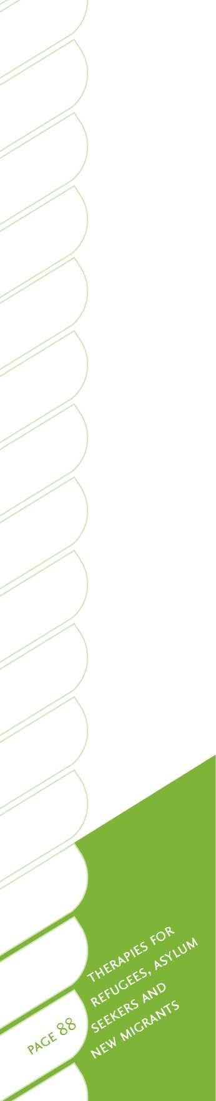Cheung, P. (1994). Post-traumatic stress disorder among Cambodians in New Zealand. *International journal of social psychiatry 40,* 17-26.
2. Cheung, P., and Spears, G. (1995). Psychiatric morbidity among New Zealand

Cambodians: The role of psychosocial factors. *Social psychiatry and psychiatric epidemiology, 30*(2), 92-97.

1. Hodes, M. (2000). Psychologically distressed refugee children in the United

Kingdom. *Child psychology and psychiatry review, 5*(2), 57-68.

1. Westermeyer, J. (1991). Psychiatric services for refugee children. In F. Ahearn,

and J. L. Athey (Eds), *Refugee children: Theory, research and services* (p.p. 127-162). Baltimore and London: The Johns Hopkins University Press.

1. Kinzie, J. D., Sack, W. H., Angell, R., Clarke, G., and Ben, R. (1989). A three

year follow-up of Cambodian young people traumatised as children. *Journal of American academy of child psychiatry, 28*, 501-504.

1. Garmezy, N., and Rutter, M. (1985). Acute reactions to stress. *Child and*

*adolescent psychiatry: Modern approaches, 2*, 152-176.

1. Lukman, B., and Bach-Mortensen, N. (1995). Symptoms in children of torture

victims: Post traumatic stress disorders? *World paediatrics and child care, 5*(7), 32-42.

1. Montgomery, E. (1998). Refugee children from the Middle East. *Scandinavian*

*journal of public health, 26*(1 Suppl 54), 1-152.

1. Jackson, K. (2006). *Fate, spirits and curses: Mental health and traditional beliefs*

*in some refugee communities*. Auckland: Auckland Refugees as Survivors, Rampart Press.

1. Watters, C. (2001). Emerging paradigms in the mental health care of

refugees. *Social science & medicine, 52*(11), 1709-1718.

1. Steel, Z., Silove, D., Bird, K., McGorry, P., and Mohan, P. (1999). Pathways

from war trauma to posttraumatic stress symptoms among Tamil asylum seekers, refugees, and immigrants. *Journal of traumatic stress, 12*(3), 421-435.

1. Gorst-Unsworth, C., and Goldenberg E. (1998). Psychological sequelae of

torture and organised violence suffered by refugees from Iraq: Trauma- related factors compared with social factors in exile. *The British journal of psychiatry, 172*(1), 90-94.

1. Ackerman, L. K. (1997). Health problems of refugees. *The journal of the*

*American board of family medicine, 10(5),* 337-348.

1. Kozaric-Kovacic, D., Ljubin, T., and Grappe, M. (2000). Co-morbidity of

posttraumatic stress disorder and alcohol dependence in displaced persons. *Croatian medical journal, 41*(2), 173-178.

1. Johnson, T. P. (1996). Alcohol and drug use among displaced persons: An

overview. *Substance use and misuse, 1*(31), 853-1889.

1. Westermeyer, J., Lyfoung, T., and Neider, J. (1989). An epidemic of opium

dependence among Asian refugees in Minnesota: Characteristics and causes. *British journal of addiction, 84*(7), 785-789.

1. Nemoto, T., Aoki, B., Huang, K., Morris, A., Nguyen, H., and Wong, W. (1999).

Drug use behaviors among Asian drug users in San Francisco. *Addictive behaviors, 24*(6), 823-838.

1. Amodeo, M., Peou, S., Grigg-Saito, D., Berke, H., Pin-Riebe, S., and Jones, L. (2004). Providing culturally specific substance abuse services in refugee and immigrant communities: Lessons from a Cambodian treatment and demonstration project. *Journal of social work practice in the addictions, 4(3),* 23 -46.
2. Bromley, M. A., and Sip, S. K. C. (2001). Substance abuse treatment issues

with Cambodian Americans. In S. L. A. Straussner (Ed.), *Ethnocultural factors in substance abuse treatment* (p.p. 321-344). New York: Guilford.

1. Simich, L., Hamilton, H., and Baya, B. K. (2006). Mental distress, economic

hardship and expectations of life in Canada among Sudanese newcomers. *Transcultural psychiatry, 43*(3), 418-444.

1. Petry, N. M., Armentano, C., Kuoch, T., Norinth, T., and Smith, L. (2003).

Gambling participation and problems among South East Asian refugees to the United States. *Psychiatric services (Washington DC), 54*(8), 1142-1148.

1. Tse, S., Wong, J., and Kim, H. (2004). A public health approach for Asian

people with problem gambling in foreign countries. *Journal of gambling issues, 12*(3), 1-15.

1. Corrigan, P. W., Kuwabara, S. A., and O'Shaughnessy, J. (2009). The public

stigma of mental illness and drug addiction: Findings from a stratified random sample. *Journal of social work, 9*(2), 139-147.

1. Hinshaw, S. P., and Stier, A. (2008). Stigma as related to mental disorders. *Annual review of clinical psychology, 4*, 367-393.
2. Bagley, C., and King, M. (2005). Exploration of three stigma scales in 83

users of mental health services: Implications for campaigns to reduce stigma. *Journal of mental health*, 14(4), 343-355

1. Guerin, B., Guerin, P., Diiriye, R. O., and Yates, S. (2004). Somali conceptions

and expectations concerning mental health: Some guidelines for mental health professionals. *New Zealand journal of psychology, 33*(2), 59-67.

1. Love, C., and Waitoki, W. (2007). Multicultural competence in bicultural

Aotearoa. In I. Evans, J. Rucklidge, and M. O'Driscoll (Eds), *Professional practice of psychology in Aotearoa New Zealand*. Wellington: New Zealand Psychological Society.

1. Love, C., and Seymour, F. (2007). *Standards of cultural competence for*

*psychologists registered under the Health Practitioners Act (2003) and those seeking to be registered*. Wellington: New Zealand Psychologists Board.

1. Thorburn, J., David, R. and Hagi, I. (2009). *Evaluation of the Auckland regional*

*refugee mobile mental health* [PDF]. Retrieved from [www.tepou.co.nz/file/](http://www.tepou.co.nz/file/) Knowledge-Exchange-stories/kex-006-final-rmt-evaluationresults.pdf.

1. Pittaway, E., McDowell, C., and Mackenzie, C. (2007). Beyond “do no harm”:

Ethical issues in refugee research. *Journal of refugee studies, 20*(special issue on methodology with McDowell, C. and Mackenzie, C.), 299-319.

1. Changemakers Refugee Forum. (2009). *Principles of engagement*. Retrieved

from [www.crf.org.nz/](http://www.crf.org.nz/).

1. 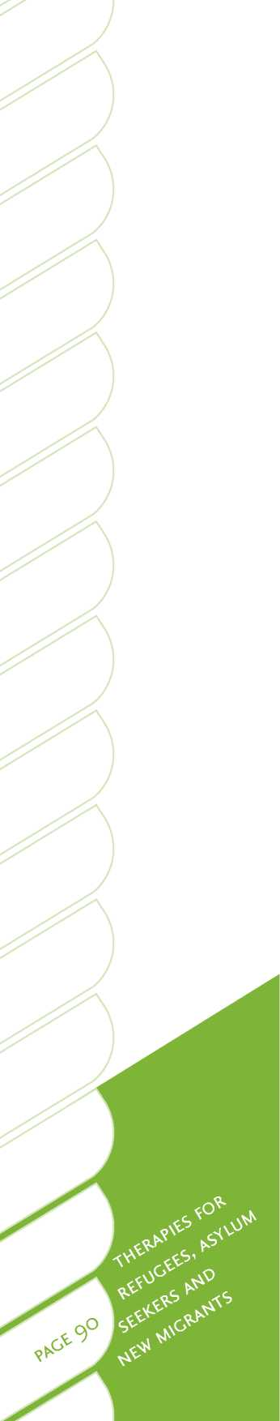Weinstein, H. M., Sarnoff, R. H., Gladstone, E., and Lipson, J. G. (2000). Physical and psychological health issues of resettled refugees in the United States. *Journal of refugee studies, 13(3), 303-327.*
2. Pedersen, P. D. (1988). *A handbook of developing multicultural awareness*.

Alexandria, Va: American Association for Counselling and Development.

1. Hofsteade, G. (2001). *Culture's consequences: Comparing values, behaviours,*

*institutions, and organizations across nations*. Thousand Oaks, CA: Sage Publications.

1. Wing-Sue, D., Carter, R., Casas, J., Fouad, N., Ivey, A., Jensen, M., LaFromboise,

T., Manese, J., Ponterotto, J., and Vasques-Nuttal, E. (1998). *Multicultural counselling competencies.* San Francisco: Sage Publications.

1. Wing-Sue, D. (2001). Multidimensional facets of cultural competence. *The*

*counselling psychologist, 29*(6), 790-821

1. Tribe, R., and Ravel, H. (2002). *Working with interpreters in mental health*.

London: Routledge.

1. Farooq, S., Fear, C. F., and Oyebode, F. (1997). An investigation of the

adequacy of psychiatric interviews conducted through an interpreter. *Psychiatric bulletin, 21*(4), 209-213.

1. Bot, H., and Wadensjo, C. (2004). The presence of third party: A dialogical

view on interpreter-based treatment. In PWD (Ed.), *Broken spirits: The treatment of traumatised asylum seekers, refugees and war and torture victims* (p.p. 355-378). New York: Brunner-Routledge.

1. Ravel, H., and Smith, J. A. (2003). Therapists' experiences of working with

language interpreters. *International journal of mental health, 32*(2), 6-31.

1. Miller, K., Martell, Z., Pazdirek, L., Caruth, M., and Lopez, D. (2005). The role

of interpreters in psychotherapy with refugees: An exploratory study. *American journal of orthopsychiatry, 75*(1), 27-39.

1. Terheggen, M. A., Stroebe, M. S., and Kleber, R. J. (2001). Western

conceptualizations and Eastern experience: A cross-cultural study of traumatic stress reactions among Tibetan refugees in India. *Journal of traumatic stress, 14*(2), 391-403.

1. Murray, K., Davidson, D., and Schweitzer, R. (2008). *Psychological wellbeing of*

*refugees settling in Australia, assessment and intervention: Guidelines for psychologists providing services for refugees*. Melbourne: Australian Psychological Society.

1. Muecke, M. A. (1992). New paradigms for refugee health problems. *Social*

*science and medicine, 35*(4), 515-523.

1. Campbell, T. A. (2007). Psychological assessment, diagnosis, and treatment

of torture survivors: A review. *Clinical psychology review, 27*(5), 628-641.

1. Summerfield, D. (2001). Asylum-seekers, refugees and mental health services

in the UK. *Psychiatric bulletin, 25*(5), 161-163.

1. von Buchwald, U. (1994). Refugee dependency: Origins and consequences. In A. J. Marsella, T. Bornemann, S. Edblad, and J. Orley (Eds.), *Amidst peril and pain: The mental health and well-being of the world's refugees* (p.p. 229-237). Washington D.C: American Psychological Association.
2. Valtonen, K. (2004). From the margin to the mainstream: Conceptualizing refugee settlement processes. *Journal of refugee studies, 17*(1), 70-96.
3. Summerfield, D. (2002). Commentary. *Advances in psychiatric treatment, 8*,

247-248.

1. Koehn, P, and Sainola-Rodriguez, K. (2005). Clinician/patient connections in

ethno-culturally non-concordant encounters with political-asylum seekers: A comparison of physicians and nurses. *Journal of transcultural nursing [serial online], 16*(4), 298-311.

1. Altinkaya JO, H. (1999). Birds in a gilded cage: Resettlement prospects for

adult refugees in New Zealand. *Social policy journal of New Zealand, 13*, 31-42.

1. Samarasinghe, K., and Arvidsson, B. (2002). ‘It is a different war to fight here

in Sweden'-The impact of involuntary migration on the health of refugee families in transition. *Scandinavian journal of caring sciences, 16*(3), 292-301.

1. van der Kolk, B., Roth, S., Pelcovitz, D., Sunday, S., and Spinazzola, J. (2005).

Disorders of extreme stress: The empirical foundation of a complex adaptation to trauma. *Journal of traumatic stress, 18*(5), 389-399.

1. Van Der Kolk, B. A. (2006). Clinical implications of neuroscience research in

PTSD. *New York Academy of Sciences, 1071*, 277-293.

1. Mendes, D., Ventura, P., de Medeiros Passarela, C., and de Jesus Mari, J.

(2008). A systematic review on the effectiveness of cognitive behavioral therapy for posttraumatic stress disorder. *The international journal of psychiatry in medicine, 38*(3), 241-259.

1. Neuner, F., Onyut, P. L., Ertl, V., Odenwald, M., Schauer, E., and Elbert, T.

(2008). Treatment of posttraumatic stress disorder by trained lay counselors in an African refugee settlement: A randomized controlled trial. *Journal of consulting and clinical psychology, 76*(4), 686-694.

1. Te Pou. (2009). *A guide to talking therapies in New Zealand*. Auckland: Te Pou.
2. Grey, N., and Young, K. (2008). Cognitive behaviour therapy with refugees

and asylum seekers experiencing traumatic stress symptoms. *Behavioural and cognitive psychotherapy, 63*, 3-19.

1. Hinton, D., Chhean, D., Pich, V., Safrean, S., Hofmann, S., and Pollack, M.

(2005). A randomized controlled trial for cognitive-behaviour therapy for Cambodian refugees with treatment-resistant PTSD and panic attacks: A cross-over design. *Journal of traumatic stress, 18*(6), 617-629.

1. Hinton, D., Pham, T., Tran, M., Safrean, S., Otto, M. W., and Pollack, M.

(2004). CBT for Vietnamese refugees with treatment-resistant PTSD and panic attacks: A pilot study. *Journal of traumatic stress, 17*(5), 429-433.

1. Neuner, F., Schauer, E., Klaschik, C., Karunakara, U., and Elbert, T. (2008). A

comparison of narrative exposure therapy, supportive counseling, and psychoeducation for treating posttraumatic stress disorder in an African refugee settlement. *Journal of consulting and clinical psychology, 72*(4), 579-587.

1. 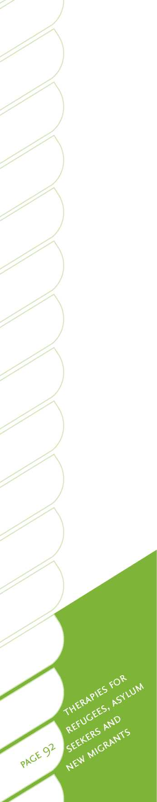Ehntholt, K. A., Smith, P. A., and Yule, W. (2005). School-based cognitive- behavioural therapy group intervention for refugee children who have experienced war-related trauma. *Clinical child psychology and psychiatry, 10*(2), 235 -250.
2. Barrett, P. M., Moore, A. G. and Sonderegger, R. (2000). The FRIENDS program for young former-Yugoslavian refugees in Australia: A pilot study. *Behaviour change, 17*(3), 124-133.
3. Ehntholt, K. A., and Yule, W. (2006). Practitioner review: Assessment and treatment of refugee children and adolescents who have experienced war-related trauma. *Journal of child psychology and psychiatry, 47*(12), 1197-1210.
4. Michelson, D., and Sclare, I. (2009). Psychological needs, service utilization and provision of care in a specialist mental health clinic for young refugees: A comparative study. *Psychology and psychiatry, 14*(2), 273­296.

111 . Schulz, P. M., Resick, P. A., Huber, L. C., and Griffin, M. G. (2006). The effectiveness of cognitive processing therapy for PTSD with refugees in a community setting. *Cognitive and behavioral practice, 13*(4), 322-331.

1. Resick, P. A., and Schnicke, M. K. (1993). *Cognitive processing therapy for rape*

*victims: A treatment manual.* Newbury Park, CA: Sage.

1. d'Ardenne, P., Ruaro, L., Cestari, L., Fakhoury, W., and Priebe, S. (2007).

Does interpreter-mediated CBT with traumatized refugee people work? A comparison of patient outcomes in East London. *Behavioural and cognitive psychotherapy, 35*(3), 293-301.

1. Paunovic, N., and Ost, L. G. (2001). Cognitive-behavior therapy vs exposure

therapy in the treatment of PTSD in refugees. *Behaviour research and therapy, 39*(10), 1183-1197.

1. Bae, S. W, and Kung, W. W. M. (2000). Family intervention for Asian

Americans with a schizophrenic patient in the family. *American journal of orthopsychiatry, 70*(4), 532-541.

1. Kameguchi, K., and Murphy-Shigematsu, S. (2001). Family psychology and

family therapy in Japan. *American psychologist, 56*(1), 65-70.

1. Soo-Hoo, T. (1999). Brief strategic family therapy with Chinese Americans.

*American journal of family therapy, 27*(2), 163-179.

1. Yang, L. H., and Pearson, V. J. (2002). Understanding families in their own

context: Schizophrenia and structural family therapy in Beijing. *Journal of family therapy, 24*(3), 233-257.

1. Denborough, D. (2006). *Trauma: Narrative responses to traumatic experience*.

Adelaide: Dulwich Centre Publications.

1. Denborough, D. (2008). *Collective narrative practice: Responding to*

*individuals, groups, and communities who have experienced trauma*. Adelaide: Dulwich Centre Publications.

1. Denborough, D. (2002). Community song writing and narrative practice.

*Clinical psychology review,* September(17).

1. Denborough, D., Freedman, J., and White, C. (2008). *Strengthening*

*resistance: The use of narrative practices in working with genocide survivors*. Adelaide: Dulwich Centre Foundation.

1. Morgan, A. (2000). *What is narrative therapy: An easy to read introduction.*

Adelaide: Dulwich Centre Publications.

1. Ncube, N. (2006). The Tree of Life Project: Using narrative ideas in work

with vulnerable children in Southern Africa. *International journal of narrative therapy and community work, 1*, 3-16.

1. Sliep, Y. (2005). A narrative theatre approach to working with communities affected by trauma, conflict and war. *International journal of narrative therapy and community work, 2,* 47-52.
2. White, M. (2004). Working with people who are suffering the consequences

of multiple trauma: A narrative perspective. *International journal of narrative therapy and community work, 1*, 45-76.

1. Lustig, S., Weine, S., Saxe, G., and Beardslee, W. (2004). Testimonial

psychotherapy for adolescent refugees: A case series. *Transcultural psychiatry, 41*(1), 31-45.

1. Schauer, M., Neumer, F., and Elbert, T. (2005). *Narrative exposure therapy: A*

*short term intervention for traumatic stress disorders after war, terror or torture*. Gottingen: Hogrefe & Huber.

1. Webster, A., and Robertson, M. (2007). Can community psychology meet

the needs of refugees? *The Psychologist, 20*(3), 156.

1. Goodkind, J. R. (2005). Effectiveness of a community-based advocacy and

learning program for Hmong refugees. *American journal of community psychology, 36*(3), 387-408.

1. Goodkind, J. R., and Foster-Fishman, P. G. (2002). Integrating diversity and

fostering interdependence: Ecological lessons learned about refugee participation in multiethnic communities. *Journal of community psychology, 30*(4), 389-409.

1. Miller, K., and Rasco, L. (2004). *The mental health of refugees: Ecological*

*approaches to healing and adaptation*. New York: Routledge.

1. Moritsugu, J., and Grover, D. K. (2009). *Community psychology*. London: Allyn

& Bacon.

1. Reich, S., Riemer, M., Prilleltensky, I., and Montero, M. (2007). *International*

*community psychology: History and theories*. New York: Springer.

1. Grodin, M. A., Piwowarczyk, L., Fulker, D., Bazazi, A. R., and Saper, R. B.

(2008). Treating survivors of torture and refugee trauma: A preliminary case series using Qigong and T'ai chi. *The journal of alternative and complementary medicine, 14*(7), 801-806.

1. Field, T. M., Sunshine, W., Hernandezreif, M., Quintino, O., Schanberg, S.,

Kuhn, C., and Burman, I. (1997b). Massage therapy effects on depression and somatic symptoms in chronic fatigue syndrome. *Journal of chronic fatigue syndrome, 3*(3), 43-51.

1. Delaney, J. P. A., Leong, K. S., Watkins, A., and Brodie, D. (2002). The

short-term effects of myofascial trigger point massage therapy on cardiac autonomic tone in healthy subjects. *Journal of advanced nursing, 37*(4), 364-371.

1. Hart, S., Field, T., Hernandez-Reif, M., Nearing, G., Shaw, S., Schanberg, S.,

and Kuhn, C. (2001). Anorexia nervosa symptoms are reduced by massage therapy. *Eating disorders, 9*(4), 289-299.

1. Hernandez-reif, M., Dieter, J., Field, T., Swerdlow, B., and Diego, M. (1998). Migraine headaches are reduced by massage therapy. *International journal of neuroscience, 96*(1-2), 1-11.
2. 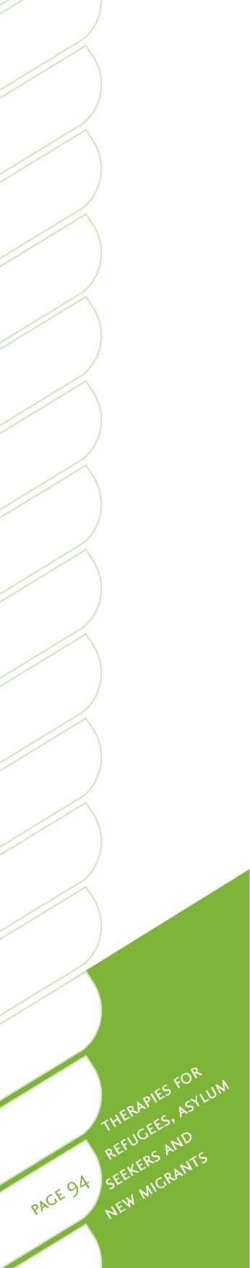Ironson, G., Field, T., Scafidi, F., Hashimoto, M., Kumar, M., Kumar, A., Price,

A., Goncalves, A., Burman, I., Tetenman, C., Patarca, R., and Fletcher, M. A. (1996). Massage therapy is associated with enhancement of the immune system's cytotoxic capacity. *International journal of neuroscience, 84*(1), 205-217.

1. Foster, K. A., Liskin, J., Cen, S., Abbott, A., Armisen, V., Globe, D., Knox, L., Mitchell, M., Shtir, C., and Azen, S. (2004). The Trager approach in the treatment of chronic headache: A pilot study. *Alternative therapies in health and medicine, 10*, 40-46.
2. Hasson, D., Arnetz, B., Jelveus, L., and Edelstam, B. (2004). A randomized clinical trial of the treatment effects of massage compared to relaxation tape recordings on diffuse long-term pain. *Journal of psychotherapy & psychosomatics, 73*(1), 17-24.
3. Field, T., Morrow, C., Valdeon, C., Larson, S., Kuhn, C., and Schanberg, S. (1992). Massage reduces anxiety in child and adolescent psychiatric patients. *Journal of the American Academy of Child & Adolescent Psychiatry, 31*(1), 125-131.
4. Sherman, K. J., Ludman, E. J., Cook, A. J., Hawkes, R. J., Roy-Byrne, P., Bentley, S., Brooks, M. Z., and Cherkin, D. C. (2010). Effectiveness of therapeutic massage for generalized anxiety disorder: A randomized controlled trial. *Depression and anxiety, 27*(5), 441-450.
5. Field, T., Seligman, S., and Scafidi Saul, F. (1996). Alleviating posttraumatic

stress in children following Hurricane Andrew. *Journal of applied developmental psychology, 17*(1), 37-50.

1. Field, T., Hernandez-Reif, M., Hart, S., Quintino, O., Drose, L., Field, T., Kuhn,

C., and Schanberg, S. (1997). Effects of sexual abuse are lessened by massage therapy. *Journal of bodywork and movement therapies, 1*(2), 65-69.

1. Field, T., Ironson, G., Scafidi, F., Nawrocki, T., Goncalves, A., Burman, I.,

Pickens, J., Fox, N., Schanberg, S., and Kuhn, C. (1996). Massage therapy reduces anxiety and enhances EEG pattern of alertness and math computations. *International journal of neuroscience, 86*, 197-205.

1. Field, T., Peck, M., Krugman, S., Tuchel, T., Schanberg, S., Kuhn, C., and

Burman, I. (1998). Burn injuries benefit from massage therapy. *Journal of burn care and rehabilitation, 19*(3), 241-244.

1. Levine, P. A. (1997). *Waking the tiger, healing trauma*. Berkley: North Atlantic

Books.

1. Shapiro, F. (2001). *Eye movement desensitization and reprocessing: Basic*

*principles, protocols and procedures* (2nd ed.). New York: Guilford Press.

1. Tinker RHW, S. A. (1999). *Through the eyes of a child: EMDR with children.*

New York: W.W. Norton & Company.

1. Arns, M. D. R. S, Strehl, U., Breteler, M. and Coenen, A. (2009). Efficacy of

neurofeedback treatment in ADHD: The effects on inattention, impulsivity and hyperactivity: A meta-analysis. *Clinical EEG and neuroscience, 40*(3), 180-189.

1. Powers, M. B., Vording, M., and Emmelkamp, P. M. G. (2009). Acceptance

and commitment therapy: A meta-analytic review. *Psychotherapy and psychosomatics, 8*(1), 73-80.

1. Hayes, S. C. (2002). Buddhism and acceptance and commitment therapy.

*Cognitive and behavioral practice, 9*(1), 58-66.

1. Liu, E. T. H, Chen, W. L, Li, Y. H., Wang, C. H., Mok, T. J, and Huang, H. S. (2008). Exploring the efficacy of cognitive bibliotherapy and a potential mechanism of change in the treatment of depressive symptoms among the Chinese: A randomized controlled trial. *Cognitive therapy and research, 33(5),* 449-461.
2. Fanner, D., and Urquhart, C. (2008). Bibliotherapy for mental health service

users: Part 1: A systematic review. *Health information and libraries journal, 25*(4), 237-252.

1. Kaltenthaler, E., Brazier, J., De Nigris, E., Tumur, I., Ferriter, M., and Beverley, C.

(2006). Computerised cognitive behaviour therapy for depression and anxiety update: A systematic review and economic evaluation. *Health technology assessment, 10*(33).

1. Dimeff, L., and Linehan, M. (2006). Dialetic behavior therapy in a nutshell.

*Californian Psychologist, 34*, 10-13.

1. Brazier, J., Tumur, I., Holmes, M., Ferriter, M., Parry, G., and Dent-Brown, K.

(2006). Psychological therapies including dialectical behaviour therapy for borderline personality disorder: a systematic review and preliminary economic evaluation. *Health technology assessment, 10*(35).

1. Shedler, J. (2010). The efficacy of psychodynamic psychotherapy. *American*

*psychologist, 65*(1), 98-109.

1. Lundahl, BWK, C., Brownell, C., Tollefson, D., Burke, B. L. (2010). A meta­analysis of motivational interviewing: Twenty-five years of empirical studies. *Research on social work practice, 20*(1), 137-160.
2. Bazire, S. (2009). *Psychotropic drug directory 2009: The professional's pocket*

*handbook and aide memoir.* Malta: Gutenburg Press Limited.

1. Stein, D. J., Seedat, S., J.G vdL, NZD. (2000). Selective serotonin re-uptake

inhibitors in the treatment of post traumatic stress disorder: A meta­analysis of randomised controlled trials. *International clinical psychopharmacology, 18*(S), 31-39.

1. Marshall, R. D., Beebe, K. L., Oldham, M., and Zaninelli, R. (2001). Efficacy

and safety of paroxetine treatment for chronic PTSD: A fixed-dose, placebo-controlled study. *American journal of psychiatry, 158*, 198-1988.

1. Martenyi, F., Brown, E. B., Zhang, H., Koke, S. C., and Prakash, A. (2002).

Fluoxetine v. placebo in prevention of relapse in post-traumatic stress disorder. *The British journal of psychiatry, 181*(4), 315-320.

1. Lewis, J. D. (2002). Mirtazapine for PTSD nightmares (letter). *American*

*journal of psychiatry, 159*(11), 1948-1949.

1. Chung, M. Y., Min, K. H., Jun, Y. J., Kim, S. S., and Jun, E. M. (2004). Efficacy and tolerability of mirtazapine and sertraline in Korean veterans with posttraumatic stress disorder: A randomized open label trial. *Human psychopharmacology, 19*, 489-494.
2. Pae, C. U., Lim, H. K., Peindl, K., Ajwani, N., Serretti, A., Patakar, A. A., and Lee, C. (2008). The atypical antipsychotics Olanzepine and Risperidone in the treatment of posttraumatic stress disorder: A meta-analysis of randomized double-blind controlled clinical trials. *International clinical psychopharmacology, 23*(1).
3. 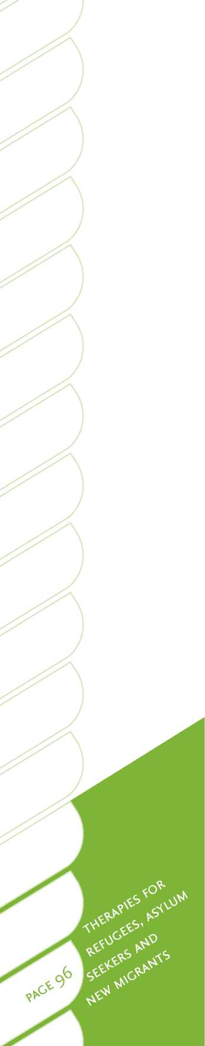Ouzdemir et al. *Quetiapine/Sertraline combination in PTSD (poster)*, presented at the 159th annual meeting of the American Psychiatric Association, May 2006. Toronto: Astrazenca.
4. Hochstrosser, B., Isaksen, P. M., Lauretzen, L., Mahnert, F. A., Roullon, F., Wade, A. G., Andersen, M., Pedersen, S. F., Swart, J. G., and Nil, R. (2001). Prophylactic effect of citalopram in unipolar, recurrent depression: Placebo-controlled study of maintenance therapy. *British Journal of Psychiatry, 178, 304-310.*
5. *Bech, P., Cialdella, P., Haugh, M. C., Hours, A., Boissel, J. P., Birkett, M. A., and Tollefson, G. D. (2000). Meta-analysis of randomised controlled trials of* fluoxetine v. placebo and tricyclic antidepressants in the short-term *treatment of major depression. The British journal of psychiatry, 176(5), 421-428.*
6. *Shah, R., Uren, Z., Baker, A., and Majeed, A. (2001). Deaths from antidepressants in England and Wales 1993-1997: Analysis of a new national database. Psychological medicine, 31, 120-121.*
7. *Guiana, G., Barbui, C., and Hotopf, M. (2007). Amitriptyline for depression.*

*Cochrane database of systematic reviews 2007, 2(CD004186).*

1. *Nierenberg, A.A., and Papakosta, G.I. (2003). Nortriptyline for treatment*

*resistant depression. Journal of Clinical Psychiatry, 64, 33-39.*

Notes



Notes

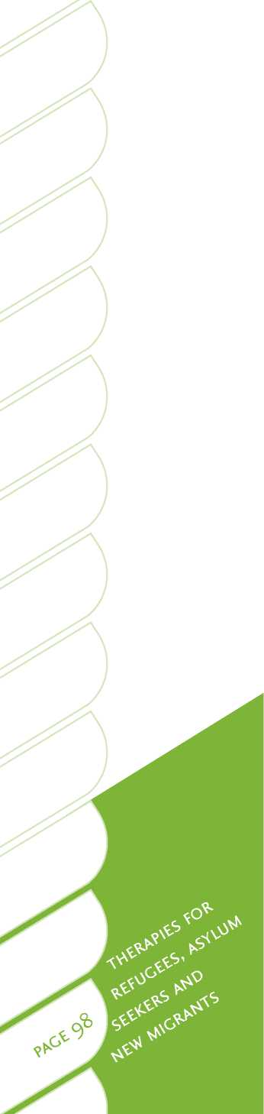



?e Pou

o Te Whakaaro Nui

web [www.tepou.co.nz](http://www.tepou.co.nz) email [info@tepou.co.nz](mailto:info@tepou.co.nz)



1. In 2006, 29 per cent of overseas-born people came from the United Kingdom and Ireland, and 29 per cent from Asia.
2. Approximately 3 per cent of the world population.
3. t Politics have increasingly become intertwined with immigration policy in many countries due to contemporary societal concerns with national security, terrorism and issues around cultural diversity and tolerance5.
4. £ In 2006, 29 per cent of overseas-born people came from the United Kingdom and Ireland, and 29 per cent from Asia.
5. Statistics New Zealand is currently undertaking a longitudinal immigration survey, which aims to better understand migrants' settlement patterns over their first three years as permanent residents in New Zealand9.
6. A part of the Department of Labour.

   f Canada, United States, Finland, Netherlands, Sweden, Denmark, Norway, Sweden and, most recently, Japan. New Zealand's quota now ranks fifth equal with Canada.
7. The only specialist refugee mental health services in Aotearoa/New Zealand are located in Auckland (RASNZ),
8. Wellington (Wellington Refugees as Survivors Trust) and Christchurch (Christchurch Resettlement Services).
9. + [www.refugeeservices.org.nz/__data/assets/pdf_file/0020/2297/Refugee_Services_Annual_Report_07-08.pdf](http://www.refugeeservices.org.nz/__data/assets/pdf_file/0020/2297/Refugee_Services_Annual_Report_07-08.pdf). t Serious ethical issues can arise when placing traumatised refugees into settlement cities where there are no specialist health services to support them. Mainstream services are often not accessible, and some district health boards continue to apply the 3 per cent service rationing cut off, where only the most florid or severe cases of presenting pathology are admitted for services.
10. Rates in these groups are as high as in Pacific populations.
11. Both acculturation (adaptation to the new culture), and maintenance of traditions and language, are associated with better settlement 3, 29, 30.
12. f Acculturation differences among family members can also result in intergenerational conflicts 3 4 6.
13. It is unclear if those who maintain close links with their own ethnic group or traditions over a longer time are at greater or lesser risk3.
14. Poor mental health was evident among skilled migrants from China, India and South Africa during the first two years of residence in Aotearoa/New Zealand 33. Thereafter, mental health status slightly improved.

    1 Refugee camps can be extremely hostile, with shifting populations and little, if any, personal space 12. Refugees may live in this context for years. Refugee camps are almost universally poorly resourced, and residents often experience a multitude of health problems resulting from poor sanitation, quickly spread diseases, malnutrition, and other factors 3, 15.
15. * While major depression prevalence may be only slightly higher in comparison to the general population.

    f Interview-based studies tend to present somewhat lower, but still consistent, rates of PTSD and depression. For example, in the U.K., van Velsen and Grost-Unworth44 completed an interview survey of a mixed group of refugees, and reported 35 per cent with major depressive disorder and 52 per cent with PTSD (although it should be noted that this was in a group referred for psychiatric assessment).
16. Despite this, only one person reported using psychiatric services during the previous year.

    In a given intake of 130 to 150 refugees at Mangere National Refugee Centre.
17. For example, by the United Nations High Commissioner for Refugees and the International Organisation for Migration when these organisations are carrying out their initial assessment and selection missions.
18. * The development of multicultural practice in Aotearoa/New Zealand must be based upon the bicultural foundations
19. of Te Tiriti O Waitangi 72 and on principles of cultural safety and competence 73. Specialist services by and for Maori were initiated in the late 1980s, and more recently have been extended to migrants of Pacific Island and Asian origins. The efforts and initiatives of health and social services in Aotearoa/New Zealand to become more culturally responsive to their Treaty of Waitangi obligations to mana whenua may have helped foster the development of more appropriate services for migrants from culturally and linguistically diverse backgrounds 72.
20. Over one-third of people who live in the Auckland region were born overseas ([www.stats.govt.nz/](http://www.stats.govt.nz/) Census/2006CensusHomePage/QuickStats/quickstats-about-a-subject/culture-and-identity/ethnic-groups-in- new-zealand.aspx).
21. * It is incumbent upon government agencies and service providers to both respond and to advocate for these rights.
22. The failure of the mental health system to adequately address these issues has, in quite recent years, sometimes resulted in deeply tragic and very public incidents featuring in the news headlines.
23. * In a number of cases, mental health issues may arise some time after a person from a forced migration background reaches a safe place and is progressing through the resettlement process.
24. Specialist refugee mental health services such as RASNZ in Auckland and the Victorian Foundation in Melbourne often employ body therapists to work with refugees who present with physical pain, as an entry point for complementary integrated psychological or medical services.

    Including mental health measures.
25. Including those endeavouring to deliver resettlement assistance in the new country and others perceived as authority figures.
26. * For quota refugees.
27. Some of the best outcomes are achieved when former service users who have recovered and settled well then go on to become support providers themselves. It is important to also include leaders of the diverse communities being served when seeking advice around service development, delivery, research and evaluation.

    For example, randomised-controlled trials and meta-analyses.

    2004 Code of Conduct for Expert Witnesses, High Court Rules, Schedule 4
28. Often accompanied by the police.

    t Upon approval, asylum seekers are referred to as convention refugees.

    £ Family reunification is a very important topic that is currently being researched in more depth in Aotearoa/New Zealand.

    This service is also offered onsite at the Mangere Refugee Resettlement Centre at Auckland.